Properties of Water

_______________ ________________ ________________

Use the images to identify:

covalent bonds

hydrogen bonds

Ionic bonds

Which atom is more electronegative? What does that mean?

Water has polar covalent bonds. Add charges on the image to show the uneven sharing of electrons.

Polar substances interact best with other _____________ substances but do not interact well with ___________ substances

Due to its polarity, water forms which type of bond with other water molecules? ____________________

Draw dotted lines to show where these bonds would form between water molecules.



Label the image that demonstrates adhesion. Explain what adhesion is and how it occurs.

Label the image that represents cohesion. Explain what cohesion is and how it occurs.

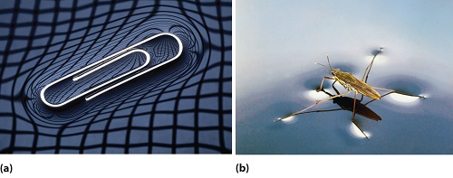

What causes water to have such high surface tension?

.

Explain how the high heat of vaporization of water allows for evaporative cooling.

Which type of organisms take advantage of evaporative cooling? Endotherms or ectotherms? Explain.

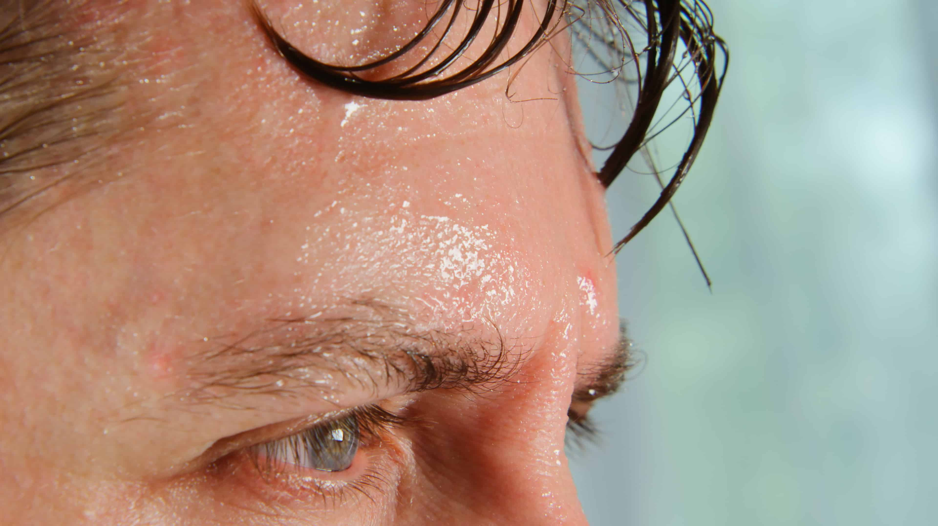

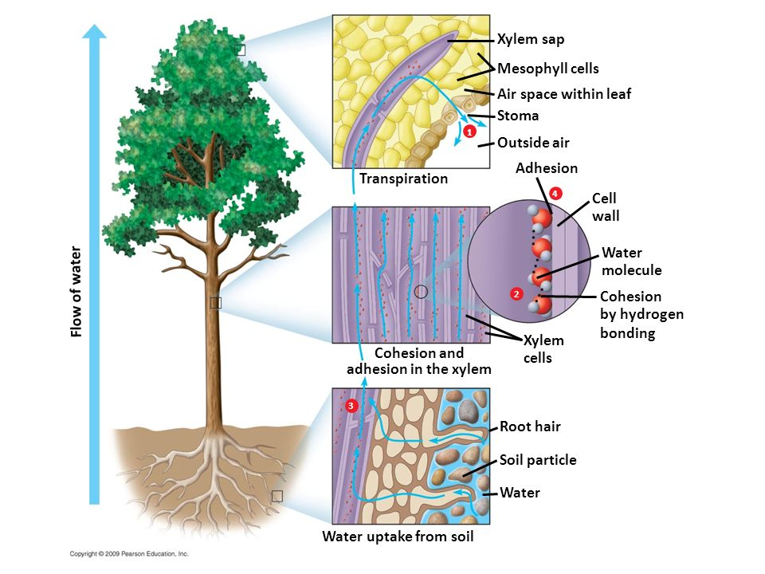

The process to the right is called

_________________________________.

Describe the role of adhesion and cohesion in this process.

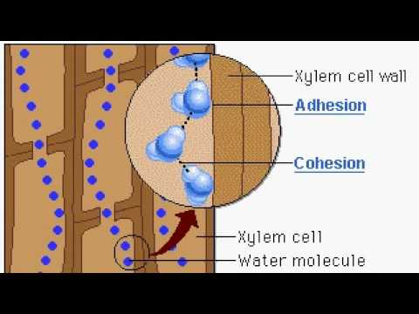

Label the image that represents atoms of liquid water and the one that represents atoms of ice.

Explain why ice floats.

How does waters high specific heat stabilize water temperatures?

