Macromolecules: Carbohydrates, Lipids and Nucleic Acids

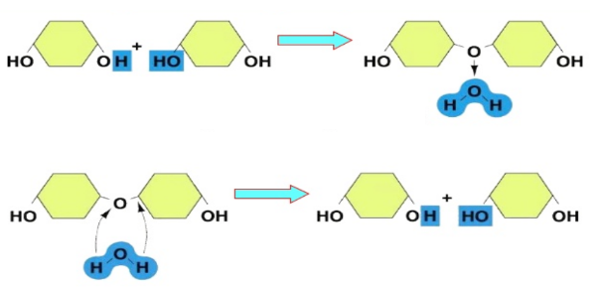

Identify each image as dehydration synthesis or hydrolysis.

Which process connects monomers together to build polymers? _____________________

Which process is used during digestion to break polymers down to their monomers?

___________________________

In which process is water removed from the molecules?

In which process is water used?

Carbohydrates

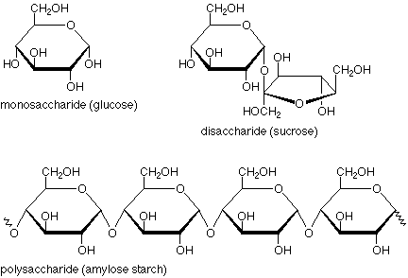

Atoms:

Monomer name: ______________________________

Examples:

Polymer name: _______________________________

Examples

Functions of Carbs:

Name of bond formed between two monosaccharides during dehydration synthesis:

What is a disaccharide?

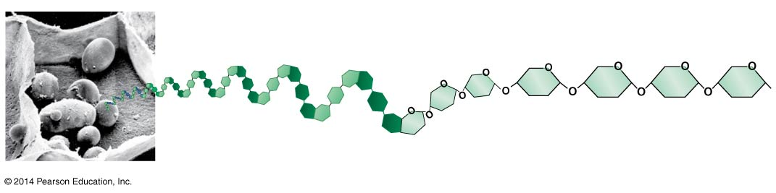Starch

Identify the function of each of these polysaccharides.

Starch:

Cellulose:

Glycogen:

All 3 of these polysaccharides are made by chaining glucose together. If this is the case, why do they each have a different structure and function?

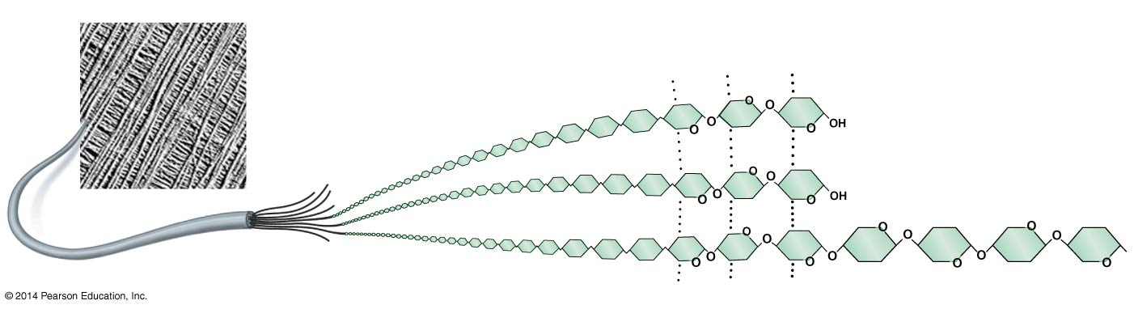Cellulose

Glycogen

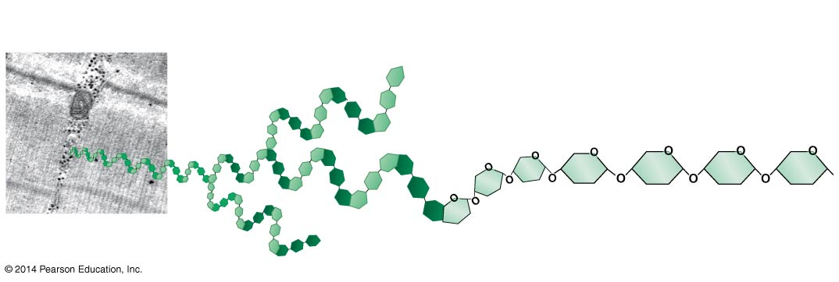

Lipids

Atoms:

What are the 3 main categories of lipids?

2 main parts (of most lipids):

Function of lipids?

What process connects fatty acids to glycerol? Bond formed?

What is a byproduct of this process?

What is the significance of the head of a phospholipid being hydrophilic, but the fatty acid tails being hydrophobic for a cell membrane?

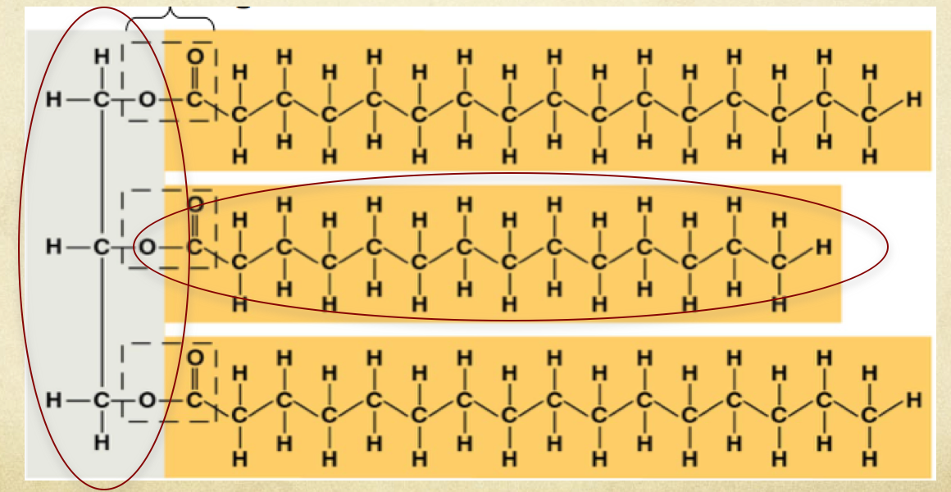

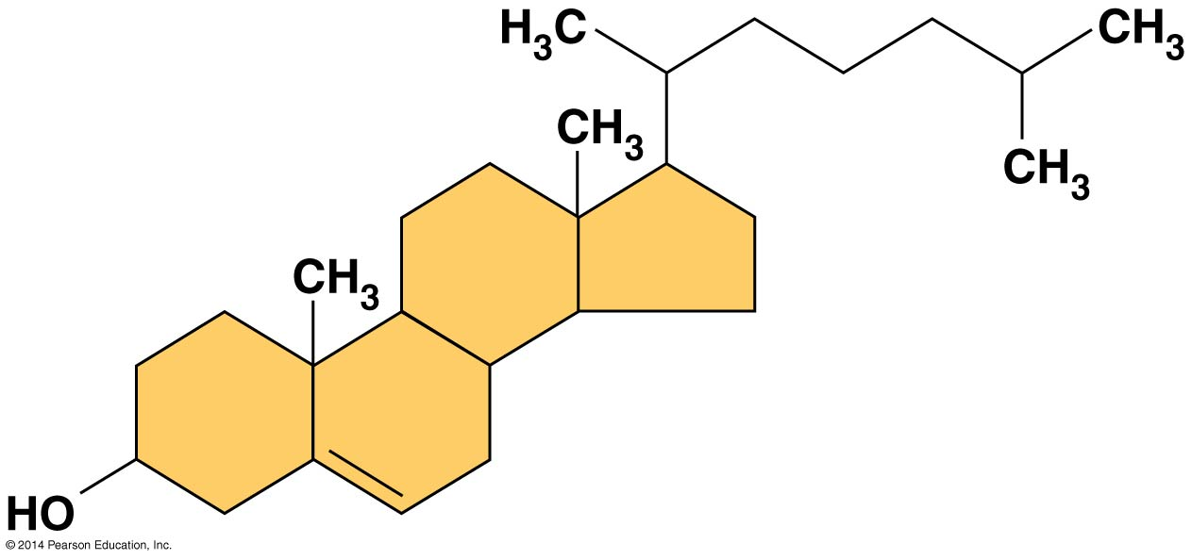

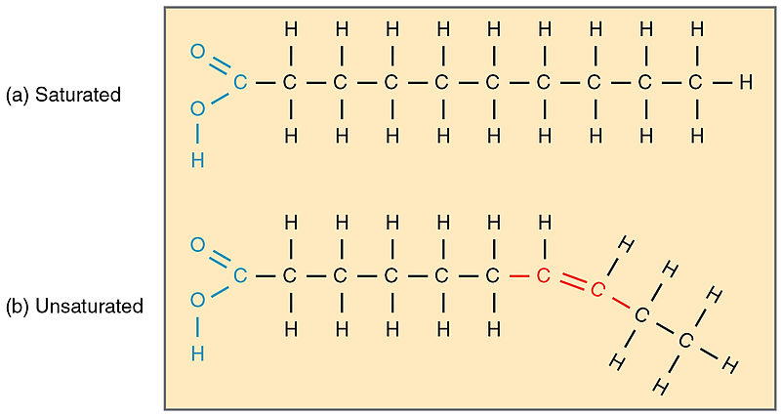

Label the diagram to the right for saturated and unsaturated fatty acids

What makes an unsaturated fatty acid different from a saturated fatty acid?

Which is likely to be liquid at room temperature?

.

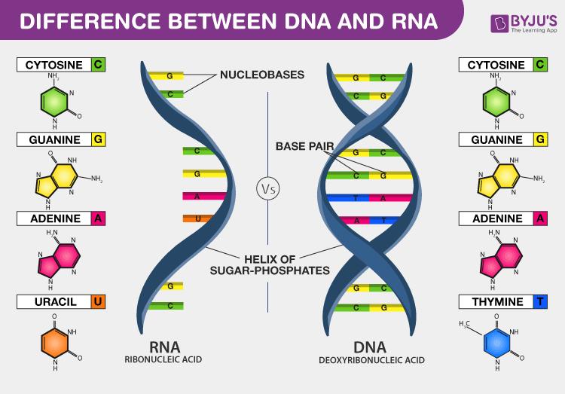Nucleic Acids

Atoms:

Monomer name: ______________________________

Name its three parts:

Polymer name: _______________________________

2 Examples

Bond formed after dehydration synthesis between two nucleotides? ________________________

Functions of Nucleic Acids:

Identify the 3 main structural differences be DNA and RNA.

Name the 2 types of bonds found in a DNA double helix and where they are found.

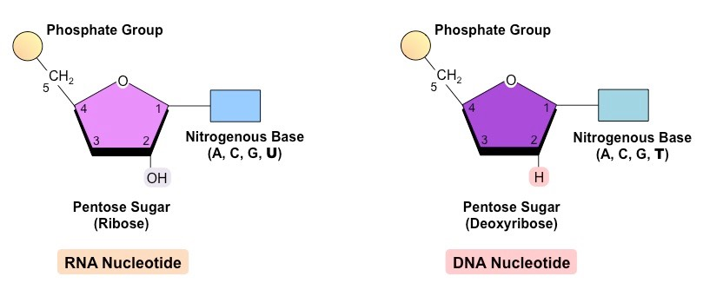

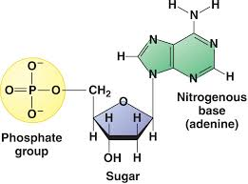

Nucleotide Details