Macromolecules: Proteins

Atoms:

Monomer name: ______________________________

How many are there?

Identify the amino group on the image.

Identify the carboxyl group on the image.

What does the R represent?

Why is the R group soooo important?



Polymer name: _______________________________

Name of bond formed between two amino acids during dehydration synthesis:

Circle the two amino acids in the image on the right.

Between which to groups does dehydration synthesis occur?

Functions of proteins:

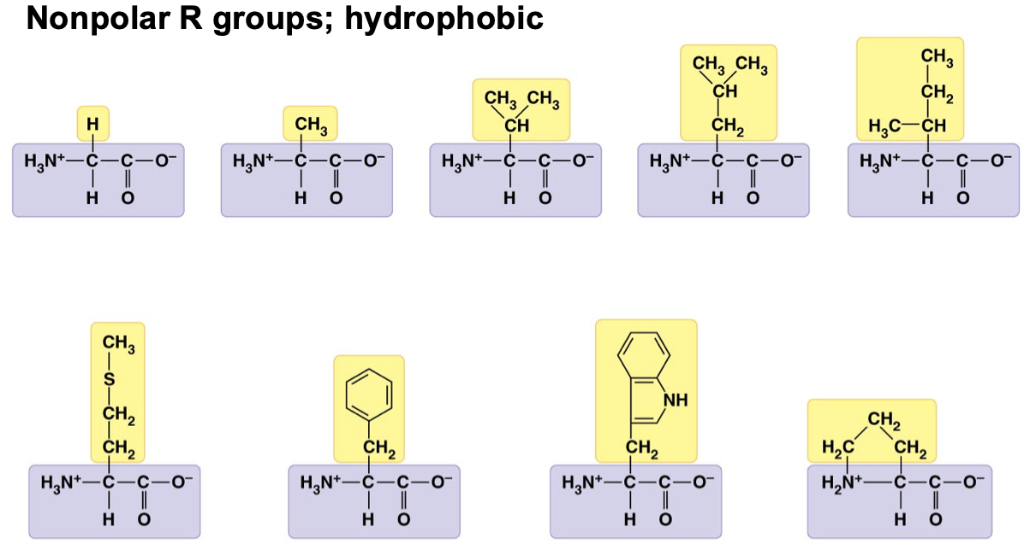

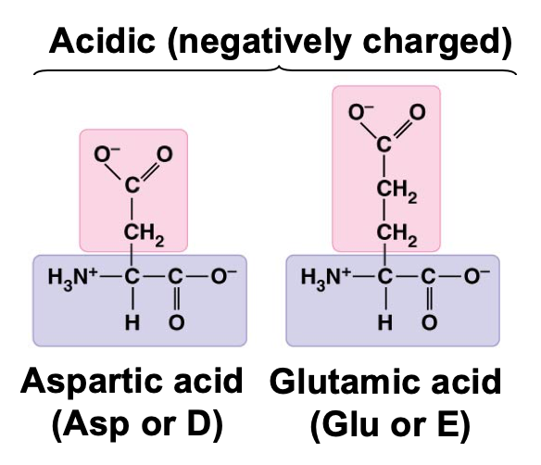

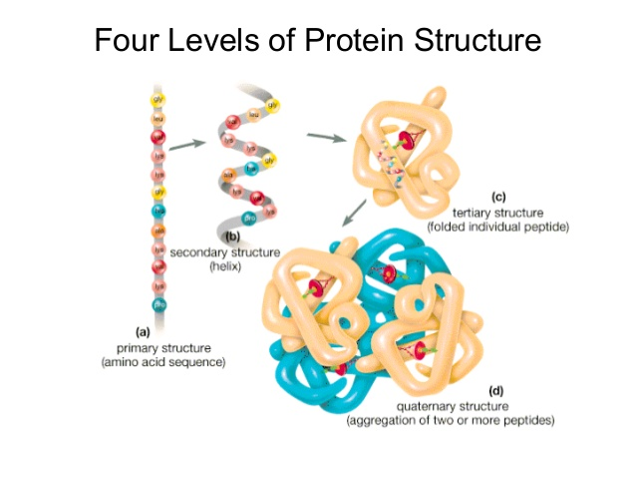

Define the following:

Primary Structure:

Secondary Structure:

Tertiary Structure:

Quaternary Structure:

What is the role of R groups in determining protein structure?

Explain the role of each of these bonds or interactions in determining the tertiary structure of proteins.

Hydrophilic/Hydrophobic interactions-

Hydrogen bonds-

Ionic Bonds-

Disulfide bridges-