Name: ___________
Main Ideas Title: 5 Fingers of Evolution Period: ___ Seat:__

Change Any changes in a gene pool, in allele or genotype frequencies, is evolution of a population
(species)

5 Causes of 1) Genetic drift occurs in small populations
Change 2) ___________________ occurs when certain traits increase an individual’s success at mating
3) Mutations- ______________________________________________
4) Gene flow- genes move in and out of the population due to immigration and emigration
5) Natural Selection (3 types…see next note section)

Genetic Drift Genetic Drift
2 Types:
Bottle neck-A random event such as a fire or flood that causes change.
It ____________________________________________________ —any one can die or be
lucky enough to survive

Founder Effect- Individuals leave a large population to establish a new population. _________
______________________________________________________________
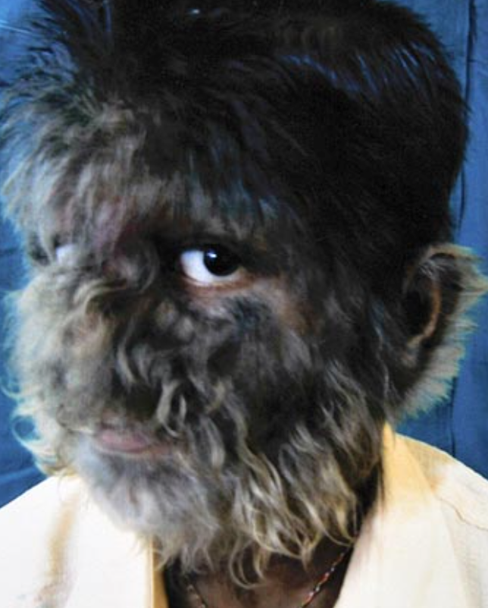
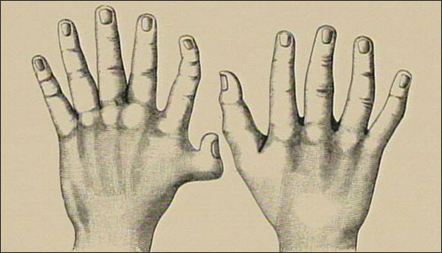

Sexual Selection Explain how sexual selection leads to change in your own words:

Why do you think sexual selection does not act on females in most species?

Mutations Explain how mutations lead to change in your own words:

Gene Flow Movement of fertile individuals between populations (immigration and emigration
-_____________________________________________
- Reduce genetic differences between populations

Name: ___________
Main Ideas Title: 5 Fingers of Evolution Period: ___ Seat:__

Change Any changes in a gene pool, in allele or genotype frequencies, is evolution of a population
(species)

5 Causes of 1) Genetic drift occurs in small populations
Change 2) ___________________ occurs when certain traits increase an individual’s success at mating
3) Mutations- ______________________________________________
4) Gene flow- genes move in and out of the population due to immigration and emigration
5) Natural Selection (3 types…see next note section)

Genetic Drift Genetic Drift
2 Types:
Bottle neck-A random event such as a fire or flood that causes change.
It ____________________________________________________ —any one can die or be
lucky enough to survive

Founder Effect- Individuals leave a large population to establish a new population. _________
______________________________________________________________

Sexual Selection Explain how sexual selection leads to change in your own words:

Why do you think sexual selection does not act on females in most species?

Mutations Explain how mutations lead to change in your own words:

Gene Flow Movement of fertile individuals between populations (immigration and emigration
-_____________________________________________
- Reduce genetic differences between populations

