Study Guidelines: Eukaryote Gene Regulation
Name: ____________
Period: ___ Seat: ____
Eukaryotes have more DNA than prokaryotes do. Differences in DNA location and organization mean that Eukaryotes use additional methods of gene regulation.

Review Objectives
1. Label the chromosome, chromatin, DNA, histone proteins, nucleosome
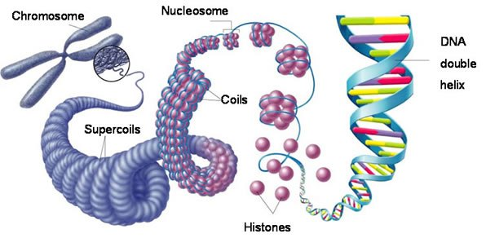

2. a. Define promotor, RNA polymerase, nucleosome
b. Describe the consequences of promotor location relative to a nucleosome
c. Identify the differences and similarities between heterochromatin and euchromatin. What role does each play in gene regulation?

3. a. Explain the process of acetylation of histone tails and its affects gene regulation
b. Explain the process of methylation of histone tails and its impact on gene expression.
c. Describe the consequences of methylation of the DNA itself

4. Describe epigenetics in your own words.

5. Identify the roles of control elements, transcription factors and mediator proteins in eukaryote transcription. What is special about enhancers?

6. Explain the series of events that must happen for transcription to start for a eukaryote gene (there are three steps)

7. a. Read pages 304-305 b. Explain each of these post-transcriptional gene regulation/expression mechanisms; RNA processing, mRNA degradation, initiation of translation and protein processing and degradation.

* 8. Make sure you understand 5 and 6. Try explaining #6 out loud or by drawing it out for at least 3 people

9. a. Explain how repressors work to regulate eukaryote genes
b. Compare the way repressors work in eukaryotes and prokaryotes

10. a. Describe how hormones may be used to regulate eukaryote genes
b. Explain how a non-hormone (nonsteroidal) molecule may be used to regulate eukaryote genes.

