Name: ___________
Main Ideas Title: Population Ecology Period: ___ Seat:__

Populations Population Group of individuals of ______________ in _________________ at same time

Factors That Abiotic factors: sunlight & temperature, ________________________, soil / nutrients
Affect Populations Biotic factors: other living organisms= prey (food), competitors, predators, parasites, _____
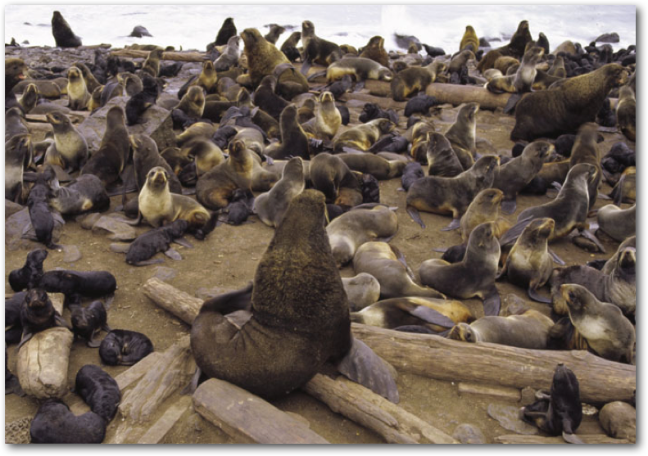
Intrinsic factors: ______________________

Population
Spacing

Population Population Growth: ________________ and _________________
Growth Population Decline: _________________ and __________________
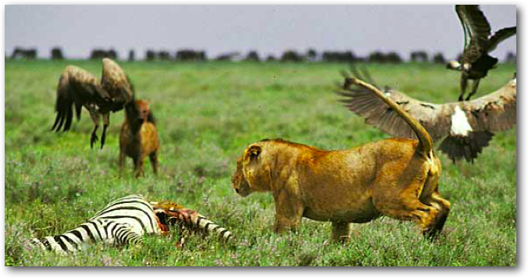

Regulating Pop. Limiting factors
Size __________________
-competition: food, mates, nesting sites
- predators, parasites, pathogens
___________________
-abiotic factors, sunlight (energy), temperature, rainfall, weather

Introduced Species Non-native species- ____________________________________________________________
Out-compete native species: _____________________________________________________
_______________________________________________________________________

Measuring Pop. How do we measure how many individuals in a population?
___________________________________________________
___________________________________________________
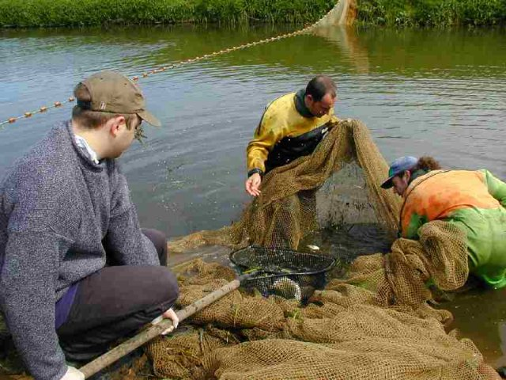
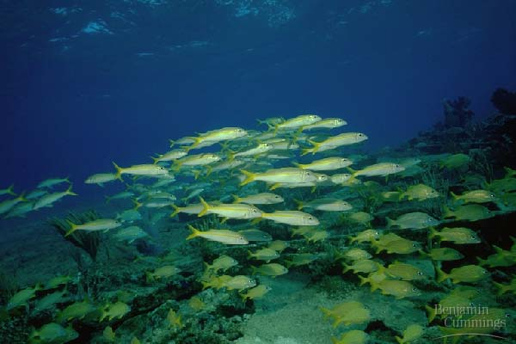

Summary

