Natural Selection Think-sheet
Name: ________________
Period: _______ Seat:____
Define population-
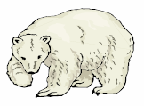
Problem 1: There are 3 types of polar bears: ones with thick coats, ones with thin coats and ones with medium coats. It is fall, soon to be winter. The temperatures are dropping rapidly and the bears must be kept warm or they will freeze to death. Many of the bears have had 2 cubs each but due to the extreme temperatures, many mothers only have one cub left.

1. Which polar bear will not benefit from natural selection?

2. Identify the type of variation we are observing in the polar bear population.

3. Which type of polar bear is the most fit in her environment? Who is least fit?

Problem 2: Below is a series of pictures representing changes in a population of cactus over many generations. Both cactus are the same species but due to variations they are slightly different. Look closely to see the variation.
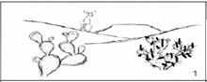
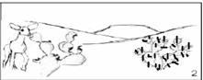
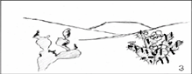
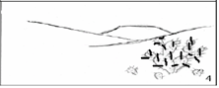

A
A
A
B
B
B
B

1. What variations are there in this cactus species?

2. How has the environment changed?

3. Why would a deer be more likely to eat cactus A versus cactus B?

4. In figure 3, cactus B has flowers, but cactus A has been eaten by the deer and is too damaged to make flowers. Flowers are essential for the cactus to reproduce. Figure 4 shows the situation several years later. What happened?

5. Do you think that evolution by natural selection is occurring in this cactus population? Explain why or why not.

6. Define fitness-
Which cactus has greater fitness in this environment?

7. a. What adaptation (special trait) seems to increase the fitness of cactus B?

b. How do you think this adaptation increases the ability of the cactus on the right to survive and reproduce?

8. What would happen to this species of cactus if there were no variations, if all were like cactus A?

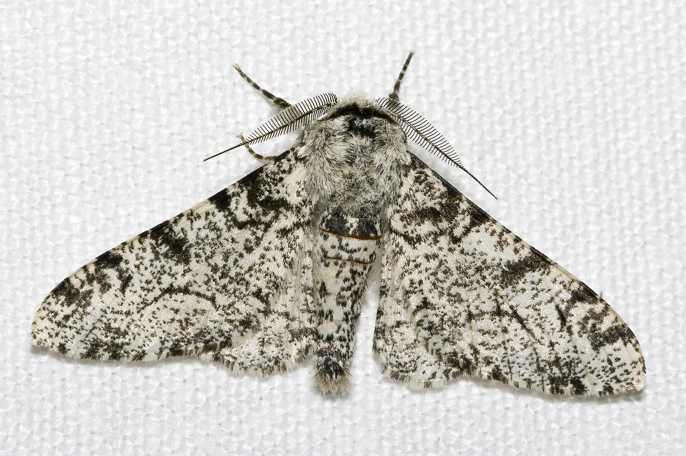
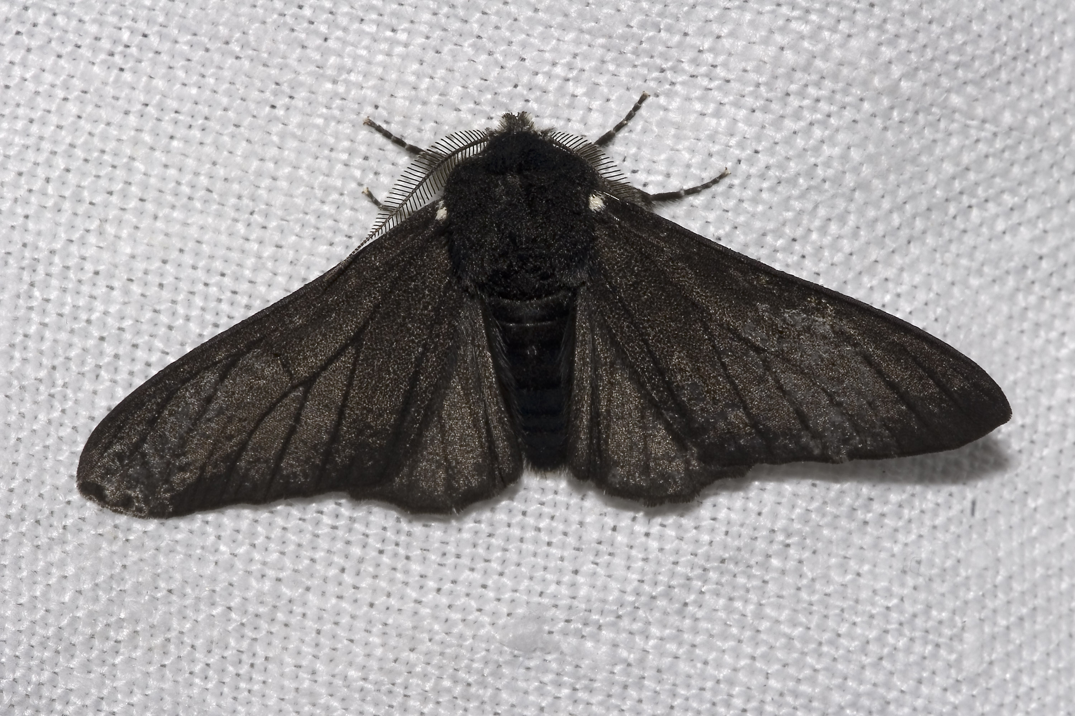
Problem 3: In a population of moths there are dark colored moths and light colored moths
living in a light colored forest (the trees have light colored bark). 99% of the moths are light colored. Pollution from man covers the trees with black soot. Over time, the population of moths seems to be 98% dark.
1. Explain how natural selection worked in this case.

2. A mad scientist decides to go out and spray paint all of the forests trees and rocks pink. Describe what will happen to this population of moths.
Problem 4:
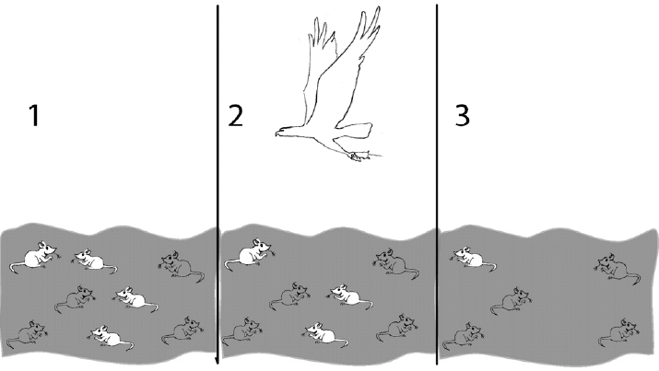
Describe how evolution by natural selection is occurring in this population of mice.

The mice that are ______________ are more likely to survive and reproduce because __________________
____________________________________________. The mice that are _________________ will slowly die off because _________________________________
___________________________________________. Because of this, slowly over time the majority, if not all the mice will be ____________________.

Which mice have higher fitness? Why?

Problem 5:
Below are two descriptions. Circle the description that explains evolution by natural selection. ONLY ONE IS A CORRECT DESCRIPTIONOF NATURAL SELECTION, YOU HAVE TO CIRCLE THE CORRECT ONE

Description 1: There is a population of bears that have variations in fur color from black to brown and a few who are white. The food they hunt has become scarce because other predators in the area are getting to the food first. The bears move north and find food out on the ice and tundra. Overtime this bear population becomes all white by choosing to not produce color in their fur so that they may camouflage with the snow to hunt better.

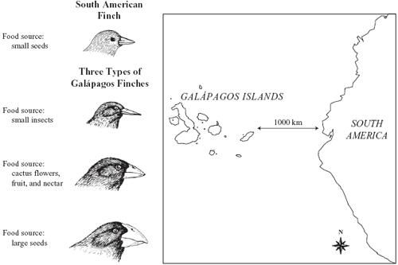
Description 2: There is a population of bears that have variations in fur color from black to brown and few who are white. The food they hunt has become scarce because other predators in the area are getting to the food first. The bears move north and find food out on the ice and tundra. Overtime this bear population becomes white because the ones with white colored fur are camouflaged by the snow when they hunt and they get more food. They reproduce more since they have more food and become more common while the darker colored bears starve and die out.

Problem 6:
The finches on the Galapagos Islands originally looked like the South American Finch which is their ancestor.
Ancestor

1. Complete the description on how the birds on island 1 evolved by natural selection.
The best food available on island 1 were insects found in small holes in trees. The finches who had ______________ were more likely to survive and reproduce because ___________________________________________
Island 1
_________________. The finches that had _______________ could not get food and died off. Eventually all you see on this island is birds with _________________________.
Island 2
2. Use your own natural selection sentence frame to complete the description for how the birds on island 3 evolved by natural selection.
The best food available on island 3 were large hard seeds.
Island 3

