Study Guidelines: Evolution by Natural Selection
Name: _________________
Period:______ Seat:_______

Living organisms are not permanent and change over time. Natural selection is the mechanism by which nature changes and favors individuals with the right traits to survive and reproduce in the new environment. This leads to change.
1. Based on the science you have learned in this class since the beginning of the year, explain why Lamark’s Theory of Aquired Characteristics is incorrect and why the Theory of Natural Selection (Decent with modification) makes more sense.

2. Define variations. Why are they important for change to occur in Decent with Modification?

3. a. Choose any species of animal and identify at least 5 variations among the individuals of the species. Ex. Tigers
b. Choose a species of plant and identify at least 5 variations amount the individuals Ex. Pine tree

4. a. List the four main components that make change by natural selection possible. b. Which do you think is most important? Justify!

5. Create a sentence for each vocabulary word. Do not redefine, but use correctly in a sentence to show understanding.

6. Compare and contrast artificial selection with natural selection.

7. Name some environmental changes that can impact a species. b. Describe the possible out comes for a population (group of the same species living in the same area) if their environment changes (Hint: think of our flow chart)

8. Polar bears live in a very cold environment. Bears who have thicker fur coats are more like to survive in this environment but naturally some have thinner coats than others. Their cold environment is becoming increasingly warmer. a. What variation is important in this species case? b. What change do you expect to see among polar bears? c. Sketch a picture of the change happening over time. d. Use your change by natural selection sentence frame (see notes) to explain how change will occur in this scenario.

9. a. Explain what survival of the fittest means (In your own words). b. Explain what it means to have high fitness. c. Explain what it meant to have low fitness.

10. Complete the back of your “Natural Selection Think sheet”
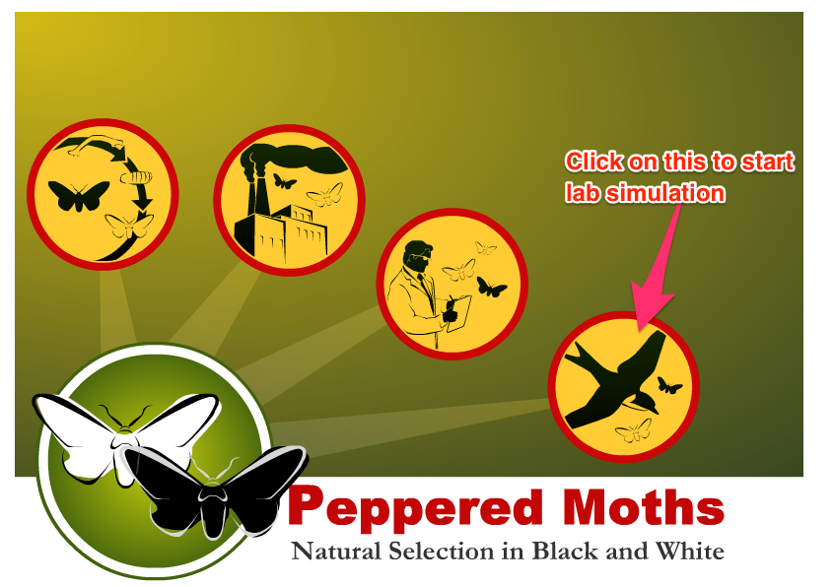
11. Go to peppermoths.weebly.com and complete the lab

12. a. Describe the major ways genetic variations are generated. *Must include at least 1 drawing to explain one of the possible causes
b. Re-watch the crossing over YouTube Video

13. a. Define gene pool, allele frequencies, genotype frequencies
b. Calculate the allele frequencies:
*Dimples is dominant to no dimples. In a gene pool, 46 out of the 98 alleles are recessive. Calculate the allele frequency for the dimples allele and the no dimples allele for this population.
*Cystic fibrosis allele is recessive to the normal dominant allele. Calculate the allele frequencies for the dominant and cystic fibrosis alleles if a gene pool has 8 cystic fibrosis alleles out of 684
*Tay Sacs allele is recessive to the normal dominant allele. If the allele frequency in a certain gene pool is 2% for Tay Sacs, what is the allele frequency for the normal allele?

c. Calculate the genotype frequencies:
*Freckles are dominant to no freckles. Population total: 1642
FF =760 Ff=42 ff= 840

* Freckles are dominant to no freckles. 44% of a population has no freckles. What is the genotype frequency for homozygous recessive? How many people of a population of 8634 are homozygous recessive?

* Cystic fibrosis is recessive to normal. 3% of a population has cystic fibrosis. What is the genotype frequency for homozygous recessive? How many people of a population of 2982 are homozygous recessive?

14. a. List and study the 5 conditions for Hardy-Weinberg Equilibrium.
b. Explain what happens to allele frequencies and genotype frequencies if all 5 conditions are met.
c. Explain what happens to allele frequencies and genotype frequencies if even 1 out of the 5 conditions are not met.
d. What can be said of a population that does not meet the 5 conditions of Hardy-Weinberg Equilibrium.

15. a. Define gene flow. b. Explain how it causes a population to evolve.

16. a. Define genetic drift bottle neck. b. Describe how a population may change under these circumstances.

17. a. Define genetic drift founder effect. b. Explain how the founder effect can make the new population created different from the original.

18. a. Name the 3 types of natural selection. b. Describe what happens during each type c. Sketch a graph for each type.

19. A group of snakes was placed into an environment with new selective pressures from its original. Read the data tables below and graph each snake in its environment. From the graph, determine what type of selection is being portrayed: directional, stabilizing or disruptive.
Snakes placed on an island where there are two predators that eat snakes.

Number of Snakes at Each Length
 |  | 2 cm | 4cm | 6 cm | 8 cm | 10 cm
Year | 1980 | 2 | 8 | 14 | 12 | 4
 | 1995 | 4 | 12 | 8 | 9 | 8
 | 2010 | 10 | 6 | 3 | 6 | 14

a. Graph (hint: x-axis is Length of snake and y-axis is number of snakes) b. Describe what happened to the snakes.
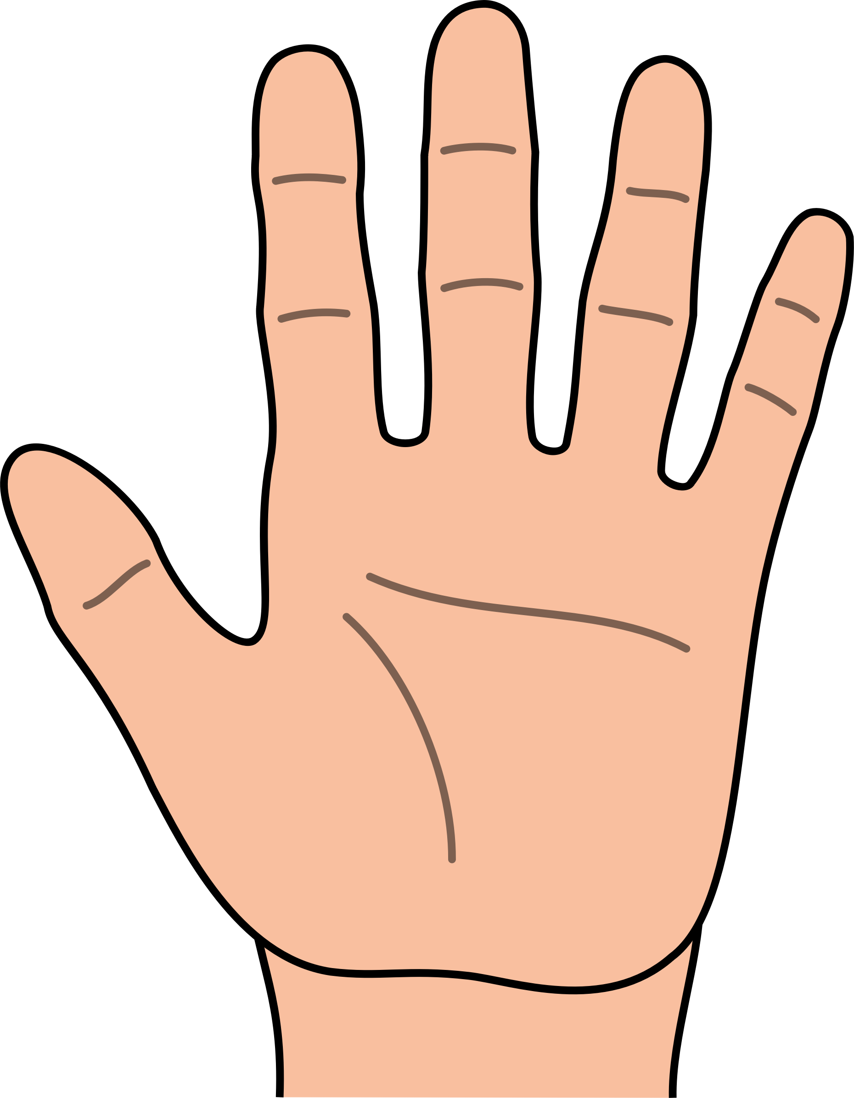
20. a. Compare and contrast genetic drift and Natural Selection. b. Which leads to adaptations?

21. a. Watch the five finger of evolution video (go to the class website). b. Label the five fingers of evolution and study them. c. Which of the five lead to adaptations? d. Explain how is this connected to Hardy-Weinberg Equilibrium?

22.a. Explain how sexual selection can cause change in a species. b. Identify the benefits and the risks of sexual selection.

23. Complete problems 4, 6, 11 and 12 on your “Hardy Weinberg Practice Problems” handouts.

24. Within a population of butterflies, the color brown (B) is dominant over the color white (b). 30% of all butterflies are white. Calculate the following:
A. The percentage of butterflies in the population that are heterozygous.
B. The frequency of homozygous dominant individuals.

25. Complete your “Hardy Weinberg Practice Problem” handout.

26. a. Define speciation. b. In 5 sentences or more, explain how isolation (any type) and the big three lead to speciation.

27. Describe the difference between prezygotic and postzygotic isolation barriers.

28. a. Identify each of the 4 types of prezygotic isolations. b. In your own words, describe how each one can lead to speciation. c. Create a chart to identify which types of prezygotic isolations are allopatric speciation and sympatric speciation

29. a. Name and describe the two main postzygotic isolation problems. b. What is a hybrid?

30. Complete your “stratigraphy, fossils and geologic time” handout by using the handouts from class and the images below.

31. a. Explain what stratigraphy is and how it helps us identify the age of a fossil. b. Explain how fossils provide evidence to support the Theory of Natural Selection
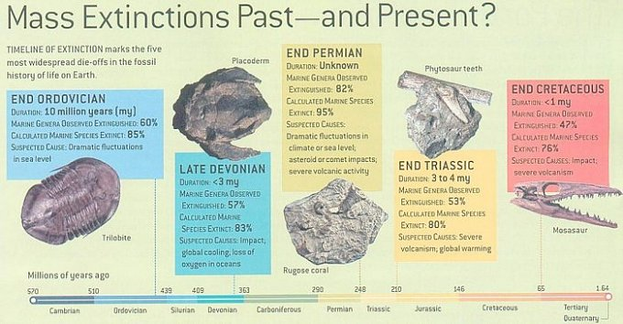
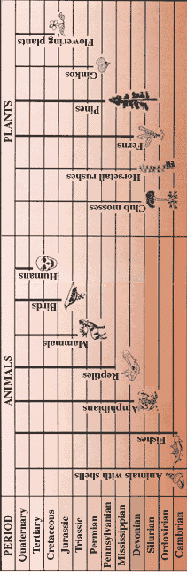
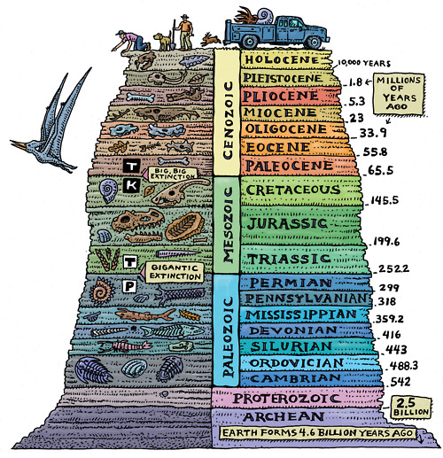

32. a. Explain how embryology is used as evidence to demonstrate common ancestry/speciation. b. Identify the role apoptosis plays in development.

33. a. Define homologous structures. b. Explain how anatomy (homologous structures) is used as evidence to demonstrate common ancestry/speciation. c. Compare and contrast convergent evolution and divergent evolution. d. Use the internet to identify 3 examples of each.

34. Complete fossil lab write-up.

35. In a population of butterflies, red color is dominant to yellow color. 28 % of all the butterflies are yellow.
What is the recessive allele frequency (q)?
What is the dominant allele frequency (p)?
What percent of the butterflies are homozygous dominant?
What percent are heterozygous?
What percent are homozygous recessive?

If there are 3000 butterflies, how many of them are heterozygous?

36. 17% of the population in the United States is lactose intolerant, a recessive condition. Calculate the following.
What is the recessive allele frequency (q)?
What is the dominant allele frequency (p)?
What percent of the population are homozygous dominant?
What percent are heterozygous?
What percent are homozygous recessive?

If there are 319 million people in the US, how many of them are homozygous dominant? (Round to the nearest million)

37. Explain how mutations provide evidence that evolution can occur.

38. a. Describe the single celled prokaryote ancestor hypothesis. b. Identify evidence for this hypothesis.
c. How does the Stanly Miller experiment fit in?

39. Compare and contrast homologous and analogous structures

40. Define phylogeny. Describe how cladograms can be used to demonstrate phylogeny.

41. a. Explain why using DNA or amino acid sequences is more useful in creating a cladogram than morphology. b. How does morphology demonstrate relatedness? c. How does DNA or amino acid sequence demonstrate relatedness.

42. Complete the “Phylogeny and Cladogram” handout.

43. Widows peak is dominant to no widows peak. 64% of a population in Hardy Weinberg Equilibrium do not have a widows peak.
What is the recessive allele frequency?
What is the dominant allele frequency?
What percent of the population are homozygous dominant?
What percent are heterozygous?
What percent are homozygous recessive?
44. . Sickle cell anemia is a recessive disorder. In an tropical population of 500, 65 people were born with sickle cell anemia.
What is the recessive allele frequency?
What is the dominant allele frequency?
What percent of the population are homozygous dominant?
What percent are heterozygous?
What percent are homozygous recessive?

