Chi Square Notes
Steps to Chi Square:

Step 1: Determine your null hypothesis

Step 2: Determine expected based on null hypothesis
-Total results and divide by number being compared
-For Punnett squares use

Step 3: Calculate Chi Square using the equation

Step 4: Calculate degrees of freedom

Step 5: Use the Chi Square Probability Chart to see if your null hypothesis is accepted or rejected…
*If .05 or less, __________ the hypothesis and it means something else is causing the results you are
seeing. Could be an outside environmental factor or if you are talking about genetics it could be a
different mode of inheritance.
*If .05 of higher, _____________ the hypothesis and results as being close enough and the differences
were simply caused by chance.
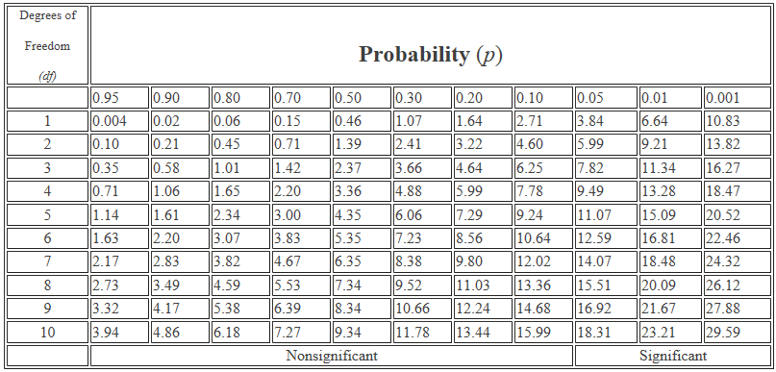

Example 1: A zookeeper hypothesizes that changing the intensity of the light in the primate exhibits will reduce the amount of aggression between the baboons. In exhibit A, with a lower light intensity, he observes 36 incidences of aggression over a one month period. In exhibit B, with normal lights, he observes 42 incidences of aggression. Should he support or reject his hypothesis?

Example 2: One hundred heterozygous (Bb) males mate with one hundred heterozygous (Bb) females. The observed outcome from these crossings were 28 BB, 56 Bb and 16 bb.

