AP BIOLOGY
Chi-square Analysis with Skittles

INTRODUCTION
The Chi-Square test (X2) is a test that makes a comparison between the data collected in an experiment versus the data you expected to find. It is used beyond genetics studies and can be used whenever you want to compare the difference between expected results and experimental data. In the case of genetics, the expected resulted can be calculated using expected values from a Punnett Square. The Chi-Square test helps you decide if the difference between your observed results and your expected results is due to random chance alone, or if there is some other factor influencing the results. For genetics and chi-square, consider the following…
-Is the difference in your data due to random chance alone and therefore your hypothesis about the
genetics of a trait is supported by the data?
-Are the differences between the observed and expected results probably not due to random chance
alone, and your hypothesis about the genetics trait is thereby not supported by the data?
-Should you consider an alternative inheritance mechanism to explain the results?
In classic genetics research where you are trying to determine the inheritance pattern of a phenotype, you establish your predicted genetic explanation and the expected phenotype or genotype ratios of the offspring as your hypothesis. For example, you think a mutant trait in fruit flies is a simple dominant inheritance. To test this you would set up a cross between 2 true breeding flies; white-eyed female x wild type male. You would then predict the ratios of phenotypes you would expect from this cross. This then establishes a hypothesis that any difference from these results will not be significant and will be due to random chance alone. This is refered to as your “null hypothesis.” A null hypothesis says that you propose that nothing else-no other factors- are creating the variation in you results except for random chance differences.
Have you ever wondered why the package of Skittles you just bought never seems to have enough of your favorite color? Or, why is it that you always seem to get the package of mostly Lemon or Lime? What’s going on at the Mars Company? Is the number of the different colors of Skittles in a package really different from one package to the next, or does the Mars Company do something to insure that each package gets the correct number of each color of Skittle? The Mars company claims they make each bag random but approximately 20% of each color should be in each package to make a total of 42 pieces. We can perform a Chi-square test on individual packages and then compare that to a larger population of the large package. I couldn’t find data on how many were supposed to be in a large bag.

Materials:
Individual bag of skittles Paper towel Calculator

Null hypothesis: ____________________________________________________________________________
___________________________________________________________________________________________________________________________________________________________________________________.

Procedure:
NOTE: You cannot eat the Skittles until told to do so!!
- Wash hands BEFORE starting the lab.
- Place the contents of your individual bag of Skittles on a paper towel.
- Record the number of different colors (classes) in Table 1 and Table 2 as “Number Observed” (o).
- Calculate the number of each color expected in Table 1 and Table 2 as “Number Expected” (e). Hint: You must count all the colors and add the total number of Skittles before you can calculate the number of expected of each color. Round to the nearest whole number.
- When everyone has completed the lab portion of their individual bag, work as a class to count and record the large bag. Record numbers in Table 3 and Table 4.
- If you still have time after the lab portion of both the individual bag and the class bag, you
may eat Skittles while you calculate the Chi-square.
- Left over Skittles should be placed in a Ziploc bag. Don’t worry, you will get the rest at a later date!

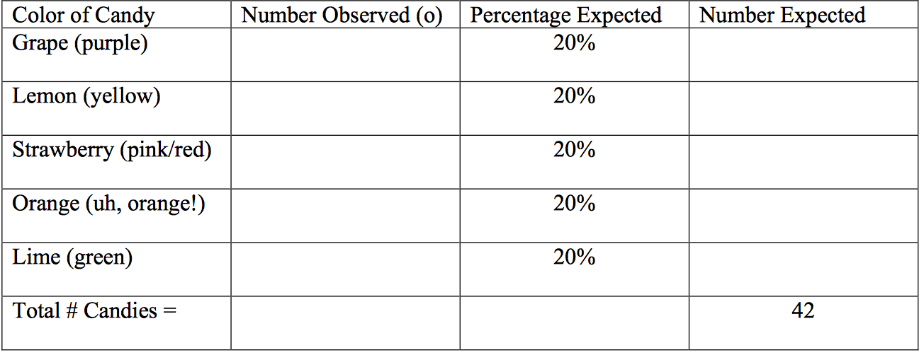
Data:

Calculate degrees of freedom:

Calculate Chi-Square:

Conclusion Questions:
1. What is the Chi-square value for your data?

2. What is the critical value (p=0.05) for your data?

3. Is your null hypothesis accepted or rejected? Why or why not?

4. What can you say about Skittles?

