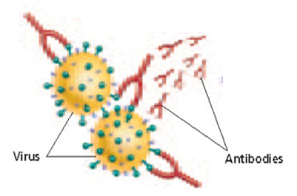
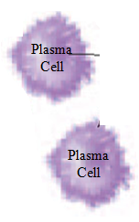
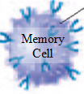
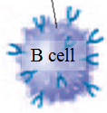
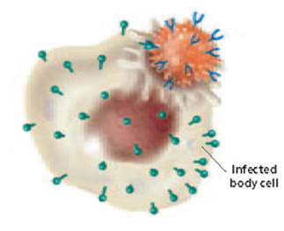
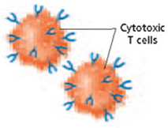
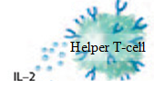
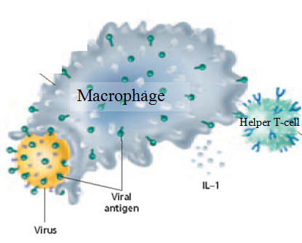
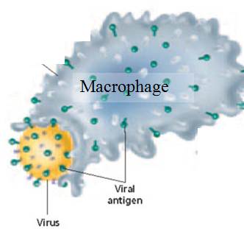
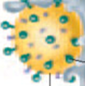
Acquired Immunity…Activating the immune system (The domino effect)
6.d
6.c
6.b
6.a
5.a
5.b

1.
2.
A pathogen (virus/bacteria/parasite) enters the body through an opening  Or  A “dead”, weakened or parts of a pathogen are injected into the body by vaccine | Cytotoxic T cells search the body and destroy any body cells that have already become infected.
Most B cells become plasma cells  (Thousands are made) | Interleukin-1 activates other helper T cells to release interleukin-2
Interleukin-2 (cytokine) activates B cells  and causes them to divide | A macrophage cell engulfs the pathogen, breaks it apart, and then presents the pathogens antigens as a major histocompatibility complex (MHC) on its surface.
Helper T cells bind their surface protein receptors to the MHC complex displayed on the surface of the macrophage causing the macrophage to release interleukin-1 | Plasma cells make and release antibody proteins that have a specific shape that will bind only with the specific antigen they were made for. The antibodies mark the pathogen for destruction
Some B cells become memory cells  (Thousands are made) | Interleukin-2 activates cytotoxic T cells and causes them to divide

