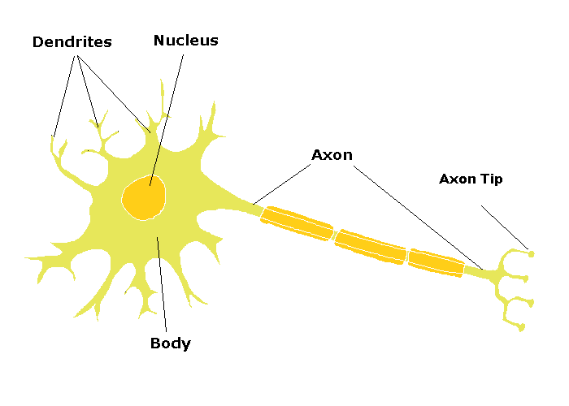Cells of the Nervous System: ________________

Name:__________________

Period:______ Seat: ______

1.

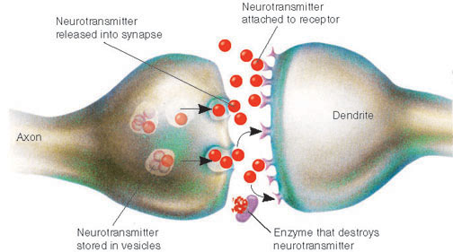

7.

7b.

7a.

5.

6.

4.

3.

2.