Pigments of Photosynthesis Separation

Background: Chlorophyll a is the primary pigment in photosynthetic plants. Two molecules of chlorophyll a are located in the reaction center of photosystems I and II. Other chlorophyll a, chlorophyll b and carotenoids (carotenes and xanthophylls) capture light energy (photons) and transfer it to chlorophyll a in the reaction center. Carotenoids also protect the photosynthetic system from the damaging effects of ultraviolet light.

Procedure:
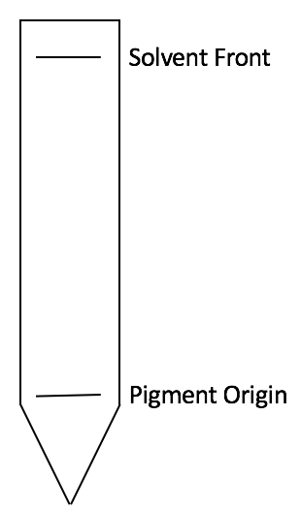
1. Grab your chromatography paper by touching only the sides.
2. Using a pencil, draw a line just above cut portion of the paper (see diagram to the right)
3. Place a piece of spinach on top of the line. Then firmly press down with your penny.
4. Repeat step 4, 8 to 10 times.
5. Add approximately 1 cm of solvent to the bottom of your test tube.
6. Gently place your chromatography paper into the test tube so that the tip of the paper is in the solvent and then place stopper onto test tube.
7. When solvent is approximately 1 cm from the top of the paper, remove the paper and immediately mark the location of the solvent line before it evaporates.
8. Measure the distance from the pigment origin to the solvent front and record data.
9. Measure the distance for each pigment from the pigment origin line to the top of the highest point of each color band. Record data in table.

Data:
Solvent distance: ____________ mm

Band Number | Pigment Name | Color | Migration distance (mm) | R_{f} value
1 | Chlorophyll b | Dark green
2 | Chlorophyll a | Light Green
3 | Xanthophyll | Yellow
4 | Carotene | Yellow Orange

Retention factor: R_{f} = distance pigment migrated (mm)
distance solvent front migrated (mm)

Create a graph comparing the R_{f} values of each pigment

Conclusion Questions:
1. Which of the 4 pigments migrated the farthest? Why?

2. Which type of chlorophyll is most soluble?

3. Why do you think leaves change color in the fall?

4. What is the function of plant pigments in photosynthesis?

Pigments of Photosynthesis Separation

Background: Chlorophyll a is the primary pigment in photosynthetic plants. Two molecules of chlorophyll a are located in the reaction center of photosystems I and II. Other chlorophyll a, chlorophyll b and carotenoids (carotenes and xanthophylls) capture light energy (photons) and transfer it to chlorophyll a in the reaction center. Carotenoids also protect the photosynthetic system from the damaging effects of ultraviolet light.

Procedure:
1. Grab your chromatography paper by touching only the sides.
2. Using a pencil, draw a line just above cut portion of the paper (see diagram to the right)
3. Place a piece of spinach on top of the line. Then firmly press down with your penny.
4. Repeat step 4, 8 to 10 times.
5. Add approximately 1 cm of solvent to the bottom of your test tube.
6. Gently place your chromatography paper into the test tube so that the tip of the paper is in the solvent and then place stopper onto test tube.
7. When solvent is approximately 1 cm from the top of the paper, remove the paper and immediately mark the location of the solvent line before it evaporates.
8. Measure the distance from the pigment origin to the solvent front and record data.
9. Measure the distance for each pigment from the pigment origin line to the top of the highest point of each color band. Record data in table.

Data:
Solvent distance: ____________ mm

Band Number | Pigment Name | Color | Migration distance (mm) | R_{f} value
1 | Chlorophyll b | Dark green
2 | Chlorophyll a | Light Green
3 | Xanthophyll | Yellow
4 | Carotene | Yellow Orange

Retention factor: R_{f} = distance pigment migrated (mm)
distance solvent front migrated (mm)

Create a graph comparing the R_{f} values of each pigment

Conclusion Questions:
1. Which of the 4 pigments migrated the farthest? Why?

2. Which type of chlorophyll is most soluble?

3. Why do you think leaves change color in the fall?

4. What is the function of plant pigments in photosynthesis?

