Name: ___________

**Main Ideas Title: Population Genetics and Evolution** Period: ___ Seat:__

The Bell Curve Traits vary and can be mapped along _______________________________________________

_________________________________, whereas a few individuals have extreme traits.

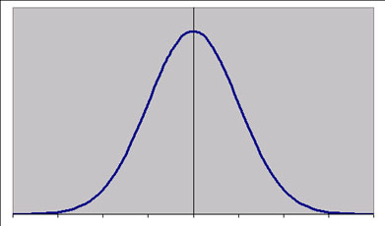

What causes *_______________________________ cause variations in phenotypes

Phenotype variation? How do variations come about within the same species?

1) ___________________________________

2) Sexual reproduction

-Crossing over in meiosis

-Independent assortment

-Fertilization

Gene Pool **Gene Pool** – ______________________________ for every gene of a particular population

Allele Frequencies **Allele frequency-** ____________________________ in a populations gene.

Calculate allele frequencies

Geneotype Genotype Frequencies- the percent of the population __________________________________

Frequencies ________________________________________________________ at any given time.

Example: Population total: 2396

AA = 910 Aa=695 aa= 791

Calculate genotype frequencies…

Hardy-Weinberg Itis a theoretical model of a population in which no evolution occurs and the gene pool of the

Equilibrium population is stable. Allele frequencies and genotype frequencies do not change.

5 Conditions for Equilibrium

1) Large Population (no genetic drift)

2) Random mating

3) No mutations

4) No gene flow – no immigration or emigration

5) No natural selection

If _______________________ of these conditions ___________________,

then the ________________________

5 Causes of 1) Genetic drift occurs in small populations

2) ___________________ occurs when certain traits increase an individual’s success at mating

3) Mutations- ______________________________________________

4) Gene flow- genes move in and out of the population due to immigration and emigration

5) Natural Selection (3 types)…

Gene Flow Movement of fertile individuals between populations (immigration and emigration

-_____________________________________________

-Reduce genetic differences between populations

Genetic Drift Genetic Drift

2 Types:

Bottle neck-A random event such as a fire or flood that causes change.

It ____________________________________________________ —any one can die or be

lucky enough to survive

Founder Effect- Individuals leave a large population to establish a new population. _________

______________________________________________________________

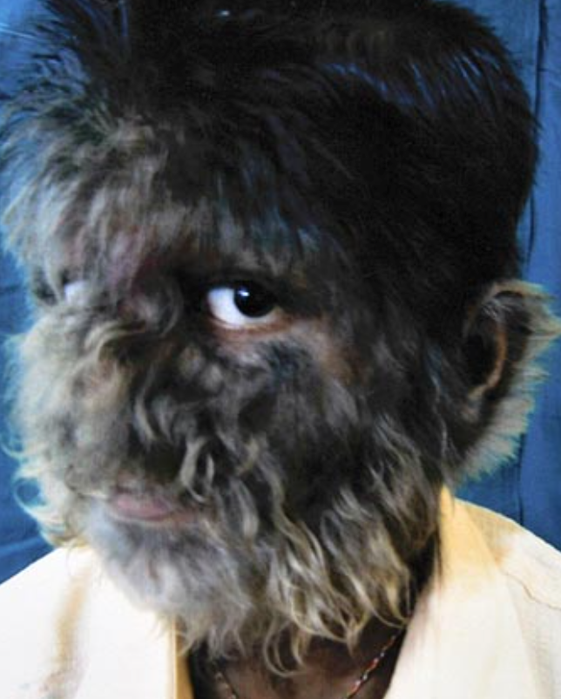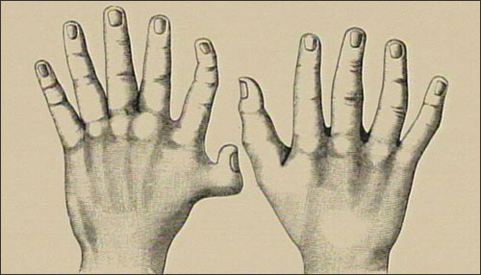

**3 Types of Natural Selection**

Directional Favors the formation of _________________________

Selection

Stabilizing Favors the formation of _______________________

Selection

Disruptive Favors _____________________________________

Selection

Genetic Drift vs. Natural Selection

Summary