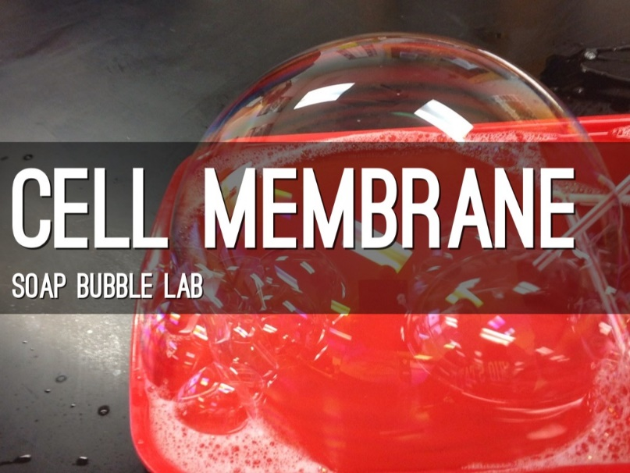
Cell Membrane Bubble Lab
Background
Bubbles make a great stand in for cell membranes. They’re fluid, flexible, and can self-repair. Bubbles and cell membranes are alike because their parts are so similar. If you could zoom down on a cell membrane, you’d see that much of the membrane is a double layer of little molecules called phospholipids. Phospholipids have a love-hate relationship with water. One end, the “head,” is attracted to water, and the other end, the “tail,” is repelled by water. This classifies phospholipids as amphipathic molecules. Place phospholipids in water and they quickly form a double layer with the heads facing out on both sides.

A soap molecule has the same split personality. The “head” of a soap molecule is charged (ionic) and attracts to water molecules, which have regions of positive and negative charge (polar). The hydrocarbon tail of the soap molecule is not charged and is repelled by water’s polarity (hydrophobic). This explains why we use soap to clean. The hydrocarbon tail of soap mixes with and dissolves in other hydrocarbons, like oils and fats, while the head region grabs a hold of passing water molecules and follows them down the drain. The surface of a bubble has three layers. The middle layer is a thin film of water. On both sides of this film is a layer of soap molecules with hydrophilic heads oriented toward the water film and hydrophobic tails pointing away.

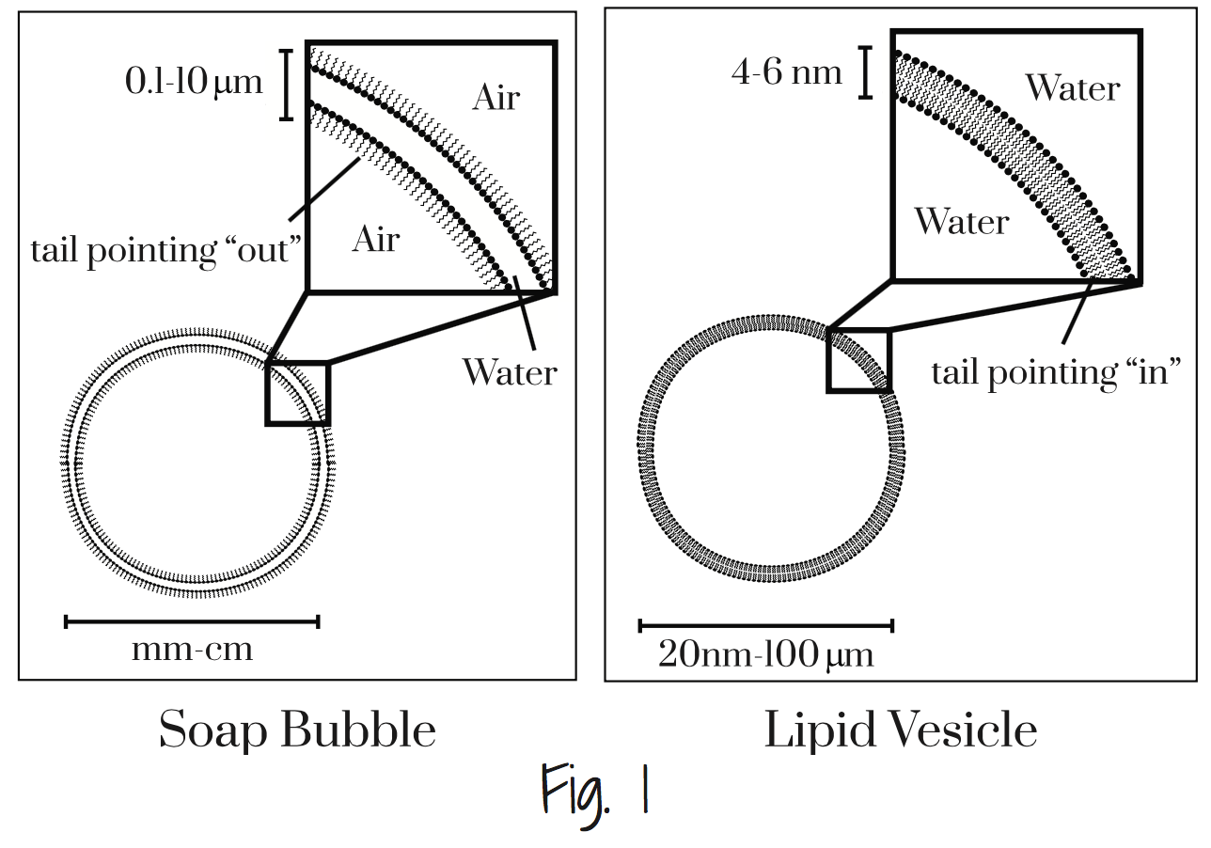
The diagram below (Fig. 1) offers a nice depiction of this comparison.

Materials:
-1000 mL beaker -900 mL water -100 mL dish soap -25 mL corn syrup -String (optional)
-4 bendable straws -Spool of thread -2 “clean” straws -Shallow tray

Procedure Part A (set up)
- Create the bubble solution by mixing the water, soap, and corn syrup in the 1000ml beaker.
- Create a bubble frame by using the following instructions.

Method One
a. Bend 4 straws at elbows.
b. Flatten the shorter ends of straws and fold flatted surface in the middle (See Fig. 2).
c. Connect straws together by inserting short ends into long ends to create a square (See Fig. 3).

Method Two
a. Cut straws in 5 1⁄2 inch lengths.
b. Run a 30 inch string through all four straws.
c. Tightly tie ends of string together to create a frame.
d. Cut off loose ends of string.

- Create a ring of thread by tying a loop about two fingers wide.
- Cut off the loose ends.
- Place bubble frame into shallow tray
- Add bubble solution to slightly cover bubble frame.

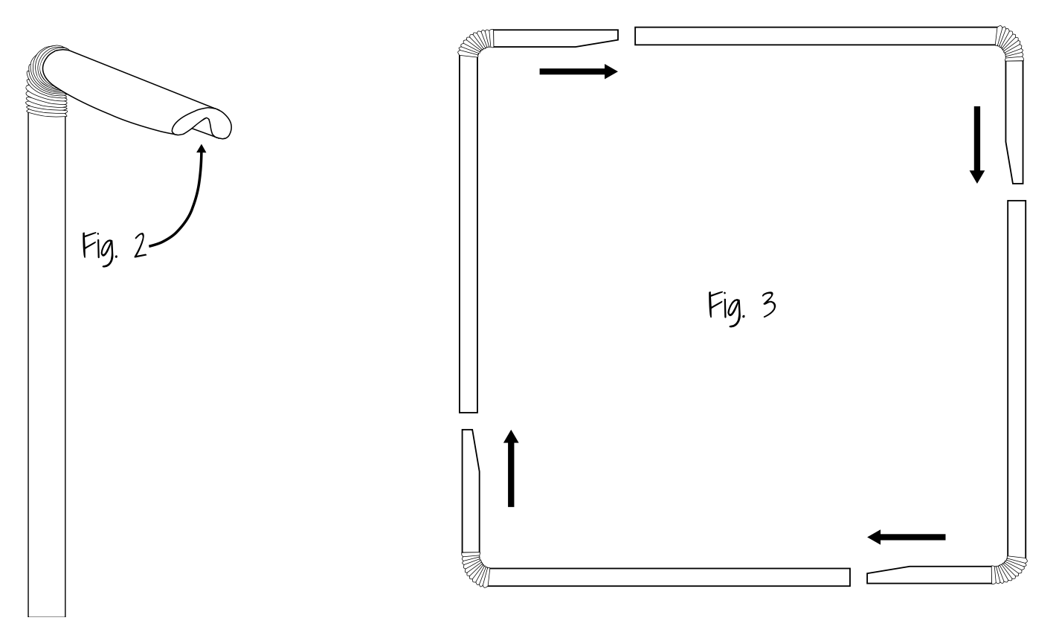

Cell Membranes Bubble Lab

Cell Concept 1 – Membranes are Fluid and Flexible
Cell membranes are not static, they bend and flex in order to adapt to changing conditions.
1. Lift bubble frame out of solution so that a thin film spans across frame.
2. Tilt the frame back and forth and observe the surface of the film.
3. Notice the swirl of color as the light reflects off the film. Molecules in the cell membrane move about in a
similar fashion.
4. Hold the frame by the edges and rotate the sides in opposite directions. (See Fig. 4) Notice the elasticity of
the film.
5. Hold the bubble film parallel to the floor and gently move the frame up and down until the surface begins to
bounce up and down.
6. Like the bubble film, membranes can flex without breaking.
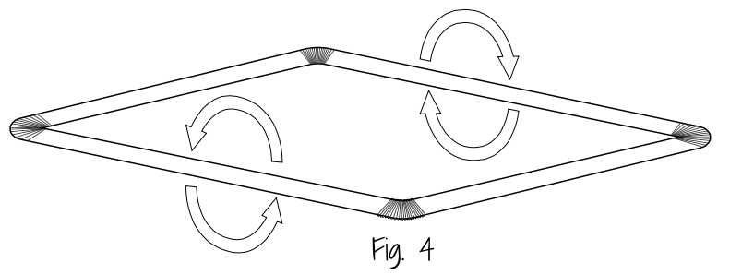

Questions:
1. What is the name of this fluid model?

2. Explain what you think is happening to the lipids.

Cell Concept 2 – Membranes Can Self-Repair
1. Lift bubble frame out of solution so that a thin film spans across frame.
2. Cover the surface of your finger in bubble solution.
3. Slowly push finger through film. Film should allow finger to pass without breaking.
4. Remove finger from film. Film should repair itself.
5. Try the same procedure with your entire hand.
6. Like the bubble layer, cell membranes can spontaneously repair small tears in the lipid bilayer.

Questions:
1. Based on what you have learned, how do you think the membrane self repairs?

2. Why was your finger able to pass through the bubble without popping it?

Cell Concept 3 – Eukaryotic Cells Feature Membrane Bound Organelles
The membranes surrounding organelles in Eukaryotic cells feature a phospholipid bilayer like the one found in the outer “plasma” membrane.
1. Place the tip of a clean straw into the bubble solution in the tray.
2. Gently blow on the other end of the straw to create a bubble.
3. Slowly lift the tip of the straw out of the liquid while continuing to fill the bubble with air.
4. Allow the bubble to grow to a size of about 6” wide.
5. Return the tip of the straw back into the bubble solution and try to create a smaller bubble inside the larger bubble.
6. Notice how the smaller bubble creates a compartment of air that is contained within but separated from the air of the larger bubble.
7. In a similar fashion, Eukaryotic cells feature membrane bound organelles that create specialized compartments within a single cell. The primary structure of the outer cell membrane as well as the membranes that enclose organelles is a double layer of phospholipids known as a phospholipid bilayer.

Questions: 1. Which organelles are membrane bound organelles?

2. Which organelles we have learned about have double membranes?

Cell Concept 4 – Membrane Proteins Perform Special Functions
Some specialized proteins embed within the lipid bilayer, giving the membrane unique properties.
1. Lift bubble frame out of solution so that a thin film spans across frame.
2. Hold the frame parallel to the tray.
3. Gently lay loop of thread onto film surface.
4. Use a pencil or pen to break the bubble film that is inside the loop of thread.
5. Loop of thread should rapidly expand into the shape of a circle.
6. Insert pencil or finger into middle of thread loop.
7. Rock frame back and forth to see thread loop drift across film.
8. Membrane proteins can also drift across the lipid bilayer.

Questions: 1. Name the functions cell membrane proteins may have.

Cell Concept 5 – Gap Junctions Aid Transport Between Animal Cells
Gap junctions form between neighboring animal cells, allowing their cytoplasms to connect directly. This provides a quick way to move material between two cells.
1. Place the tip of a clean straw into the bubble solution in the tray.
2. Gently blow on the other end of the straw to create a bubble.
3. Lift the straw out of the liquid and continue to blow air into the bubble.
4. Continue to gently blow air into the bubble as you slowly pull out the straw.
5. As the tip of the straw leaves the bubble, you should be able to briefly observe a small tunnel existing between the bubble and straw tip.
6. This tunnel is allowing air to freely move between the straw and the bubble without breaking the bubble film.
7. In the same manner, gap junctions allow for the rapid transit of ions and small molecules between adjacent animal cell membranes.

Questions: 1. Why would cells need to form a gap junction?

Cell Concept 6 – Many Bacteria Cells Reproduce Through Binary Fission
Some Single-celled bacteria reproduce by splitting into two. This is known as binary fission.
1. Place the tip of a clean straw into the bubble solution in the tray.
2. Gently blow on the other end of the straw to create a bubble.
3. Lift the straw out of the liquid and continue to blow air into the bubble.
4. Increase the size of the bubble until it is about 6” wide.
5. Hold a piece of thread that is twice as long as the bubble and slide it underneath the bubble.
6. Lift the thread up through the bubble and the bubble should split into two.
7. In binary fission, bacterial cells divide when a thin ring of proteins located at the cells midpoint contracts, effectively cleaving the cell in two.

Questions: What similar process do eukaryotes like plants and animals go through?

