Study Guidelines: Cell Membrane and Cell Communication
Name: ____________
Period: ___ Seat: ____
Each cell in a multicellular organism is a living thing. The cell membrane plays a major role in how the cell interacts with its environment. It not only protects it and determines what enters and exits the cell, but it is also used to help cells communicate with each other.
***Three big ideas: structure/function, transport and communication***

1. Draw a simple sketch of the cell membrane and label the main components.

2. a. Define phospholipid, amphipathic, lipid bilayer
b. Explain why cell membranes are organized in a lipid bilayer.

3. a. Describe the fluid mosaic model.
b. Explain how heat affects membrane fluidity.
c. Identify the role saturated/unsaturated fats and cholesterol play in membrane fluidity.
d. Why is fluidity important?

4. Identify and explain at least two examples that show how life has evolved to deal with membrane fluidity in varying environments (hint see pg 96 of your book or reading handout)

5. a. Define integral protein, peripheral proteins, selective permeability, transport proteins
b. Explain the 6 major functions of membrane proteins
c. State the role of carbohydrates in the cell membrane.

6. a. Define concentration gradient and passive transport
b. Compare and contrast diffusion, facilitated diffusion and osmosis
c. What causes molecules to diffuse/move if there is not input of energy?

7. a. Draw a picture of a cell in a hypotonic solution, isotonic solution, hypertonic solution
b. In your own words, explain how a cell reacts in a: hypertonic solution, isotonic solution,
hypotonic

8. a. Describe the purpose of osmoregulation
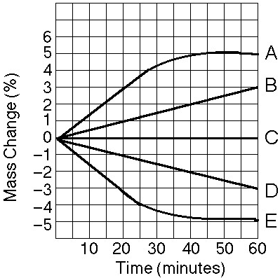
b. True story: A student buys a turtle from a man on the street. She is told that all the turtle needs is a tank full of water and he will be happy. The student sets up the tank, feeds it regularly, but it dies by the end of the first month. She later finds out it was a land tortoise, not a turtle (most turtles can live on water and land). Explain the role osmosis probably played in its death. Be specific and use terms you have learned.

9. Study the graph to the right carefully.
a. Which line(s) represents a cell that is in an isotonic
solution? Justify.
b. Which line(s) represents a cell that has been placed
in a hypertonic solution? Justify.
c. Which line (s) represents a cell that has been placed
in a hypotonic solution? Justify.

10. a. Explain how active transport differs from simple and facilitated diffusion.
b. Describe the role ATP and phosphorylation play in active transport.
c. Read and study figure 5.14 on page 104 of your textbook

11. a. Identify the conditions in which endocytosis and exocytosis would occur.
b. Compare and contrast endocytosis and exocytosis.
c. Identify the role membrane proteins play in these two types of transport.
d. Define vesicle.
e. Explain why energy is needed during these types of transport.

12. Name and describe the 3 types of endocytosis. (Pg 107 of your textbook)

13. a. Identify the two most important components in cell communication
b. Define target cell

14. a. Name the 3 stages of cell communication
b. Explain (in your own words) what happens during each phase of cell signaling
c. Define ligand and relay molecules

15. Explain how plasma membrane protein receptors differ from intracellular protein receptors (think about their ligands too)

16. Identify the 3 major ways a signal can temporarily change a cell.

17. a. Explain how a G-protein coupled receptor is activated.
b. Describe how a Ligand-gated ion channel is activated
c. Explain how a tyrosine kinase receptor is activated.

18. Compare and contrast relay molecules to secondary messengers

19. Describe what happens during a phosphorylation cascade (make sure you talk about protein kinases!)

20. Identify and explain the role of secondary messengers in a signal transduction pathway.

21. a. Provide an explanation and reasoning for why a smaller cell size is better for obtaining
nutrients and removing waste from the cell than a larger cell. (Think about the lab results)
b. Explain the role surface area to volume ratio plays in obtaining nutrients and removing
waste. What is better…a small surface area to volume ratio or a large surface area to
volume ration (again use data and calculation from the lab)?

