Name: ___________

**Main Ideas Title: DNA Replication** Period: ___ Seat:__

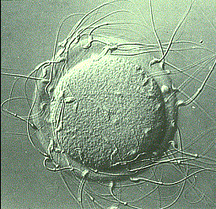DNA Replication DNA Replication is the process of making _____________________ copy of DNA

This occurs inside the nucleus ___________________________________ by mitosis, meiosis or binary fission (cytoplasm)

Semi-Conservative Each of the new DNA molecules are exact copies of each other.

Model _____________________________________________________________________________

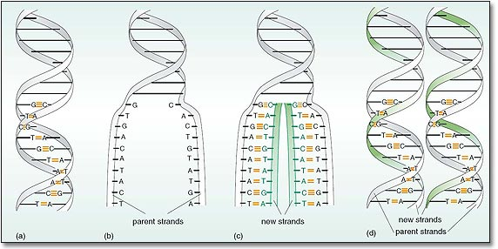

Step 1: Unzipping Helicase enzymes bind to an origin of replication and unzip the two

the DNA strands by ___________________________________________…

creating a replication bubble and replication forks

-Single stranded binding proteins bind to the strands to prevent them from

re-connecting

-Topoisomerase helps relieve strain in the rest of the DNA molecule



Pro vs. Eu Prokaryotes have ___ origin of replication. Eukaryotes have __________ origins of replication

Step 2: Adding -_____________________________________________ (sequence of 5-

10 RNA nucleotides) Nucleotides to start the process

-DNA polymerase III adds new nucleotides to the 3’ end, ______________________________

______________________________________________________________________________

Where is the Nucleotides arrive as nucleosides with 3 phosphate groups!

energy coming *_______________________________________________________________________-

from?

Leading vs. Leading strand- ____________________________________________________ and DNA

Lagging Strand polymerase III continuously adds nucleotides 5’ 🡪 3’ direction

Lagging strand- The strand that goes in the 3’ 🡪 5’ direction so DNA polymerase III does not

work

*Many primers are needed and ___________________________________________________

_____________________________________________________________________________

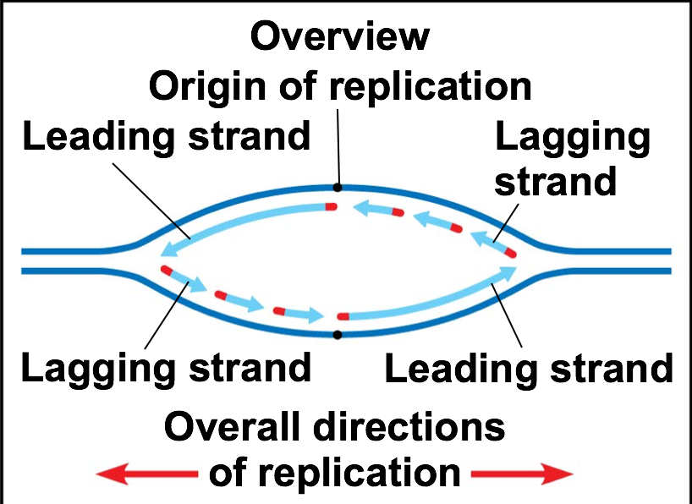

Lagging Strand 1) RNA primase adds RNA primer

2) DNA Polymerase III adds nucleotides in 5’ to 3’ direction

3) DNA Poly III detaches when it reaches next primer

4) ______________________________________________________________________

5) ______________________________________________________________________

Proofreading and -DNA polymerase enzymes have proofreading mechanism… only 1 in 10 billion errors

Repair -__________________________________: other enzymes review DNA, cuts out and replaces

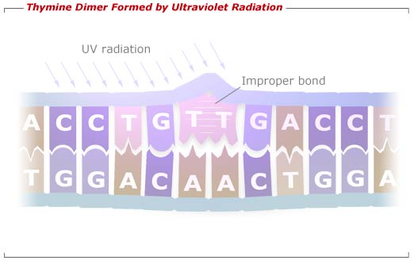 incorrect nucleotides

-Nucleotide excision repair- damaged DNA is cut out and replaced

Ex: Thymine dimers ---Xeroderma pigmentosum

Mutations ___________________________:

The proteins may work better or cause the organism to look different

Replicating Telomeres are repeat segments of TTAGGG at the ends of DNA molecules

Telomeres ____________________________________________________________________________

Telomerase enzymes lengthen ends but only in germ cells, cancer cells and stem cells

Summary