DNA Structure and DNA Replication

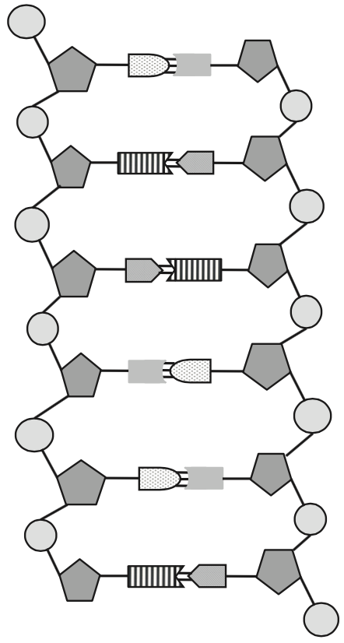
1. Use Chargaff’s base pairing rules to write the complimentary DNA strand
GAAGCTACCCAGTCAAGT

2. Label the 5’ ends, 3’ ends and all the bases.

Explain how these strands are antiparallel.

3. Complete the table
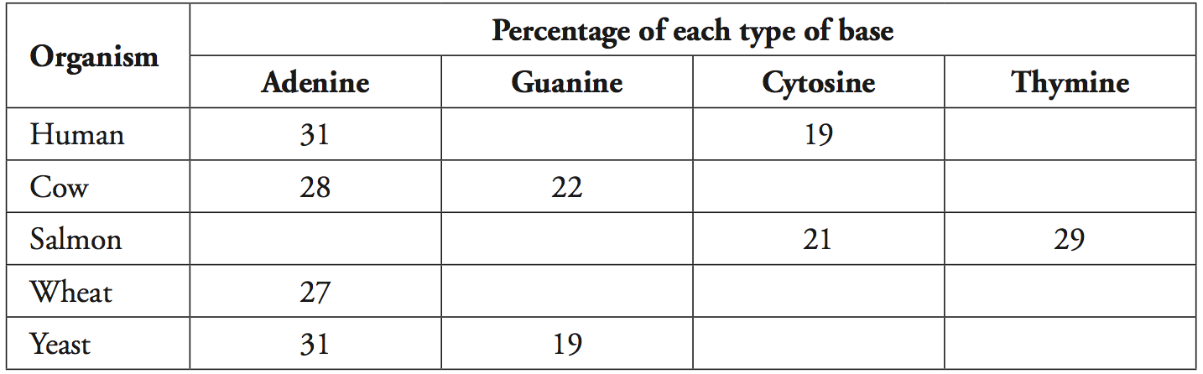

4. What is meant by semi-conservative replication?

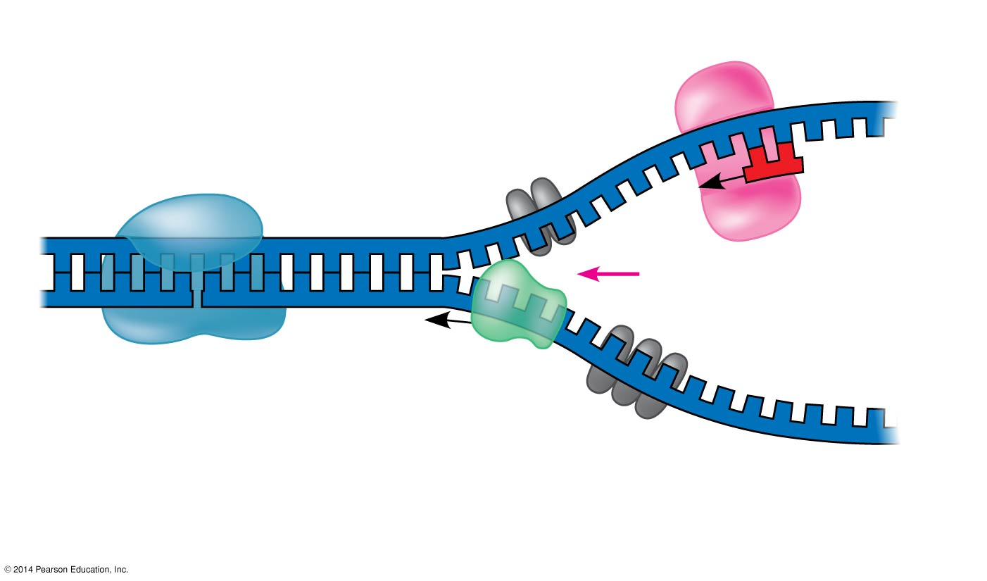
5. Label the Helicase, single stranded binding proteins, topoisomerase, primase, primer, replication fork, origin of replication

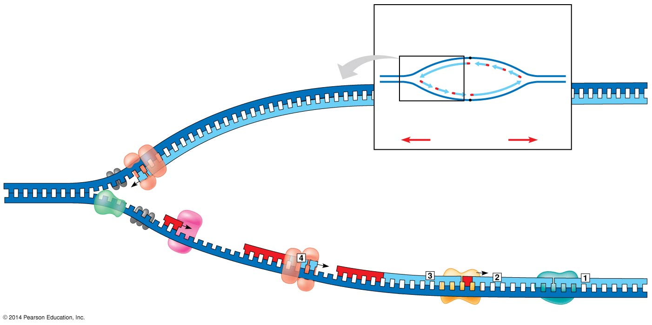

6. Label the
a. 5’ and 3’ ends of each strand
(templates and new)
b. Leading strand
c. Lagging strand
d. DNA Polymerase III
e. DNA polymerase I
f. DNA ligase
g. Okazaki fragments

How do the leading and lagging strands differ?

