Name: ___________
Main Ideas Title: The Function and Structure of DNA Period: ___ Seat:__
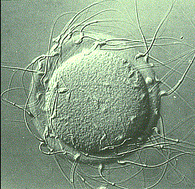
What is DNA? D = ______________ N = _______________A = _______________
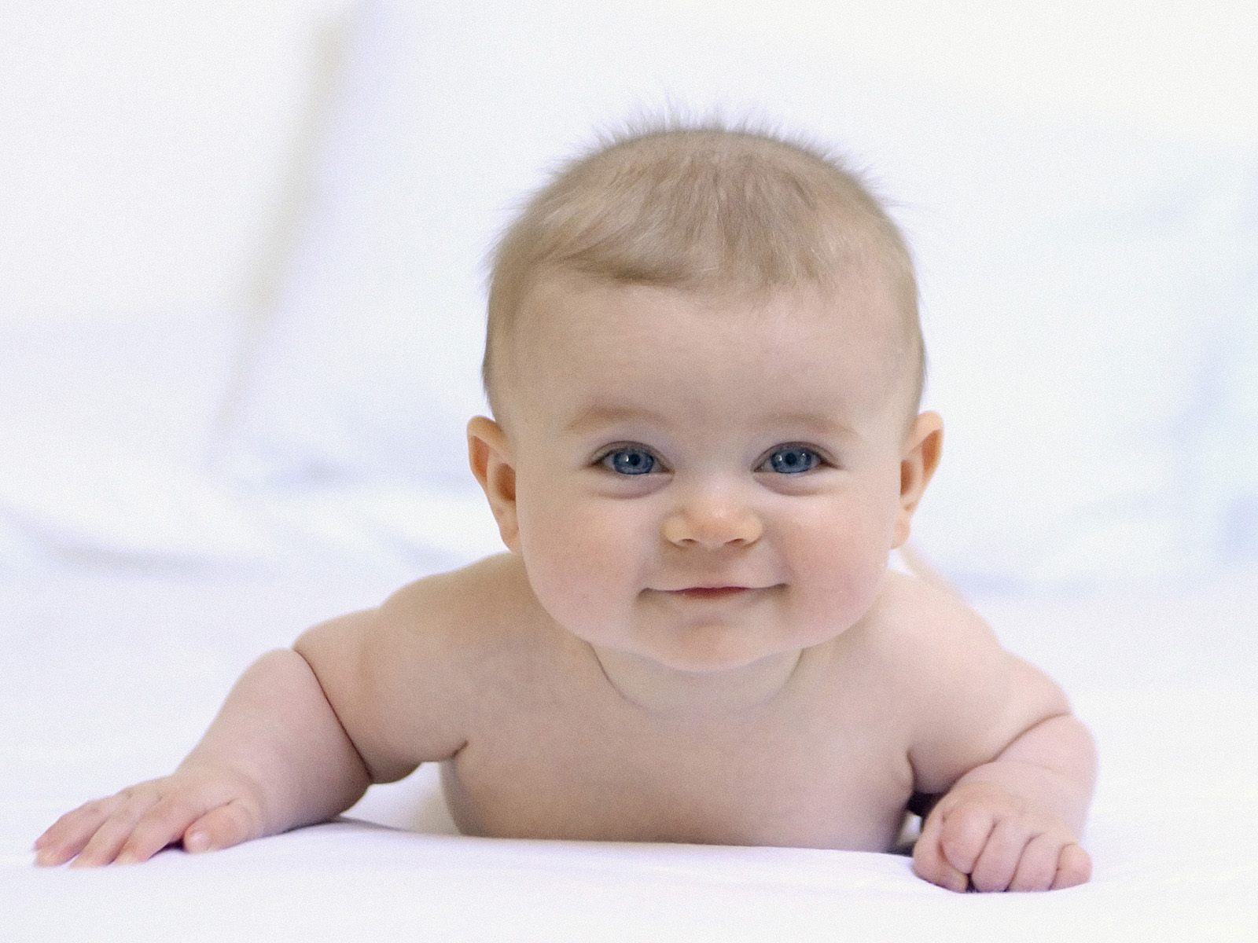
  - DNA is a molecule that ____________________________________________________
_______________________________________________________________________
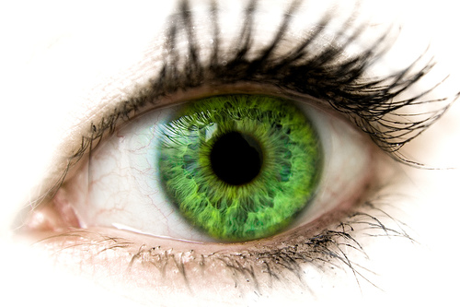
- Many of its instructions are directions for carrying out the daily activities of the cell
  - This information _________________________________________________________
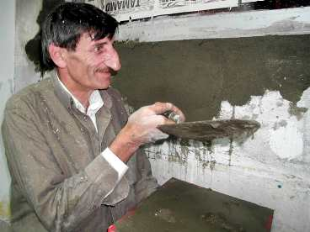
DNA is like an instruction manual that can be read
The instructions in DNA __________________________________________________

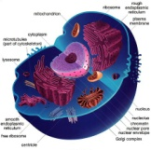
Where is DNA DNA is found in ________________________ Inside the _______________________
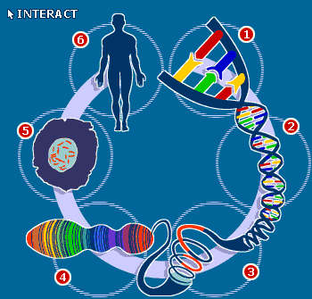
found? ___________________________ and cytoplasm of prokaryotes

Cell ***Every cell in your body has the same copy of DNA instructions but…
Differentiation Cell Differentiation-_________________________________________________
__________________________________________________________
This makes cells look and behave differently

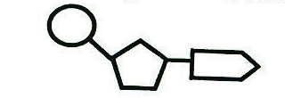
DNA structure DNA is made up of units called ___________________
A nucleotide has three parts:
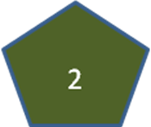
- _______________________
- _______________________
3. ___________________

______________ A nucleotide always has a phosphate connected to a dexoyribose sugar which is connected to 1
of 4 bases
*_________________ *Guanine (G) *_________________ *Cytosine (C)

Purines and 2 categories of bases: Purines ____________________________________________________
Pyrimidines Pyrimidines ________________________________________________

How is DNA A DNA molecule is made by using ________________________________________________
made? __________________ of the next– forming a long single strand

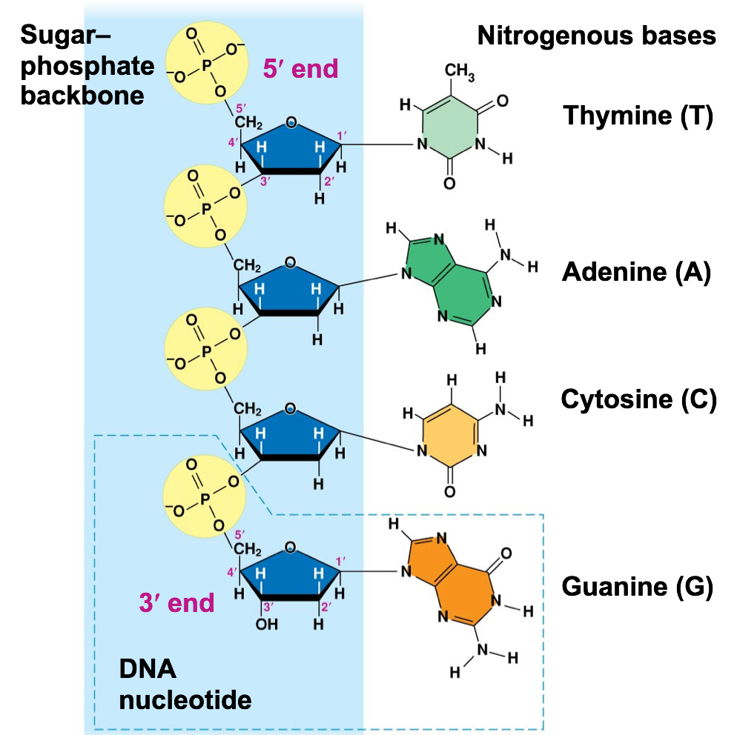
5’ and 3’ End
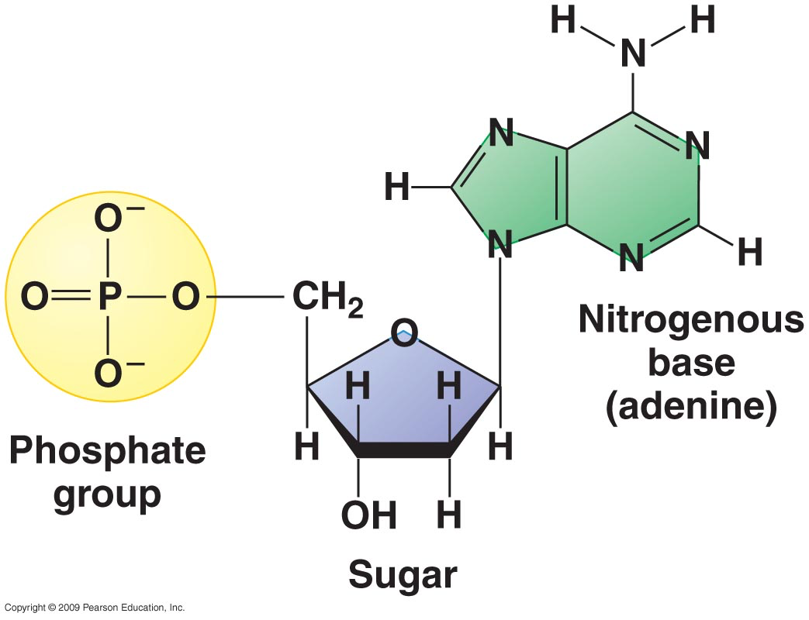
________________
_______

________________

________________

________________
________

2 Strands and DNA is made up of 2 strands connected in the middle by _______________________________
Chargaff’s Rules This looks like a ladder with a sugar/phosphate backbone and bases as steps
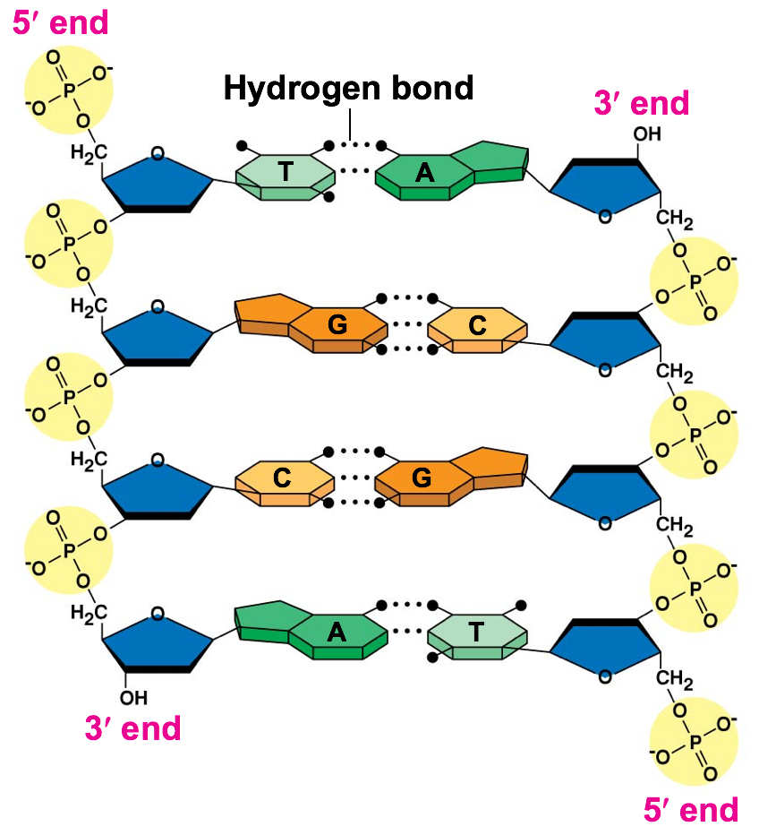
Chargaff’s base pairing rules (Always! Always! Always!):
Adenine Thymine
A T
Cytosine Guanine
C G

The Double Helix The hydrogen bonds between the two strands _________________________________________________
_________________________________________________

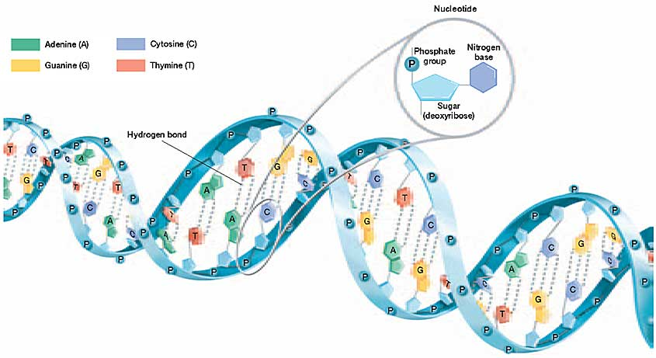
The two ____________________________________________ to each other

Photo 51 Scientist Rosalind Franklin used X-ray diffraction to conclude DNA was a double helix with 2
_____________________________________________________________________________
with hydrophobic nitrogenous bases facing inward

Where are the -DNA has its “written” language or “secret code” to spell out instructions which
“instructions”? ___________________________________
-___________________________________________________________________
Create your own sequence of at least 12 bases

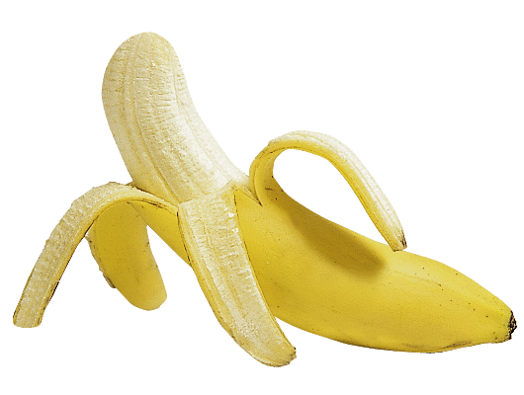

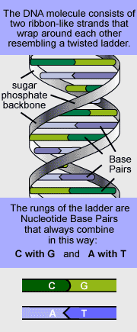
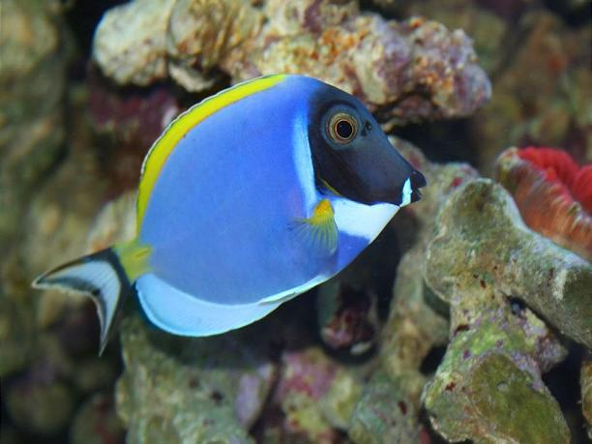
Its universal!!! All living things have DNA for instructions
________________________________________________
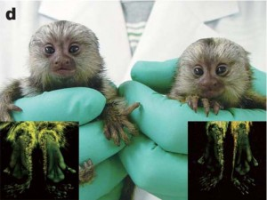
Each living thing/individual has a ____________________________

Summary

