Name: ___________
Main Ideas Title: Transcription Period: ___ Seat:__

Genes: Your Most of our DNA is “junk” DNA= no instructions
Special Instructions ____________________________________________________________________________
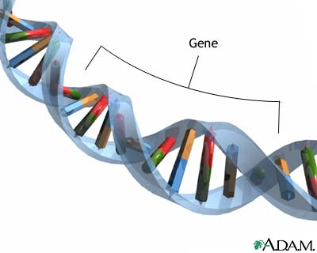
Genes vary in length.
Some contain hundreds of base pairs
Some contain thousands of base pairs
19,000 human genes have been identified
The instructions in your genes are directions for synthesizing (making) specific polypeptides.

Gene Expression Gene Expression and protein synthesis are the processes of re-
& Protein writing the DNA instruction and then reading the instructions in DNA to make a Synthesis protein
To read the instructions:
-__________________________________________________________ (Transcription)
-2nd read every 3 bases in the RNA (Translation)
The flow of instructions (central dogma) is symbolized as
_____ _____ _____

Transcription on Transcribe each of these 2 sequence of DNA into mRNA (Remember A-U, T-A, G=C)
Paper Sequence 1 – Human Insulin gene sequence
DNA: T A C G T A C A C G T T A C A A C G T G A A G G T A A
mRNA:
Sequence 2 – Cow Insulin gene sequence
DNA: T A C G T A C A T G T T A C A A C G C G A A G G C A C
mRNA:

In the cell This step takes place inside the nucleus
What happens? Basic of basics summary…
-____________________________________________________________________________
____________________________________________________________________________
-mRNA leaves the nucleus to find a ribosome
-The DNA zips back up and is unchanged

Initiation 1)___________________________________________________________________________
2) ____________________________________ with additional transcription factors forming a transcription initiation complex
3) RNA Polymerase begins to unwind the DNA
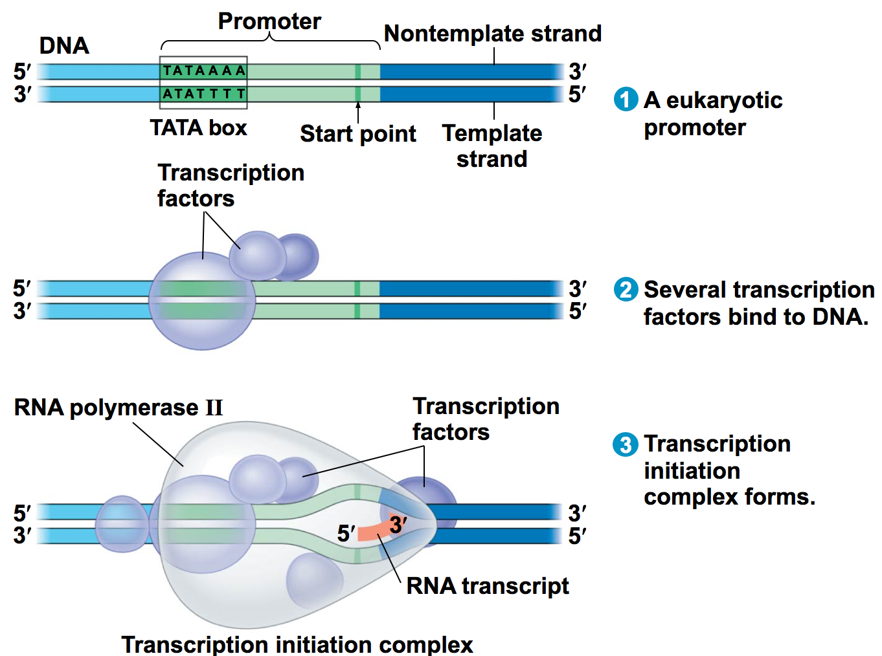

Elongation 1) RNA polymerase unwinds the DNA
2) __________________________________________________________________________
molecule in the 5’ 3’ direction
3) mRNA begins to peel away from the DNA and the DNA zips back up
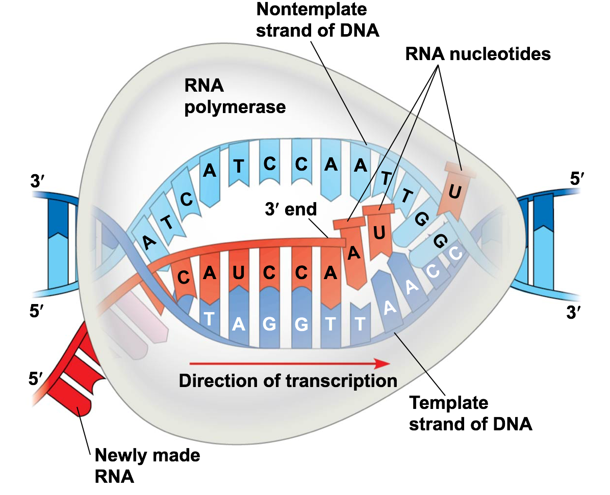

Termination *In prokaryotes it stops at a termination sequence
*Eukaryotes:
1)RNA polymerase transcribes ____________________________________ (AAUAAA)
2) Proteins cut the pre-mRNA free

RNA Processing 5’ end gets a __________________________(modified guanine nucleotide)
3’ end gets a ________________________ by adding 50-250 more adenines (A)
WHY???
*Facilitates the export of mature mRNA
*Helps protect the mRNA from degradation
*Helps 5’ end attach to ribosome
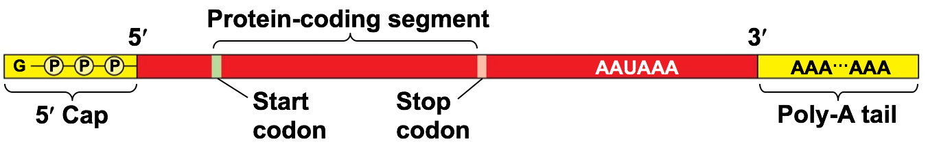

RNA Splicing Not all parts of the pre-mRNA are needed to code for a polypeptide in eukaryotes
-_________________________________________________________
-Exons are spliced together
*Alternate RNA splicing – one gene can code for 2 or more polypeptides
Humans…19,000 genes…100,000 different proteins

Summary

