Name: ___________
Main Ideas Title: Translation mRNA Protein Period: ___ Seat:__

Translation on Must always transcribe before you can translate
Paper ______________________________________________________________________

Central Dogma: __________ ___________ _______________

DNA: TACTCTGGATTCAGCCAAGCTATC
mRNA:
protein:

Significance of Builds protein to exact specifications of DNA instructions.
Translation *exact size and shape
What determines size and shape?
The _______________ and _____________________________________

Where does it On a ______________________in the cytoplasm
take place? Ribosomes provide a location for all necessary parts for building a protein to assemble

The ribosome up Made of rRNA and proteins
close Key features: - 2 subunits, large and small
*_________________________________
- 3 binding sites- A, P, E
*A- holds next tRNA in line to drop off its amino acid
*P- Site where tRNA connects its amino acid to the growing
polypeptide chain
*E- exit site once the tRNA has dropped off its amino acid
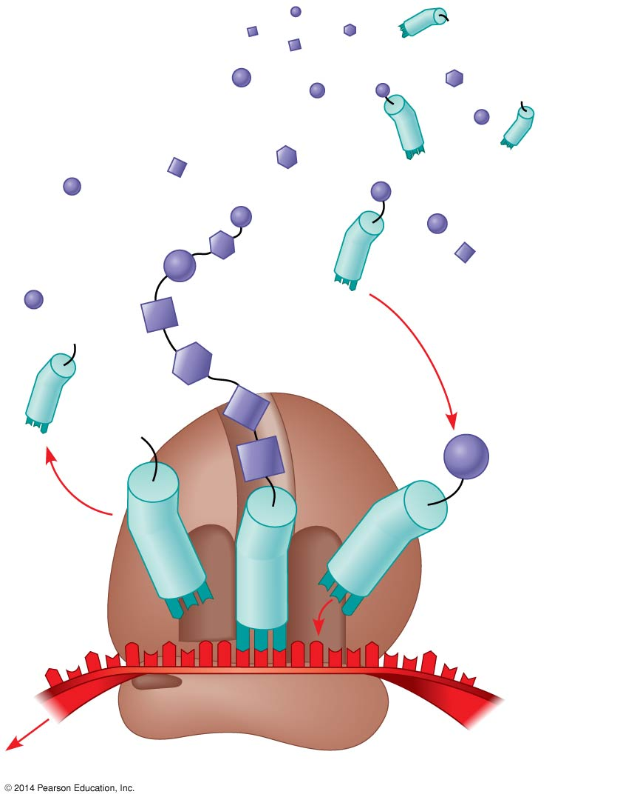

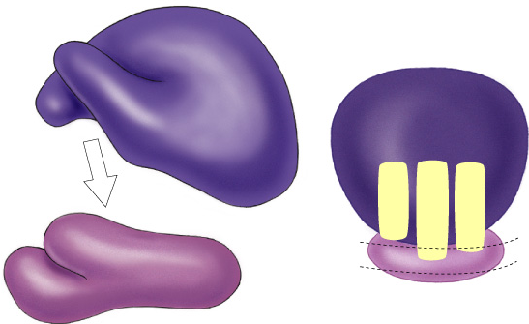

tRNA up close Made of RNA folded into a “clover leaf” shape
_____________________________________________________________________________
Key features
- ____________ in the middle loop matches to codon to ensure correct amino acid is dropped off
- amino acid attached to its 3’ end
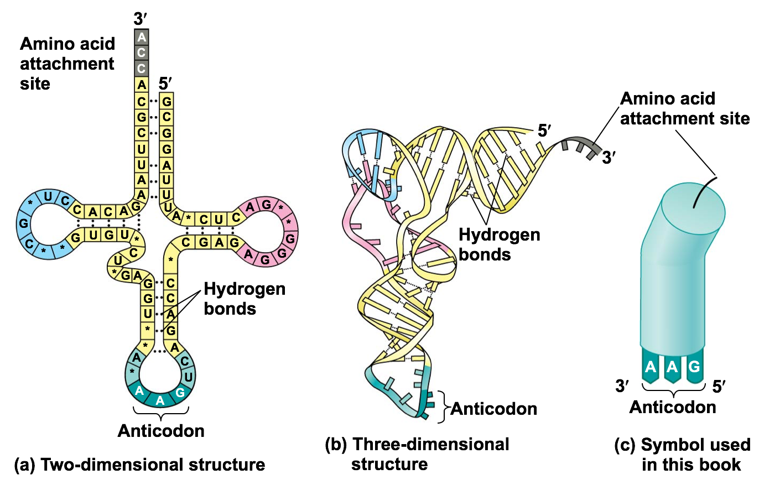

Loading tRNA Aminoacyl tRNA synthetase- Enzyme which bonds specific amino acid to tRNA
_____________________________________________________________________________
Bonding amino acid to tRNA requires energy
ATP → AMP

3 steps of _____________-brings together mRNA by binding to 5’ cap, ribosome subunits, initiator tRNA
translation ________________- adding amino acids based on codon sequence (GTP energy used)
________________- Stop codon plus release factor, H₂0, GTP

How do proteins ____________________________ ~20 amino acids at start of protein that act as address label
know where to go? Possible destinations: -secreted from cell -nucleus -mitochondria -chloroplast
-cell membrane -cytoplasm
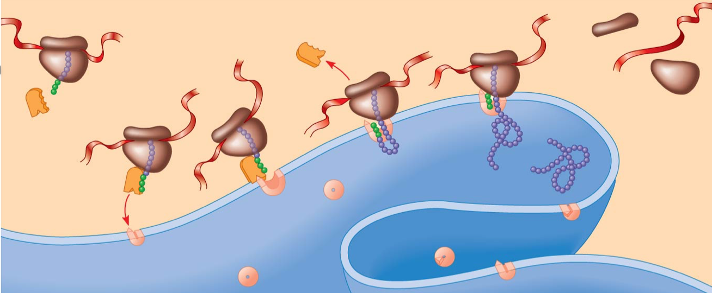

Translation in _____________________________________________________________________________
*DNA is in cytoplasm
*no mRNA editing/processing
*ribosomes read mRNA as it is being transcribed

Summary

