What affects the rate of photosynthesis?
Name:_____________________
Period:______ Seat: ______

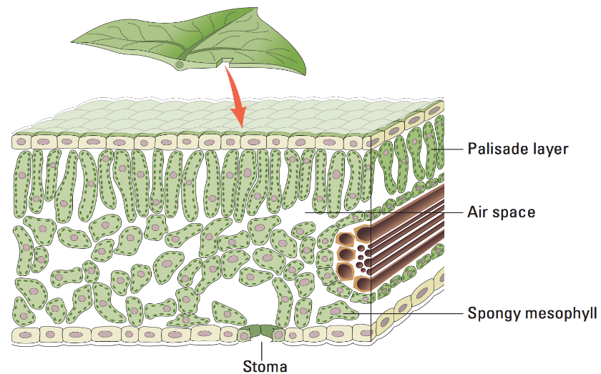
Background: Photosynthesis is an amazing process that makes life possible on earth, by converting energy from the sun and synthesizing organic molecules from thin air. As an enzyme driven reaction, the rate of photosynthesis can be measured either by the disappearance of a substrate or the accumulation of its products.
Cuticle
Pre-Lab Questions:
1. Write the chemical equation for photosynthesis:

2. What could you measure to determine the rate of photosynthesis?

The leaf is composed of layers of cells. The spongy mesophyll layer is normally infused with gases, oxygen and carbon dioxide. Leaves (or disks cut from leaves) will normally float in water because of these gases. If you draw the gases out from the spaces, then the leaves will sink because they become more dense than water. If this leaf disk is placed in a solution with an alternate source of carbon dioxide in the form of bicarbonate ions, then photosynthesis can occur in a sunken leaf disk. As photosynthesis proceeds, oxygen accumulates in the air spaces of the spongy mesophyll and the leaf becomes buoyant and floats. Oxygen and carbon dioxide are exchanged through openings in the leaf called stoma. While this is going on, the leaf is also carrying out cellular respiration. This respiration will consume the oxygen that has accumulated and possibly cause the plant disks to sink. The measurement tool that can be used to observe these counteracting processes is the floating (or sinking) of the plant disks. In other words, the buoyancy of the leaf disks is actually an indirect measurement of the net rate of photosynthesis occurring in the leaf tissue.

Pre-Lab Questions
3. What two types of gases would you expect to find in the air space?

4. How will you measure the rate of photosynthesis in this lab?

5. What is the function of the stoma?

6. List other factors you think may affect photosynthesis. (You will use this in another part of the lab)

Materials: baking soda, liquid soap, plastic syringes, leaves (spinach or ivy), hole punch, 2 cups or beakers, timer (use your phone), light source

Procedure for Measuring the Rate of Photosynthesis
1. Use your hole puncher to punch out 20 discs (try to get them between the veins)
2. Make a solution of sodium bicarbonate by mixing 300 ml of water and 3 grams of baking soda
3. Make a diluted solution of liquid detergent in a small beaker by adding 3 drops of dish soap to 70 ml of water. Do not make suds!
4. Add one drop of this dilute soap solution to your 300 ml bicarbonate solution. Swirl gently to avoid making suds.
5. Place 10 leaf disks into the syringe and pour in a small volume of the bicarbonate and soap solution. Replace the plunger and push out most of the air, but do not crush your leaves. (Just like the video)

6. Create a vacuum by covering the tip of the syringe with your finger. Draw back on the plunger.
7. Release the vacuum so that the solution will enter the disks. It may take a few times to get the disks to sink. You may need to gently tap the syringe to dislodge discs from the sides. *Try not to repeat more than 3 times which may damage the disc
8. Once they have sunk, you can put them back into the sodium bicarbonate solution and expose the disks to light. Start a timer and record how many of the disks are floating at 1 minute intervals.
-- You may need to gently swirl or stir the solution to dislodge disks that become stuck at the bottom or to each other.
9. Repeat your set-up from above, but this time do not place baking soda in the beaker. This is your control. Place another set of sunken disks into this solution and record data on the table.
10. Both the experimental group and the control should run until all the discs are floating.

Data:
Time (Minutes) | # of Floating Disks (Bicarbonate water) | # of Floating Disks (Control Group)
1
2
3
4
5
6
7
8
9
10
11
12
13
14
15

Analyzing Data
To make comparisons between experiments, a standard point of reference is needed. Repeated testing of this procedure has shown that the point at which 50% of the disks are floating (the median or ET₅₀) is a reliable and repeatable point of reference. In this case, the disks floating are counted at the end of each time interval. The median is chosen over the mean as the summary statistic. The median will generally provide a better estimate of the central tendency of the data because, on occasion, a disk fails to rise or takes a very long time to do so. A term coined by G. L Steucek and R. J Hill (1985) for this relationship is ET50, the estimated time for 50% of the disks to rise. That is, rate is a change in a variable over time. The time required for 50% of the leaf disks to float is represented as Effective Time = ET₅₀.

Graph your data for the experimental group on your separate sheet of graph paper. Determine the ET₅₀ for your leaf disks and determine the ET₅₀ for your data.

