Autotrophs and Heterotrophs
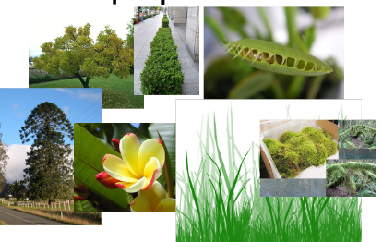
What are some common traits that autotrophs/producers have?
__________________________________________________________
__________________________________________________________
__________________________________________________________
Heterotrophs are organisms that eat other organisms to get their energy. Are plants heterotrophs? Explain.
__________________________________________________________________________________________________________________________________________________________
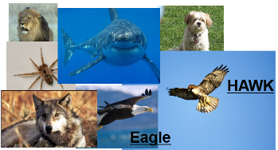
* _________________________________
What kind of food do you think carnivores eat to get their energy?
I think carnivores eat __________________________ to get their energy.
Sketch of what they eat:

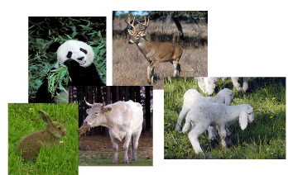
* ________________________________
What kind of food do you think herbivores eat to get their energy?
I think herbivores eat _________________________ to get their energy.
Sketch of what they eat:

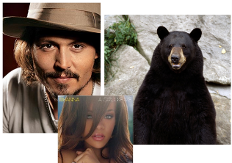
* ________________________________
What kind of food do you think omnivores eat to get their energy?
I think omnivores eat _________________________ to get their energy.
Sketch of what they eat:

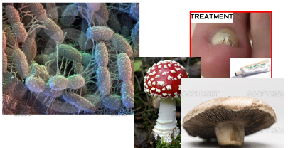
* ________________________________
What kind of food do you think omnivores eat to get their energy?
I think decomposers eat _________________________ to get their energy.
Sketch of what they eat:

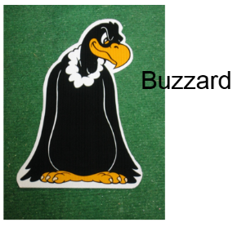
* ________________________________
What kind of food do you think omnivores eat to get their energy?
I think detritivores/decomposers eat _________________________ to get their energy.
Sketch of what they eat:
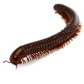

Autotrophs and Heterotrophs
What are some common traits that autotrophs/producers have?
__________________________________________________________
__________________________________________________________
__________________________________________________________
Heterotrophs are organisms that eat other organisms to get their energy. Are plants heterotrophs? Explain.
__________________________________________________________________________________________________________________________________________________________
* _________________________________
What kind of food do you think carnivores eat to get their energy?
I think carnivores eat __________________________ to get their energy.
Sketch of what they eat:

* ________________________________
What kind of food do you think herbivores eat to get their energy?
I think herbivores eat _________________________ to get their energy.
Sketch of what they eat:

* ________________________________
What kind of food do you think omnivores eat to get their energy?
I think omnivores eat _________________________ to get their energy.
Sketch of what they eat:

* ________________________________
What kind of food do you think omnivores eat to get their energy?
I think decomposers eat _________________________ to get their energy.
Sketch of what they eat:

* ________________________________
What kind of food do you think omnivores eat to get their energy?
I think detritivores/decomposers eat _________________________ to get their energy.
Sketch of what they eat:

