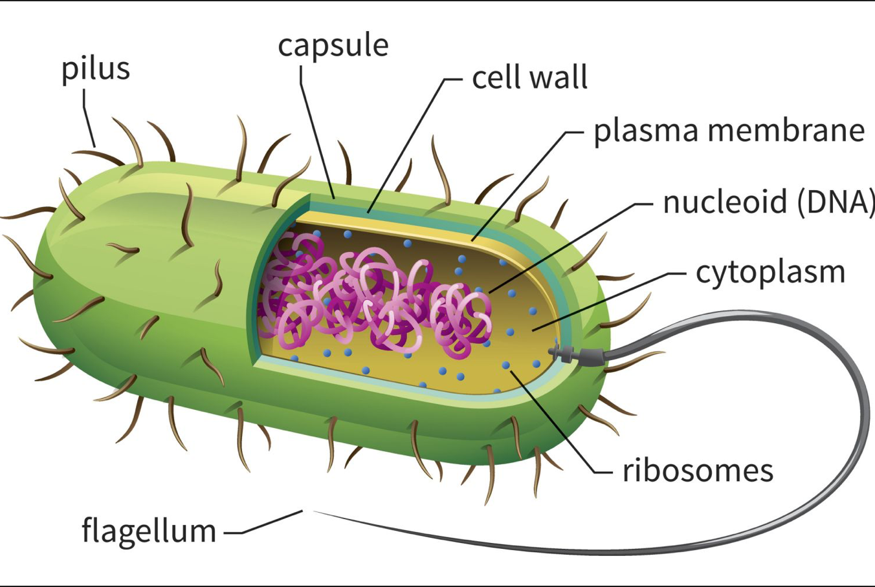
DNA (chromosome)
Plasmid
Cell Membrane

***Do an internet search to find the functions of the structures listed. ***

