Name: ___________
Main Ideas Title: Lipids Notes Period: ___ Seat:__

The Basics
Atoms Monomer Name Polymer Name Functions

Unique Lipids are ______________________________________________
Characteristics _________________________________________ than other macromolecules
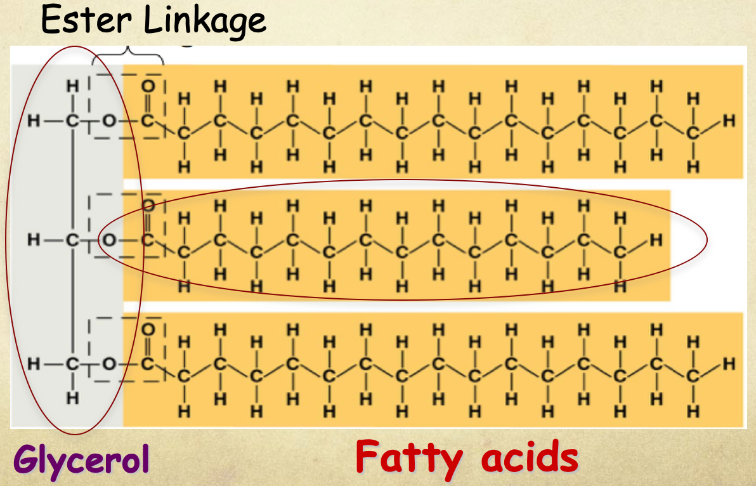
Types of Lipids: Composed of 1 glycerol and 3 fatty acids
Fats Functions: 1. _________________________________
2. Protection against heat loss (insulation)
3. Protection against physical shock
4. Protection against water loss

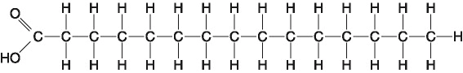
Saturated vs. ____________
Unsaturated

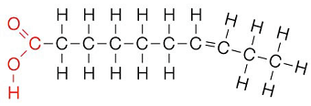
____________

Types of Lipids Function: ____________________________________
Phospholipids

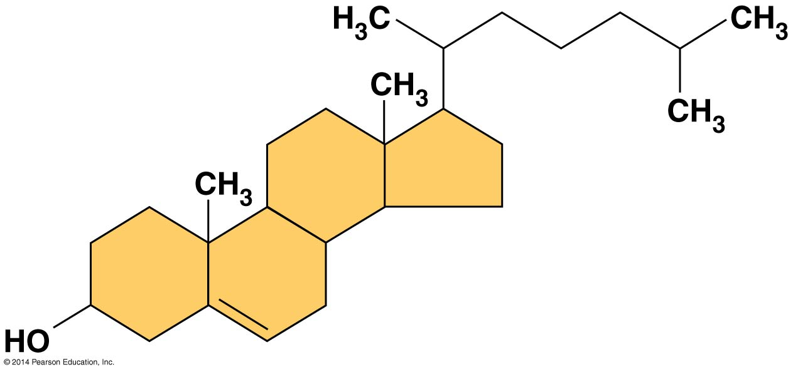
Types of Lipids Function: ____________________________________
Steroids
Key characteristics: In animals _________________________________
for steroid hormones
Obtained from food and synthesized in the liver

Summary

