*Please do not print out. Write into page 118 of your SNB (it will help you remember the information). Do NOT write down the red part below
Biodiversity

Biodiversity- The sum total of organisms living in an area or on the planet
Ready for some super hard math? Which area has greater biodiversity? How do you know?
Area 1 Area 2
giraffes, gazelles, Acacia Trees lions, zebras, baobab trees, bees
lions, zebras, wildebeests, elephants Napier grasses, crocodiles, giraffes
ostriches, buffalo, cheetahs, wild pigs rhinos, gazelles, baboons, buffalo
Jacaranda plants, baboons, rhinos,
orange clock vine, ants, bats, hyenas

Diversity = resilience to changes
Greater biodiversity = stronger resilience
Diversity = stability

+ Biodiversity and Succession
During the progression of succession over time…
- Biodiversity increases as succession progresses
- Species create more suitable conditions for new species
- More niches are formed
- Plant stratification occurs creating an understory and a canopy (niche opportunities)
*- Increases in producer diversity = increased consumer diversity

+ Biodiversity and Foreign Species
- A community with great biodiversity is less impacted by the introduction of foreign species.
- More niches are already filled
- With more biodiversity, many native species can outcompete the non-native species
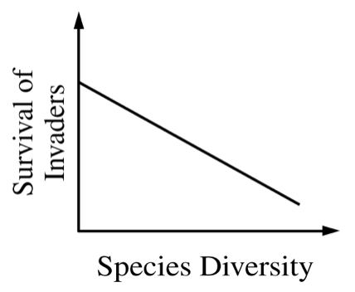

+Nutrients and materials
- Greater diversity helps with the distribution of nutrients

+Natural disasters
- Areas with more diverse communities recover faster from droughts, floods, fires, etc.

+Keystone species
- Removal of keystone species even in a highly diverse community still results in trophic cascade
(keystone species are that important)

