**Biotechnology: Genetic Engineering Visual Review**

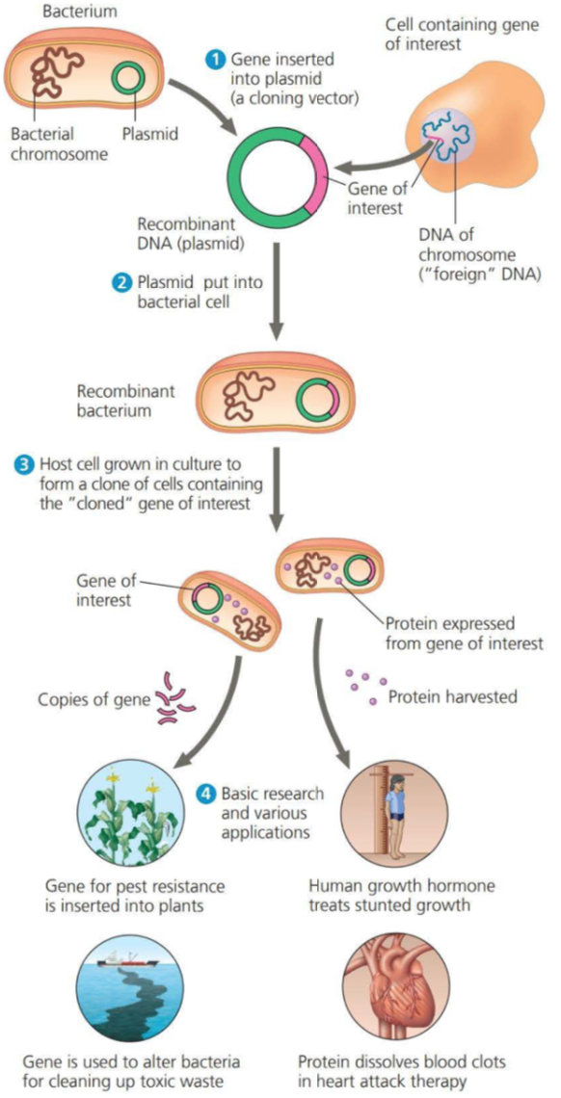

Define genetic engineering:

What is a recombinant DNA molecule?

What is a cloning vector? What is the most common used cloning vector? Why?

How is transformation involved?

If the process is successful, how can the products be used?

**Recombinant DNA**

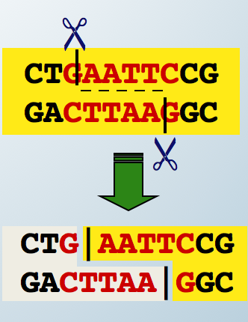

Why are restriction enzymes important in creating a recombinant DNA plasmid?

What are the ends called after cutting the plasmid and the foreign DNA?

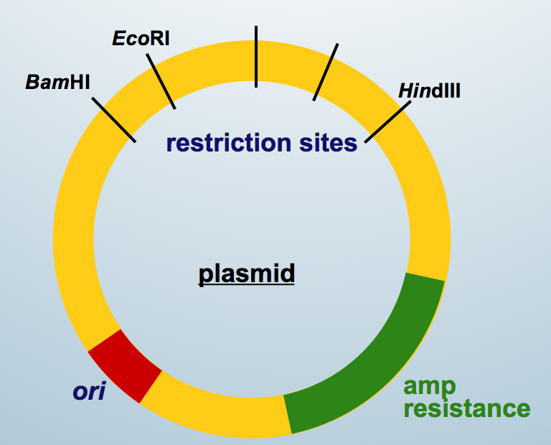

Explain how scientists use antibiotics resistance to isolate bacteria that have taken up the recombinant DNA plasmids. (think about transformation)

Is transformation always successful? How can scientists tell?

6 basic steps to making recombinant DNA (this is how we currently do it :)

1. Use restriction enzymes to cut out the donor gene and cut the plasmid to match

2. Splice the donor gene into the plasmid using ligase enzymes (“sticky ends” matching)

3. Allow for transformation to occur

4. Test for successful strains by adding antibiotics (bacteria with successful transformation will survive, others will not)

5. Allow successful strains to reproduce

6. Harvest genes to make recombinant DNA in other organisms OR harvest product (growth hormone, insulin, decomposition enzymes)

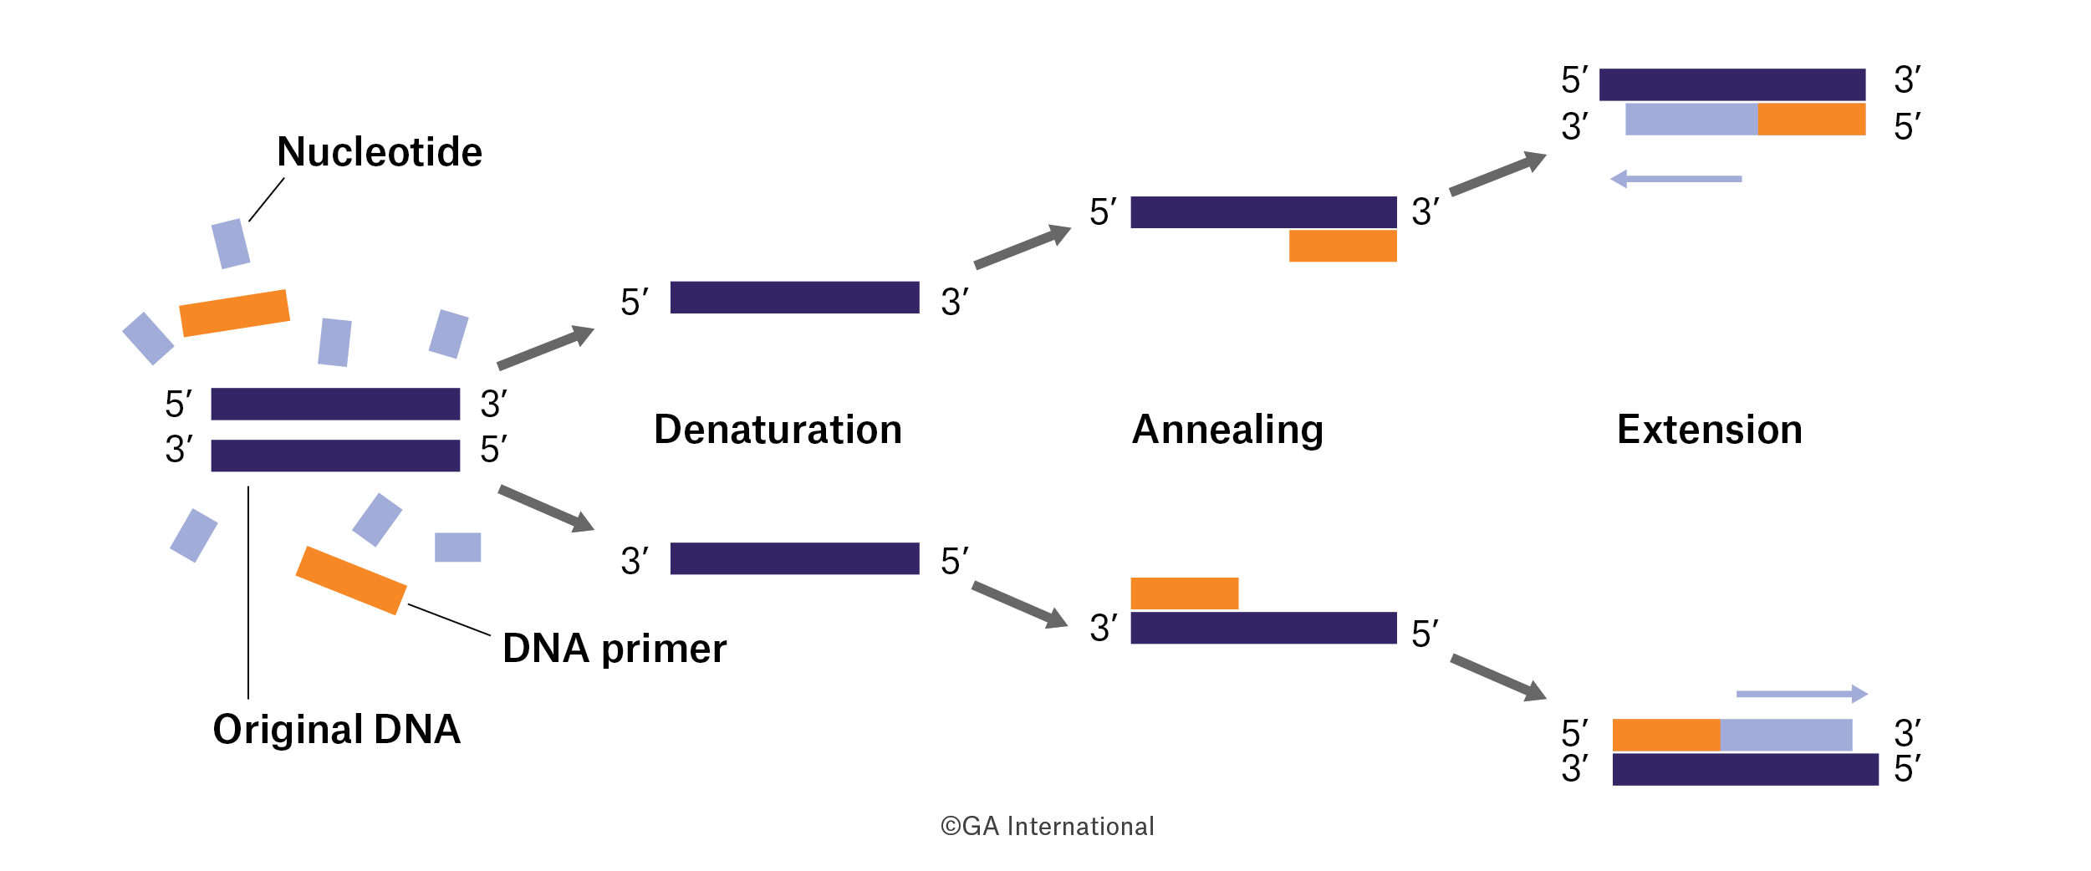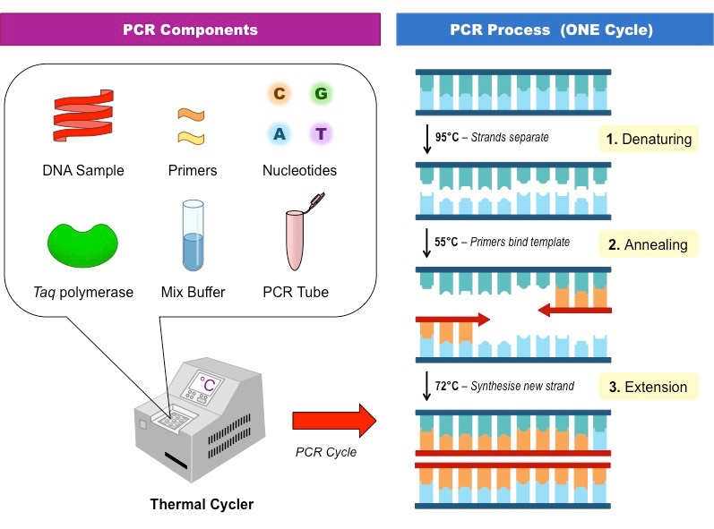

**94-96oC**

**68oC**

**Polymerase Chain Reaction (PCR)**

**72oC**

What is the purpose of PCR?

Identify all of the components necessary for PCR to take place.

What is Taq polymerase and why is it used instead of DNA polymerase III?

Explain the purpose of heating and cooling.

Explain what happens during:

Denaturation-

Annealing-

Extension (aka elongation)-

**Gel Electrophoreses**

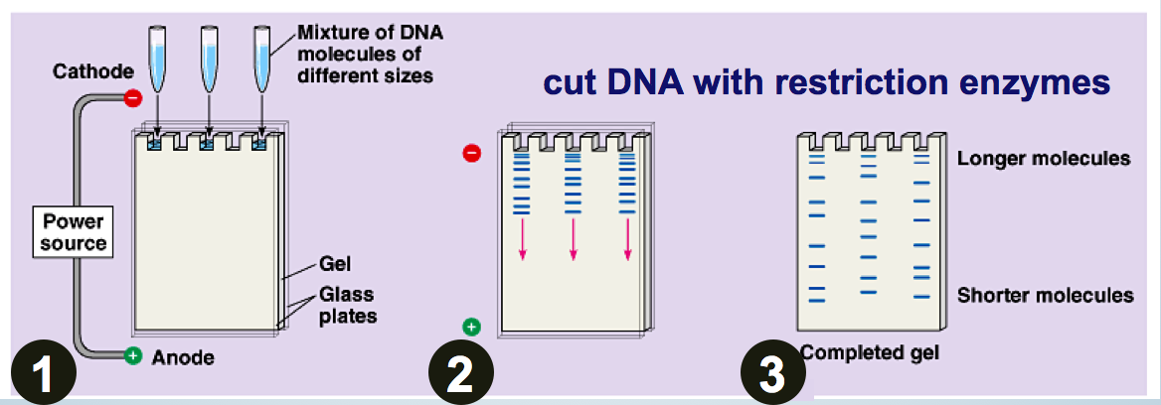

What charge is DNA?

What is the purpose of gel electrophoresis?

Explain what causes the DNA to move through the gel and why the fragments of DNA travel different distances.

Describe the 3 basic steps for gel electrophoresis.

1) Isolation-

2) Running the gel-

3) Dying and x-raying the gel-

What is the x-ray picture of a completed gel called?

What can the results of gel electrophoresis be used for?

**DNA sequencing**

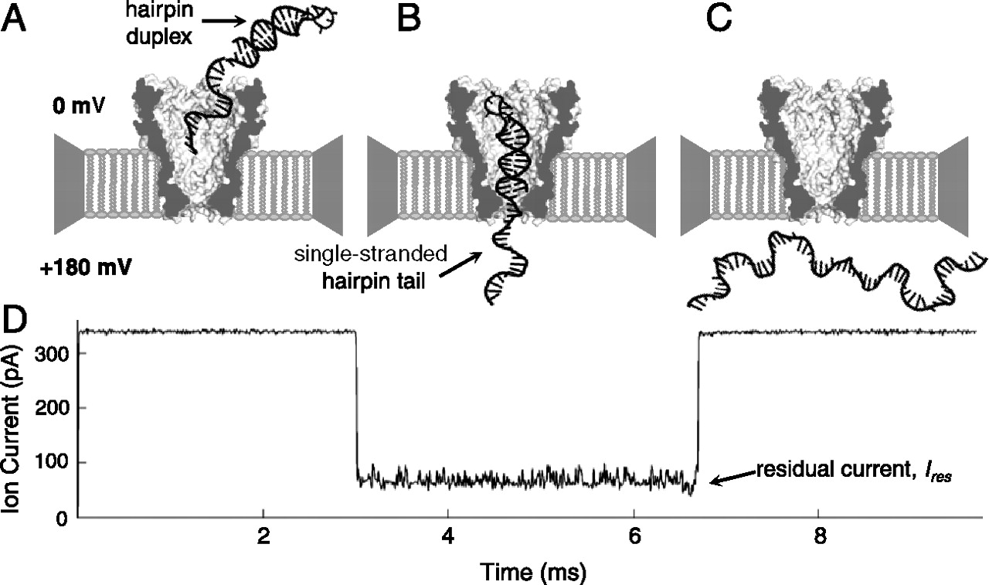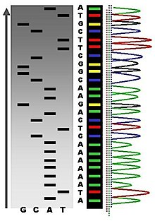

What is the purpose of DNA sequencing?

Describe how DNA sequencing works (don’t forget the electricity)

What can it be used for?

**Additional visuals: Making recombinant DNA**

