Study Guidelines: Cell Membrane and Transport
Name: ____________
Period: ___ Seat: ____
Each cell in a multicellular organism is a living thing. The cell membrane plays a major role in how the cell interacts with its environment. It not only protects it and determines what enters and exits the cell, but it is also used to help cells communicate with each other.
***Three big ideas: structure/function, transport and communication***

1. a. Compare and contrast prokaryotes and eukaryotes. What does pro no, eu do mean?
b. Identify the 4 structure that all cells have

2. Draw a simple sketch of the cell membrane and label the main components

3. a. Define phospholipid, amphipathic, lipid bilayer, membrane protein
b. Explain why cell membranes are organized into a lipid bilayer

4. a. Describe the fluid mosaic model in your own words
b. Explain how heat affects membrane fluidity.
c. Identify the role saturated/unsaturated fats and cholesterol play in membrane fluidity.
d. Why is fluidity important?

5. Identify and explain at least two examples that show how life has evolved to deal with membrane fluidity in varying environments (read “Evolution of Differences in Membrane Lipid Composition” on pg 96 in your book)

6. a. Study the functions of each organelle (FRQ next class!!!)
b. Identify the organelles involved in the protein production pathway
c. Identify the organelles involved in energy conversion

7. a. Identify at least three types of evidence to support endosymbiont theory. b. Justify how each supports the theory.

8. a. Define integral protein, peripheral proteins, selective permeability, transport proteins
b. State the role of carbohydrates in the cell membrane.

9. Explain why cells need to constantly transport materials in and out.

10. a. Define passive transport and concentration gradient
b. Compare and contrast simple diffusion and facilitated diffusion
c. What causes molecules to diffuse/move if there is no input of energy?
d. Identify the types of molecules you would expect to go through simple diffusion. Justify.

11. a. Describe the structure and properties of integral proteins that are used as transport proteins.
b. Compare and contrast channel proteins to carrier proteins.
c. Identify the types of molecules you would expect to go through facilitated diffusion.
Justify.

12. a. Explain how active transport differs from simple and facilitated diffusion.
b. Describe the role ATP and phosphorylation play in active transport.
c. Read and study figure 5.14 on page 104 of your textbook

13. a. Identify the different types of transport in the picture below. b. Justify using evidence from the picture to support your identification claims. c. What types of molecules could the shapes represent in each.
A B C D
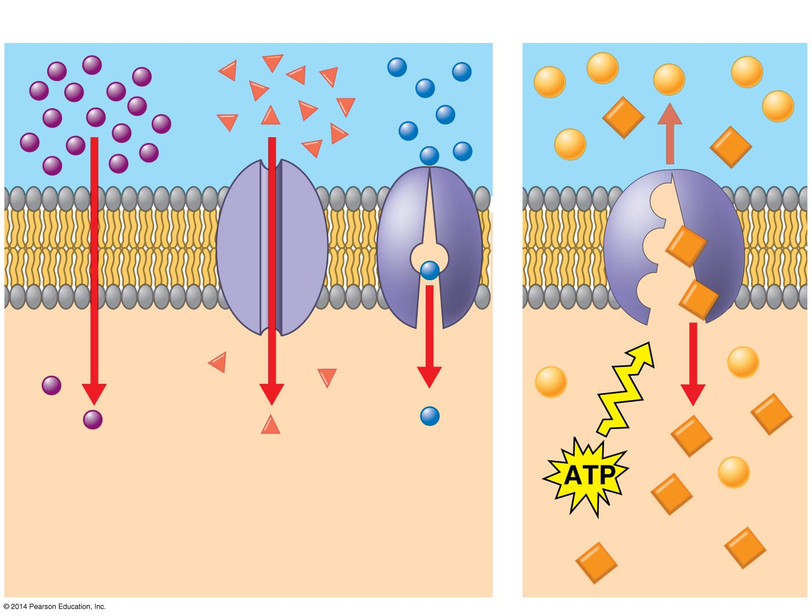

14. a. Define endocytosis
b. Identify the conditions in which endocytosis would occur for a cell.
c. Identify the role membrane proteins play in this type of transport.
d. Define vesicle in your own words.
e. Explain why energy is needed during this type of transport.

15. a. Identify and describe the 3 types of endocytosis.
b. Describe at least one biological example for each type

16. a. Explain what happens during the process of exocytosis.
b. Compare and contrast endocytosis and exocytosis
c. Describe at least one biological example that uses exocytosis

17. a. Define osmosis, free water, water potential
b. Explain how the presence of solutes affects the movement of water (osmosis).

18. a. Define tonicity
b. Draw a picture of a cell in a hypotonic solution, isotonic solution, hypertonic solution
c. In your own words, explain how a cell reacts in a: hypertonic solution, isotonic solution,
hypotonic

19. a. Define turgid and flaccid
b. Compare and contrast animal and plant cell responses in hypertonic, isotonic and
hypotonic solutions. (what is preferred by each and why)

20. a. Describe the purpose of osmoregulation and identify the main organ responsible for osmoregulation in most multicellular organisms.
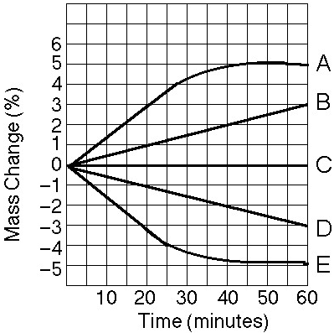
b. True story: A student buys a turtle from a man on the street. She is told that all the turtle needs is a tank full of water and he will be happy. The student sets up the tank, feeds it regularly, but it dies by the end of the first month. She later finds out it was a land tortoise, not a turtle (most turtles can live on water and land). Explain the role osmosis probably played in its death. Be specific and use terms you have learned.

21. Study the graph to the right carefully.
a. Which line(s) represents a cell that is in an isotonic
solution? Justify.
b. Which line(s) represents a cell that has been placed
in a hypertonic solution? Justify.
c. Which line (s) represents a cell that has been placed
in a hypotonic solution? Justify.

22. a. Explain the effect of surface area-to-volume ratios on the exchange of materials between cells and their environment.
b. Take a look at the following cells. Which of the following intestinal cells do you think would be the most efficient at absorbing digested materials? Explain!
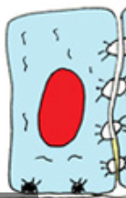
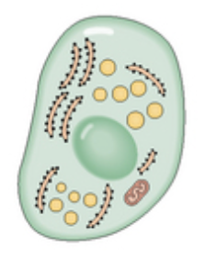
Microvilli

Intestinal Endocrine Cell Intestinal Brush Boarder Cell Mucosal Intestine Cell
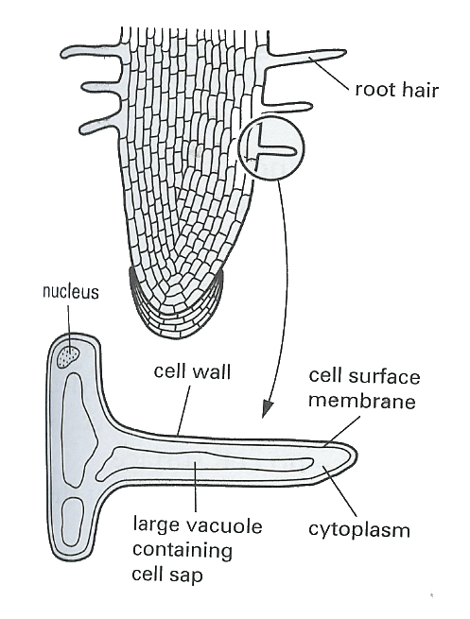

c. Root hair cells may be found on the outer layer of a plants roots. Explain how this helps the plant and how the surface area to volume ratio differs from normal root epithelial cells.

d. Which cube is the most efficient for getting oxygen and nutrients in and wastes out? Complete the chart to get mathematical evidence to support your claim.
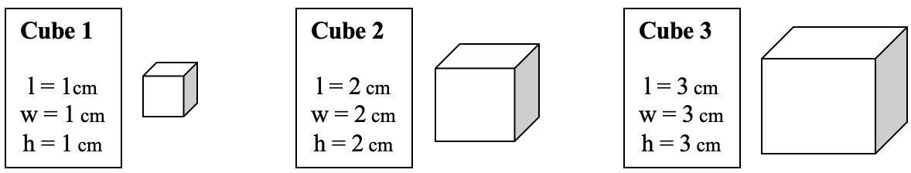

Surface Area = 6 × s × s
Volume = s × s × s
Surface Area to Volume Ratio: divide the surface area by the volume
Data Table
Cube Size | Surface Area (cm²) | Volume  (cm³) | Surface Area to Volume Ratio
1 × 1 × 1 cm
2 × 2 × 2 cm
3 × 3 × 3 cm

