Name: ___________
Main Ideas Title: Cell Communication Period: ___ Seat:__

Multicellular Multicellular organisms are _____________________________________________________
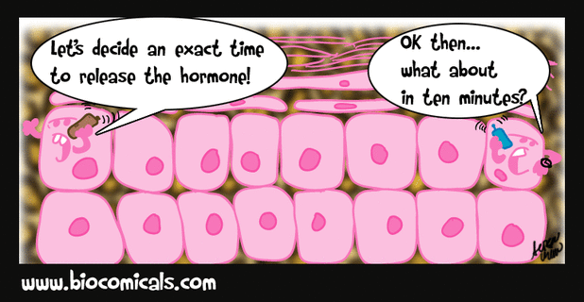
Organisms
1)

Components of 1) ______________________________
Communication 2) ______________________________
2)

Target Cells -Signal molecules are highly specific.
-_________________________________________________________________________
-These are called target cells.

Types of 1) Protein receptors in the plasma membrane
Receptors -Receptors that are embedded in the cell membrane
-____________________________________________
______________________________________

2) Intracellular Receptors
-Receptors in the cytoplasm or in the nucleus
-___________________________________________
______________________________________

3 Stages of Cell 1) Signal Reception- ____________________________________________________
Signaling (molecules involved in signaling are called ligands)
2) Signal Transduction Pathway- __________________________________________________
that leads to a change in the cell
3) Cellular Response- ___________________________________________________________

Types of Cellular The signal transduction pathway can lead to…
1) _________________________________ 2) ____________________________________
3) Turning a protein on or off 4) Rearrangement of cytoskeleton
5) Cell division 6) Cell death

Summary

