**Cell Communication**

**Local Signaling** **Long distance signaling**

Why do cells need to communicate?

What is a ligand? What types of molecules can be ligands? (give examples)

How do ligands travel through the body by endocrine signaling?

AKA: Juxtracrine

Cells are touching

Example:

Plasmodesmata

Example 1:

Growth Factor

Example 2:

Synapse

**General Steps of Cell Signaling**

Name each step.

Step 1-

Step 2-

Step 3-

Explain what happens during each step.

What is amplification?

Types of Receptors

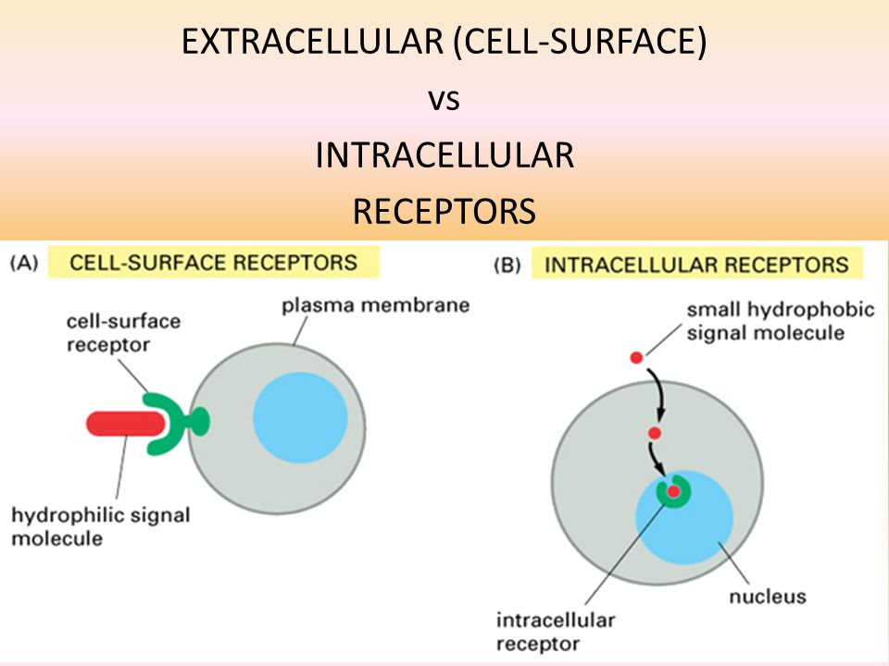

How does a ligand know which receptor to bind to?

What parts of the receptor interact with the ligands?

Receptors can be found in embedded in the ________ __________ or found floating in the ______________.

What property/characteristic of the ligand determines if it will have a surface protein receptor or an internal receptor?

What are cells called that specific ligands can affect?

Why don’t we want ligands to affect all cells?

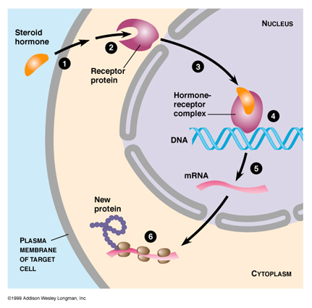

**Protein Hormones vs. Steroid Hormones**

Steroid Hormone

Made using cholesterol

Hydrophobic

______________________________

Intracellular Receptor

Hormone-Receptor Complex acts as a transcription factor

Response: Activates protein synthesis

________________________________

Protein Hormone

Made out of amino acids

____________________

Can’t pass through membrane

________________________

Starts a signal transduction pathway

Response: Activates enzymes or protein synthesis

Fast response

**Specific Types Of Surface Protein Receptors**

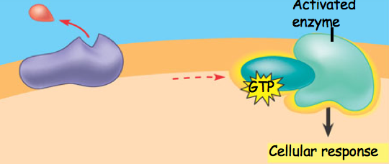

What type of protein receptor is this?

Explain what it does.

What type of ligands/hormones would initiate this?

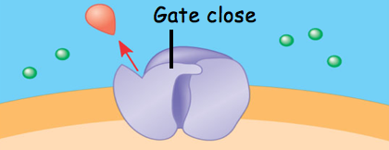

What type of receptor is this?

Explain how it works.

How are these involved in the nervous system?

What type of hormones would open these receptors?

What type of protein receptor is this?

Explain what it does.

What type of ligands/hormones would initiate this?

**Types of signal transduction pathways: Phosphorylation Cascade**

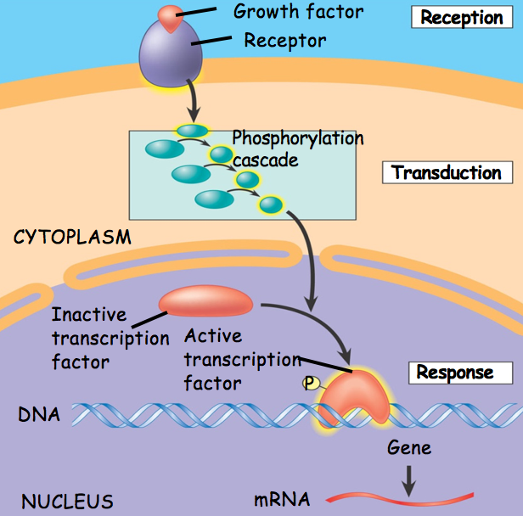

What is a kinase?

Explain how a phosphorylation cascade works.

What is its purpose?

What type of hormone would initiate a phosphorylation cascade?

What is the cellular response in this example?

**Types of signal transduction pathways: Secondary Messengers**

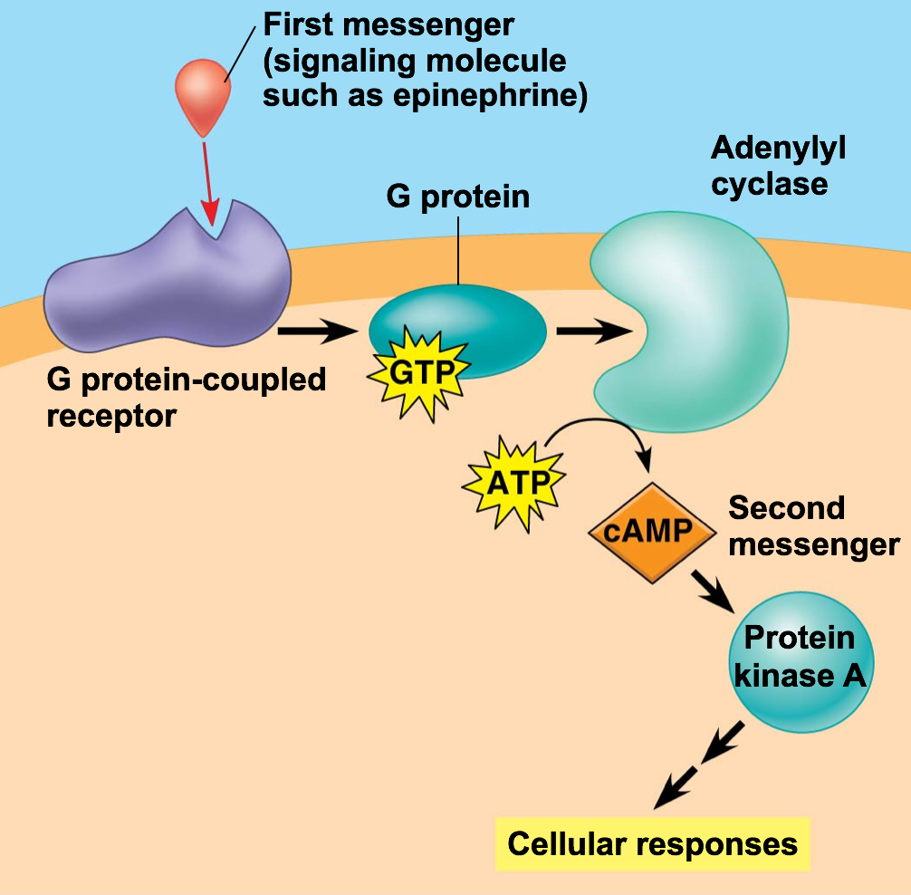

Specific examples you should know:

*Environmental change: sodium levels in the blood are high, too little water. This causes ADH (Antidiuretic Hormone) to be release from pituitary gland. It reaches its target cells (kidney cells) causing them to move more water into the blood instead of releasing it into the urine.

*Environmental change: a cut. This causes Growth Factor to be release from local cells (paracrine signaling). The cells that receive the Growth Factor enter into mitosis to replace the damaged cells

*Environmental change: you eat and raise you blood sugar levels. This causes Beta cells in the pancreas to release insulin. Its target cells are skeletal muscle cells, fat cells and liver cells. The insulin binds to surface protein receptors which starts a signal transduction pathway that causes vesicles carrying Glucose Transport Proteins (aka GLUT 4) to the fuse with the cell membrane, allowing glucose to enter the cells.

*Type 1 Diabetes: The Beta cells do not produce insulin (leads to high blood sugar since no signal to uptake)

*Type 2 Diabetes: The target cell receptors (skeletal muscle, liver, fat) do not respond when insulin binds because the cytoplasmic side of the receptor is damaged and does not activate a signal transduction pathway

*Environmental Change: pathogen enters the body.

What is the job of the Adenylyl cyclase?

What does a secondary messenger do?

What is the most common secondary messenger?

What type of hormones would initiate a secondary messenger?

If this pathway doesn’t activate a transcription factor to start protein synthesis, this pathway probably has what cellular response?