The Cell Cycle, Mitosis and Regulation

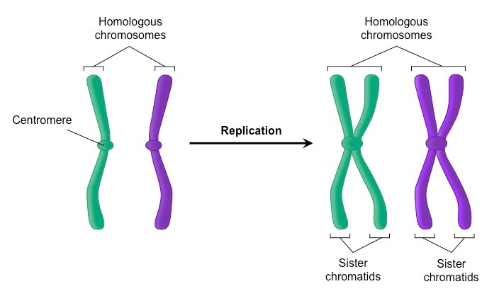

What is a chromosome made of?

What is the function/purpose of chromosomes? (name at least 3)

How can you tell if a chromosome has been copied?

What is a homologous pair?

What are sister chromatids?

What is the difference between homologous pairs and sister chromatids?

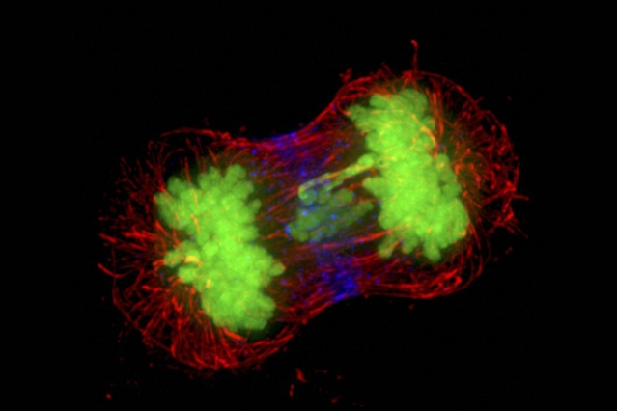

What is the purpose of the cell cycle?

What are the 3 phases of interphase? (Label them too)

What happens during each phase?

During which phase is DNA replicated?

After interphase comes _________ then finally __________.

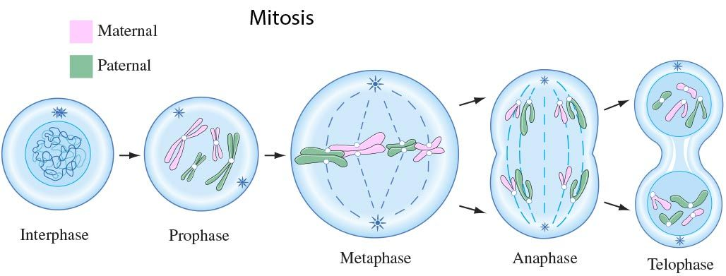

What is the purpose of mitosis? (hint: it’s not to make two cells, that’s the purpose of the whole cell cycle)

Explain what happens during each phase. (PMAT)

Prophase- Anaphase-

Metaphase- Telophase-

Identify which two phases are the most important for mitosis to correctly fulfil its purpose. Why?

What is happens during cytokinesis?

What types of cells does mitosis help make? Identical/Unidentical? Diploid/Haploid? Gamete/Somatic Cell?

Why does the cell cycle need to be regulated?

How is the cell cycle an example of cell signaling? How does a cell know when to divide?

What happens if something is wrong when a check point is reached?

What are 3 general ways the cell cycle is regulated?

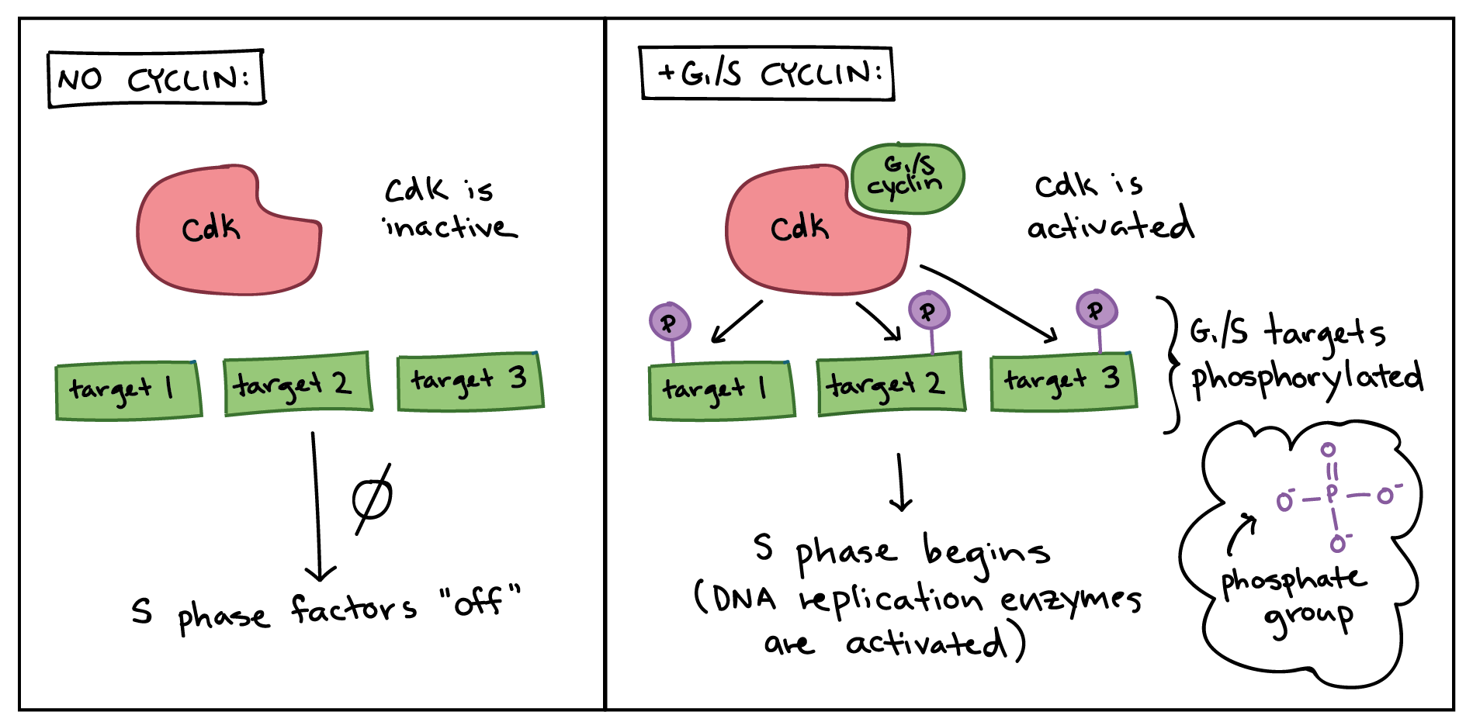

What is a CDK and what does it do?

How is it part of a phosphorylation cascade?

How does a CDK become activated?

How do Cyclin-CDK complexes help regulate the cell cycle?

Explain how each of the following molecules that are activated by a cyclin-CDK complex helps move the cell to the next phase?

Transcription factors-

The enzyme that degrades the cyclin in this current cyclin-CDK complex-

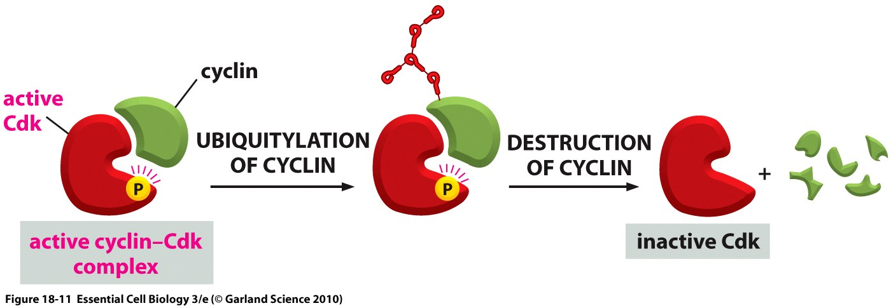

What does this graph tell us about the concentration of CDKs throughout the cell cycle?

What does it tell us about the concentration of cyclins throughout the cell cycle?

Why do cyclins need to be degraded?

What happens when you fuse a cell that is in G1 with a cell that is in M phase (mitosis)?

What happens when you fuse a cell that is in G1 with a cell that is in G2?

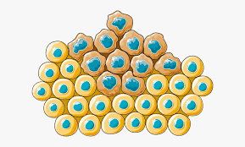

What is cancer?

What can cause a cell to become a cancer cell?

UV radiation or carcinogens (mutagens) can cause mutations in __________________ or __________________ within the cells DNA. (hint: its 2 specific categories of genes)

How can cancer cause death?

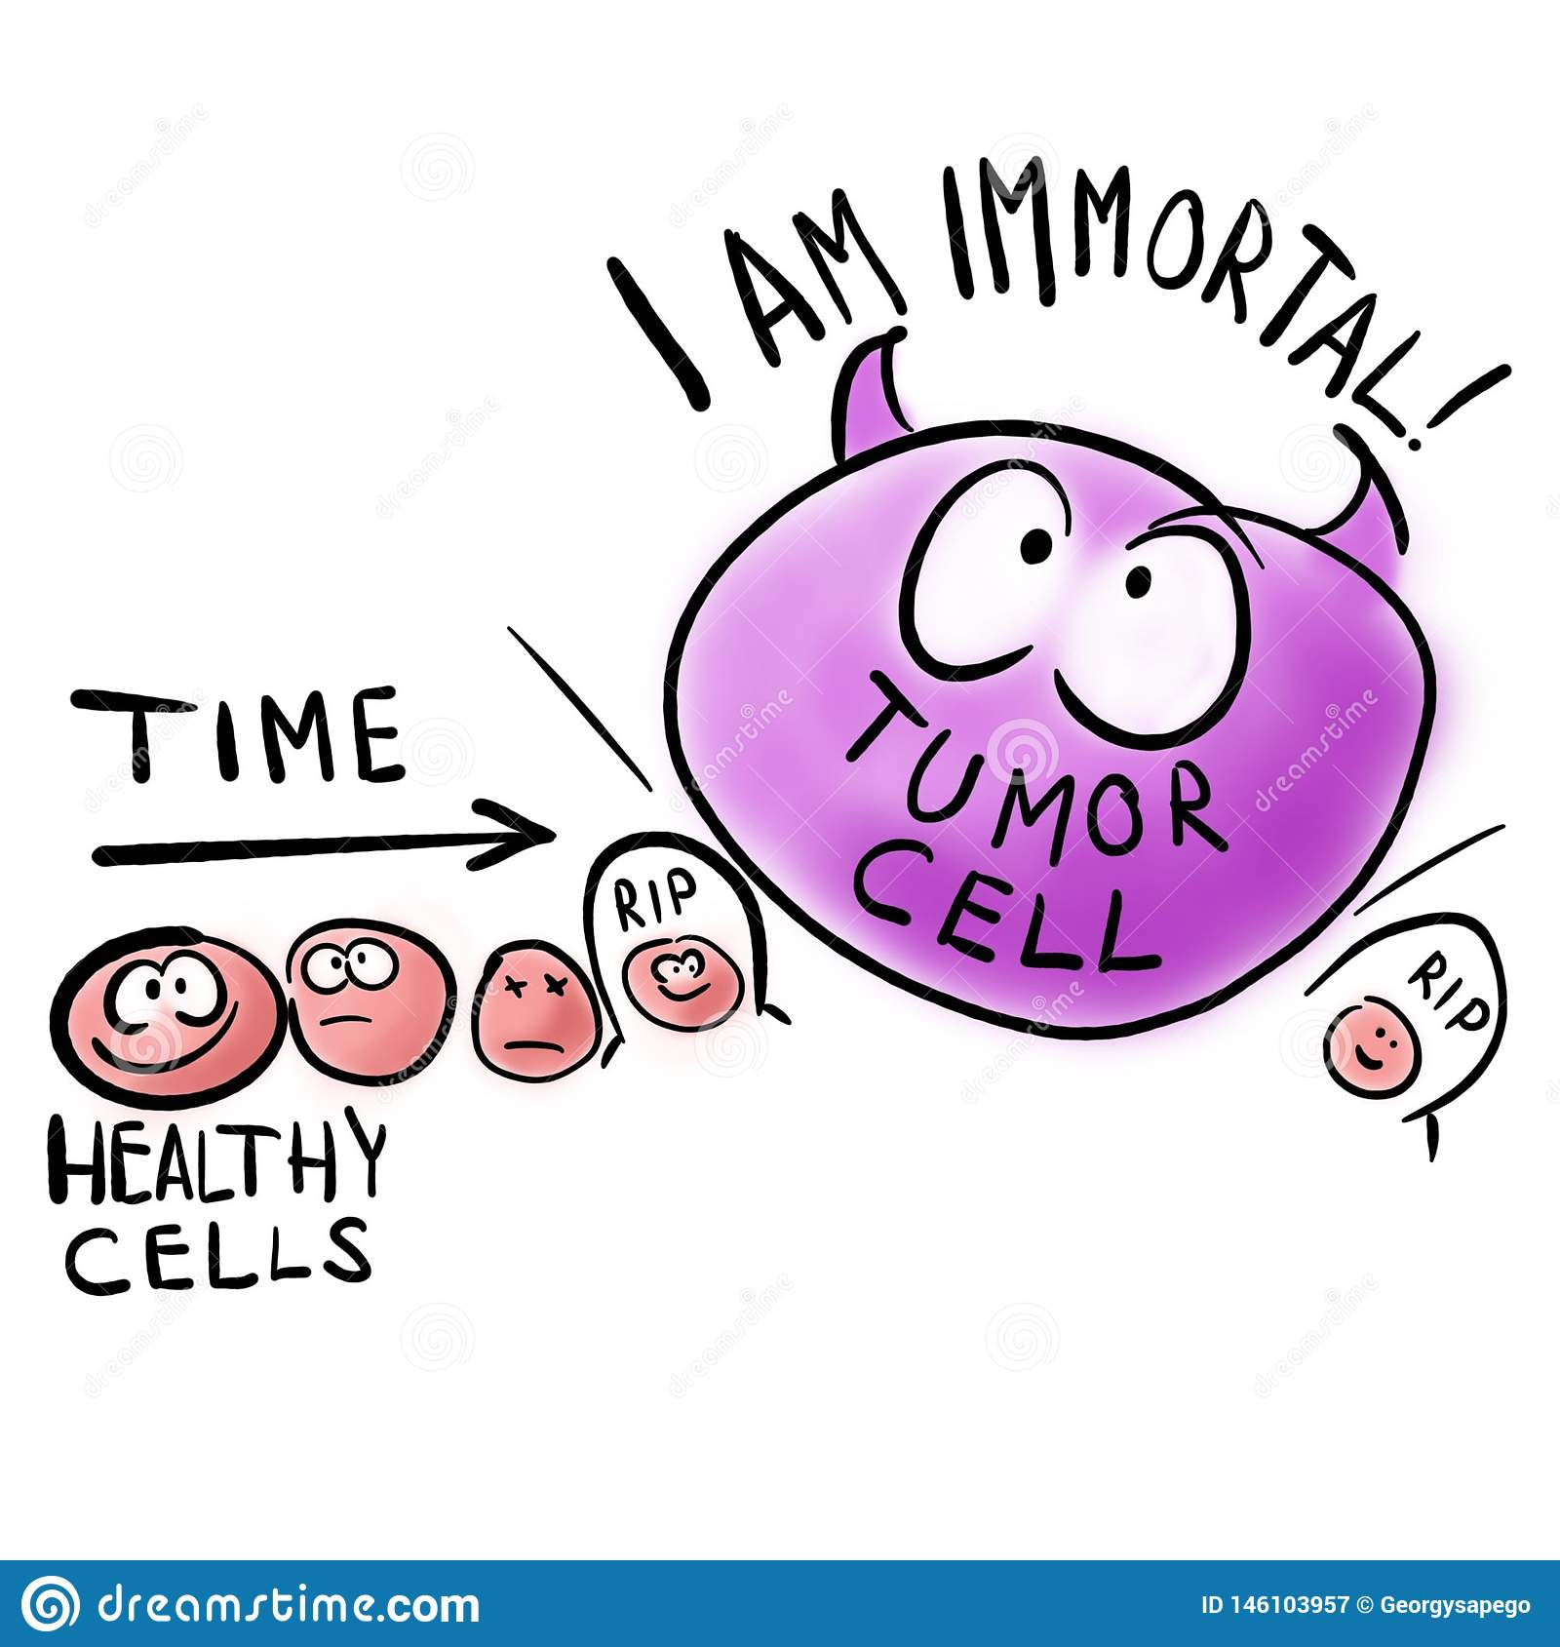

What do tumor suppressor genes make?

What happens if a tumor suppressor gene is mutated?

Explain what p53 does and how a mutated p53 gene can lead to cancer. (use the back if you need to)

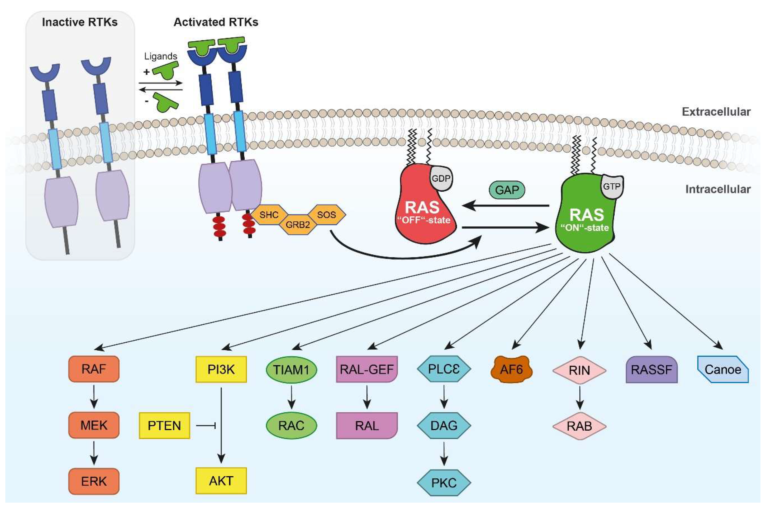

What do proto-oncogenes make?

What do we call a proto-oncogene when it is mutated?

What happens if a proto-oncogene is mutated?

Explain what RAS does and how a mutated RAS gene can lead to cancer.