Cells: Types, Endosymbiosis, Size
_____________________ ______________________
Identify and label the eukaryote cell and the prokaryote cell.

Name 2 types of eukaryote cells.

How do prokaryotes and eukaryotes differ?

What do prokaryotes and eukaryotes have in common? (CCDR)
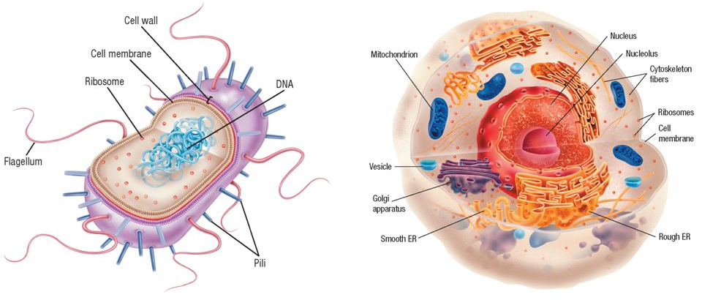

Endosymbiosis
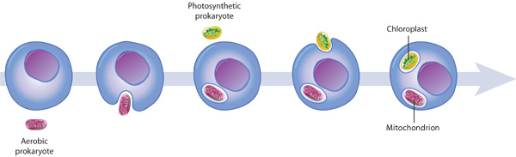
Define Endosymbiont theory-

Which 2 organelles provide the best evidence for endosymbiosis?

Explain how each of the following provide evidence for the endosymbiont theory:
Double membrane-

Size-

DNA-

Ribosomes-

Divide independently-

Enzymes-

Antibiotics-

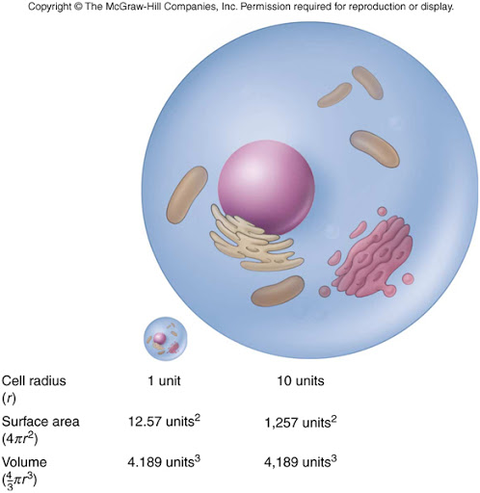
Cell Size
Which is the best size for a cell? Why?

Which is most efficient at transporting materials across its cell membrane? Why?

Calculate surface area to volume ratios for each cell.
B

A

Which cell exchanges materials the fastest? Why?

Which cell is least efficient? Why?

Cell | Surface area | Volume | Surface area to volume ratio
A | 24 | 8 | 3
B | 96 | 64 | 1.5
C | 6 | 1 | 6
D | 54 | 27 | 2

How do the folds of the inner mitochondrial membrane increase efficiency of cellular respiration?

How do the microvilli projections on intestine cells help improve efficiency of nutrient absorption?
