Prokaryotes and Eukaryotes
Name: __________________
Period: ________ Seat: _____

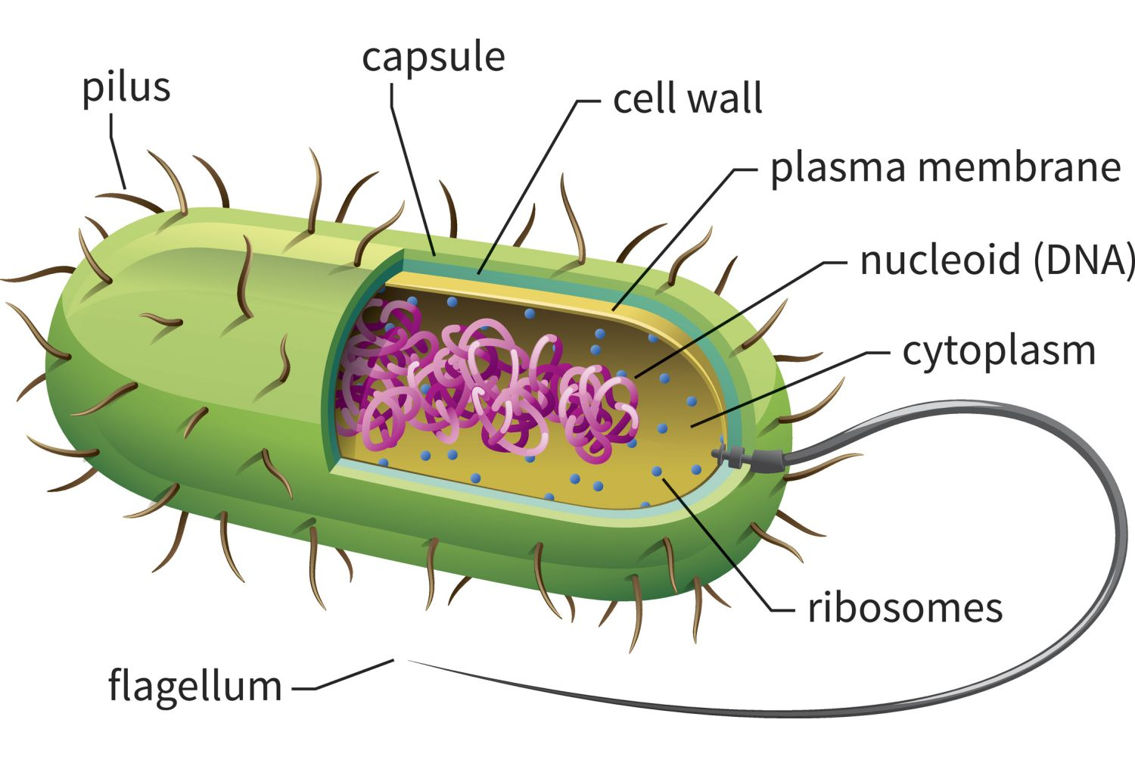
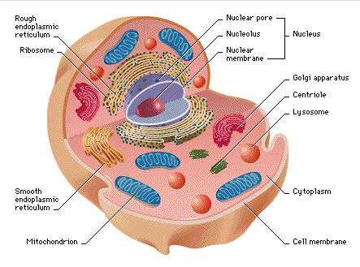

DNA

Nucleus

Size: 0.1-10 µm
Mitochondria
Size: 10-100 µm

Fill in the Venn diagram to identify the similarities and differences of the two cells above:

PCDR

