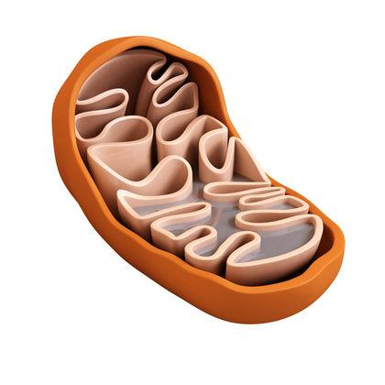Cellular Respiration Visual Review

What organelle is this?

What is unique about this organelle?

Use the image to identify the: outer membrane, *inner membrane, mitochondrial matrix, intermembrane space, mitochondrial matrix.

*Why are the mitochondrial matrix, the inner membrane and the inter membrane space so important?

Using the image, identify each of the 4 stages.

What are the classic 3 stages?

Identify which stages produce ATP.

Identify the stages that produce electron carriers. Which electron carriers?

Glycolysis, Pyruvate Oxidation, Krebs make NADH

Krebs Cycle makes FADH2

Identify the stages that produce carbon dioxide.

Identify the stage that produces water.

Which stage can occur under anaerobic conditions?

Cellular Respiration Summary

Approximately how many ATP do you get from one glucose?

1 glucose ______________

Why is ATP used instead of glucose?

What is ATP used for?

During which of the 4 stages is ATP made?

*Which stage makes the most ATP?

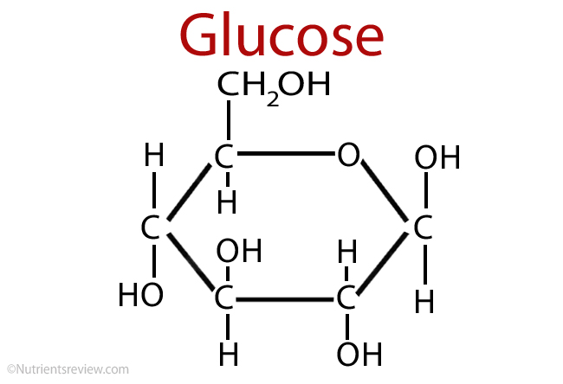

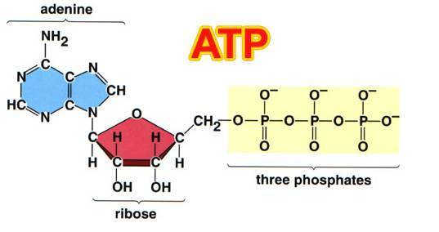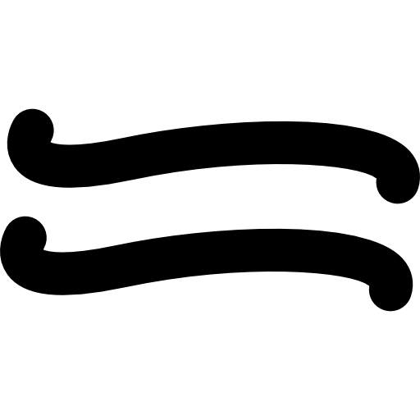

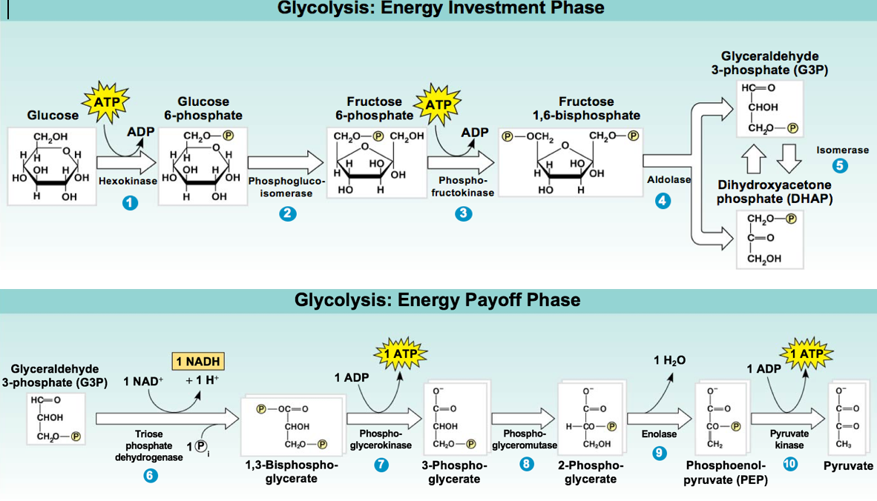

What is the purpose of glycolysis?

Explain what happens during glycolysis.

Where does it happen? How is this location different from stages 2-4?

What is made during and at the end of glycolysis? How many ATP total vs. net? Why?

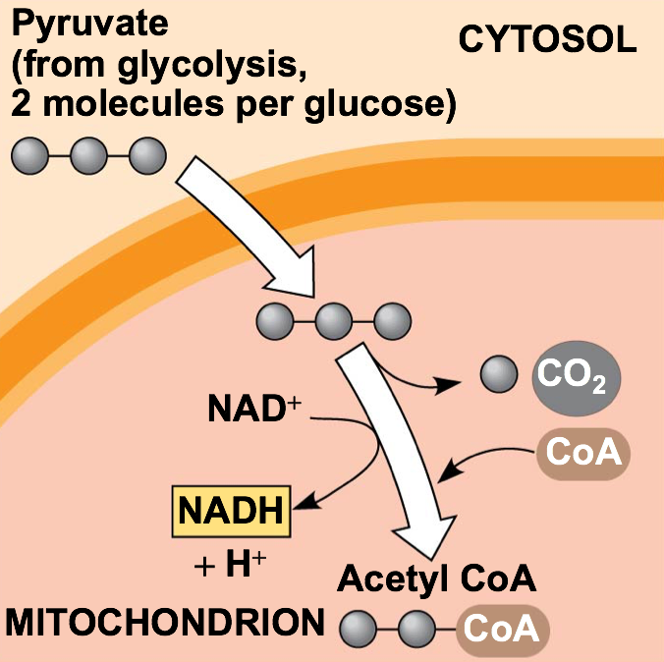

What is the purpose of pyruvate oxidation?

Which enzyme is used?

Explain what happens during pyruvate oxidation.

Where does it happen?

What is made during and at the end of pyruvate oxidation?

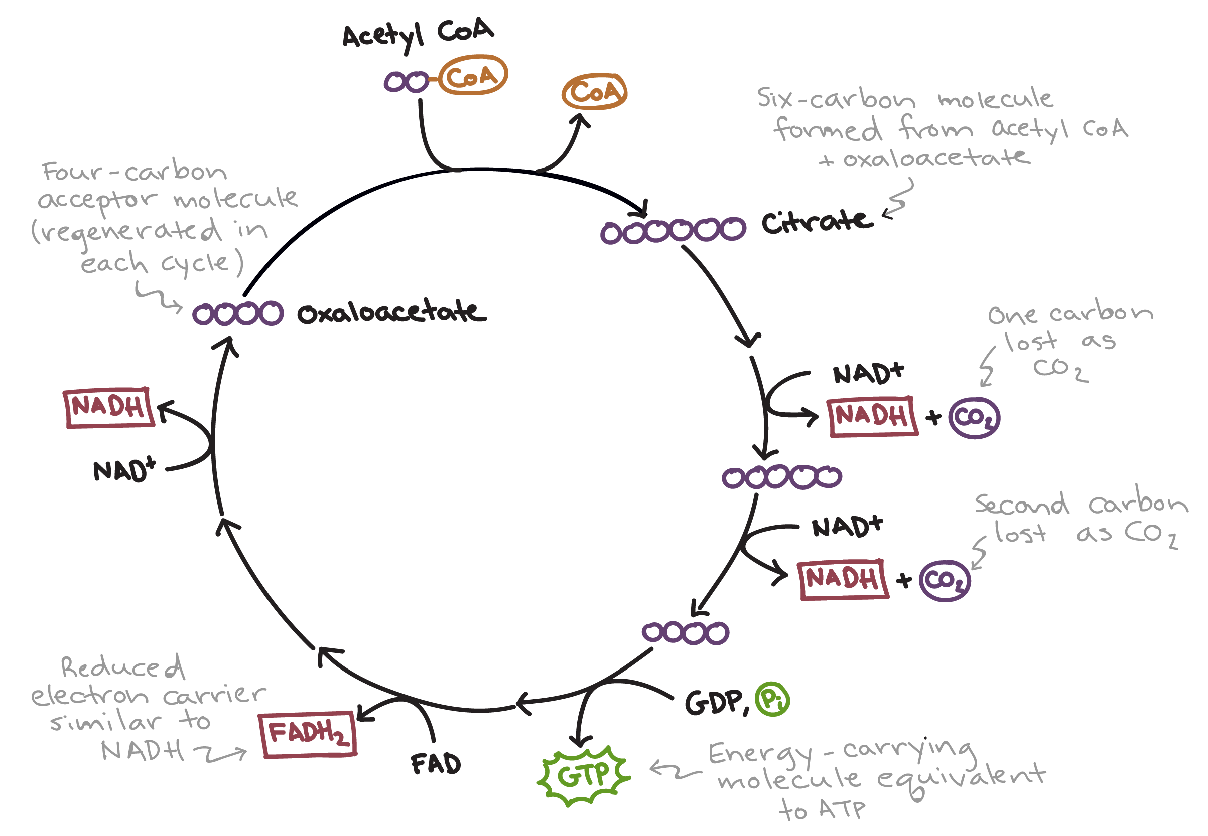

What is the purpose of Krebs Cycle?

What is another name for the Krebs cycle?

Explain what happens during the Krebs Cycle.

Where does it happen?

What is made during and at the end of Krebs Cycle?

What is the purpose of oxidative phosphorylation? What is made at the end?

What are the two steps of oxidative phosphorylation?

In what parts of the mitochondria do these two processes happen?

Explain what happens during the electron transport chain. What happens if O2 is not waiting at the end of the ETC?

*What is the overall purpose of the electron transport chain?

*Where does the energy come from to move/pump protons (H+) across the inner membrane from low to high concentration??

Oxidative Phosphorylation Continued

What is the purpose of Oxidative phosphorylation?

Explain what happens during the electron transport chain. What happens if O2 is not waiting at the end of the ETC?

Explain what happens during chemiosmosis.

Where does these two processes happen?

What is made during and at the end of oxidative phosphorylation?

What is the purpose of chemiosmosis?

Explain what happens during chemiosmosis.

Why is it important the ETC creates the proton (H+ ion) gradient first?

What is made during and at the end of oxidative phosphorylation?

Fill in the comparison diagram above using the blue boxed information.

What is the purpose of fermentation? Which stage of cellular respiration is involved in fermentation?

*Under what conditions does fermentation occur?