Main Ideas Title: Chromosome Basics

Why Human DNA contains _____________________________________
Chromosomes? The DNA inside one of your cells is ___________________________ long

How does it all DNA is wrapped up very tightly into structures we call ____________________
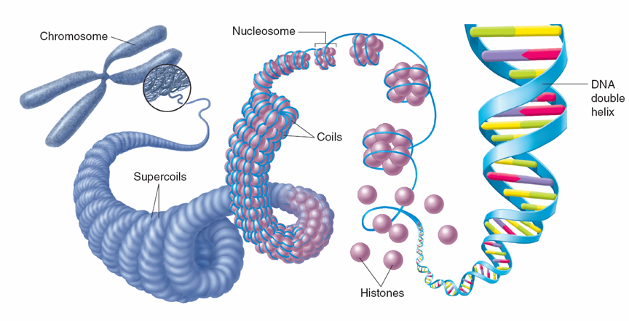
fit then?

How does DNA An entire DNA molecule all wrapped up is called a chromosome.
get wrapped into A chromosome is built out of ____________________:
chromosomes? ________________________________________
DNA + histone proteins = chromatin
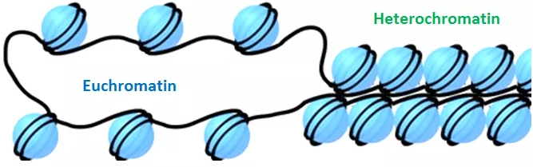
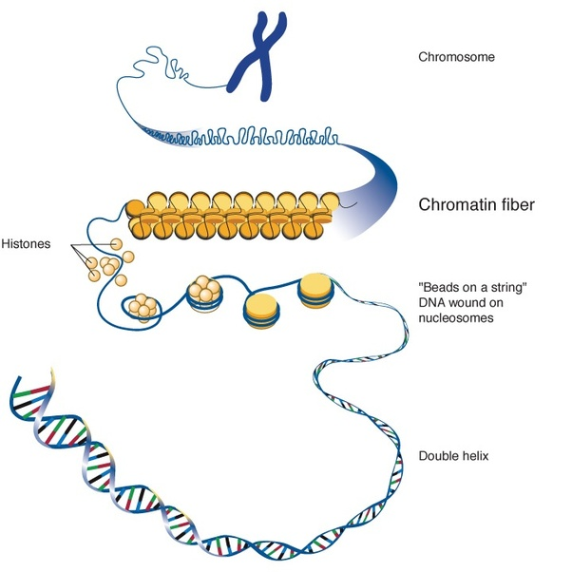
Levels of
organization and
coiling

Prokaryotes vs. Eukaryotes
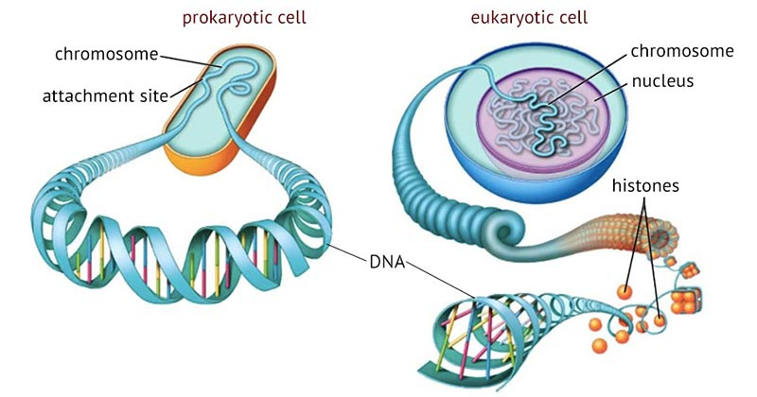

Summary

