Chromosomes and Meiosis

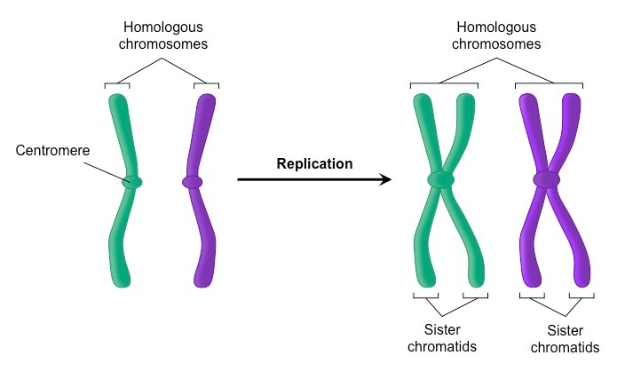

(Yes these are repeats from cell cycle and mitosis review)

What is a chromosome made of?

What is the function/purpose of chromosomes? (name at least 3)

How can you tell if a chromosome has been copied?

What is a homologous pair?

What are sister chromatids?

What is the difference between homologous pairs and sister chromatids?

How can you tell the difference between a haploid cell and a diploid cell?

Using n, how would you write the chromosome numbers for each? Haploid: n= Diploid: 2n=

A haploid cell can also be called _____________ and _____________

A diploid cell can also be called _____________ and _____________

Which process helps create 2 identical diploid cells? _____________

Which process helps create 4 unidentical haploid cells? ____________

Have either of these cells gone through S phase? How can you tell?

How many chromosomes do humans have in their gametes? ____

How many chromosomes do humans have in their somatic cells? ____

Why do chromosomes in the sperm and egg have to match?

Diploid

Haploid

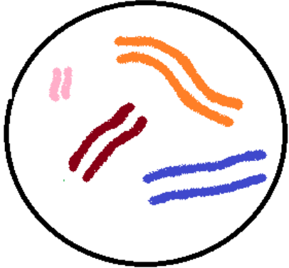

What is the difference between euchromatin and heterochromatin as far as:

Condensation-

Gene Expression-

Number of genes-

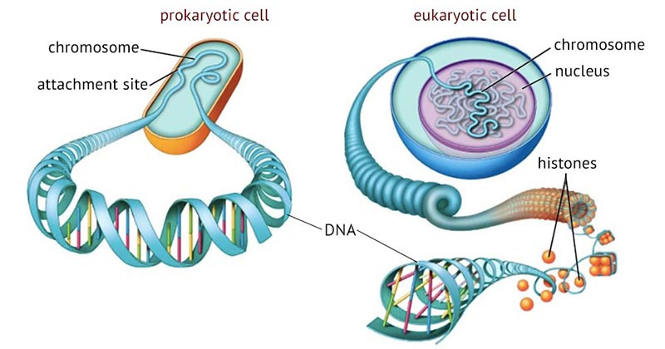

Prokaryote vs. Eukaryote Chromosomes

Prokaryote Eukaryote

Location found:

Shape:

Histone proteins Present?:

Number of chromosomes:

Plasmids used?:

Amount of genes:

Telophase II

Anaphase II

Metaphase II

Prophase II

Telophase I

Anaphase I

Metaphase I

Prophase I

What is the purpose of meiosis?

Move chromosomes around to ensure reduction of chromosome number (cut the number in half) and rearrangement of

genetic information (crossing over and law of independent assortment)

What happens during interphase before meiosis?

Which 4 phase are most important? Why?

What types of cells are made at the end? Identical/Unidentical? Diploid/Haploid? Gamete/Somatic Cell?

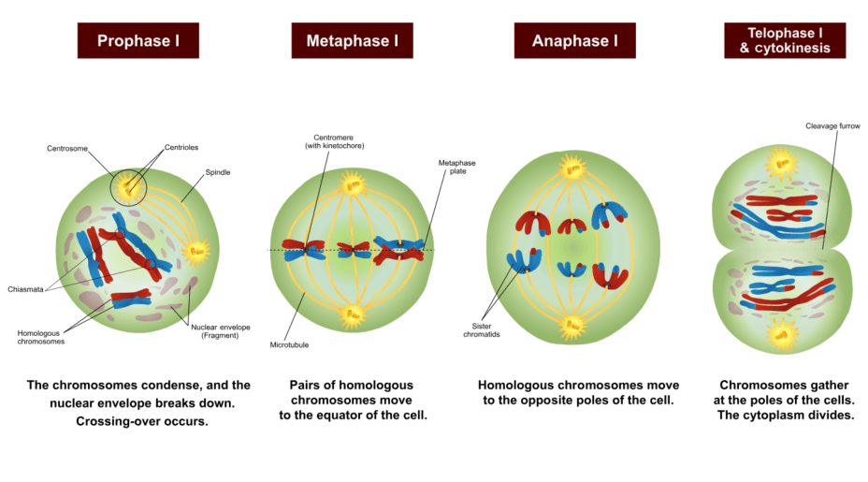

What is the purpose of meiosis I?

During which phase do homologous pairs form tetrads for synapsis and crossing over to occur?

What is the law of segregation?

What is the law of independent assortment?

Why are metaphase I and anaphase I so important?

How many cells are made at the end? ____

Telophase I

Anaphase I

Metaphase I

Prophase I

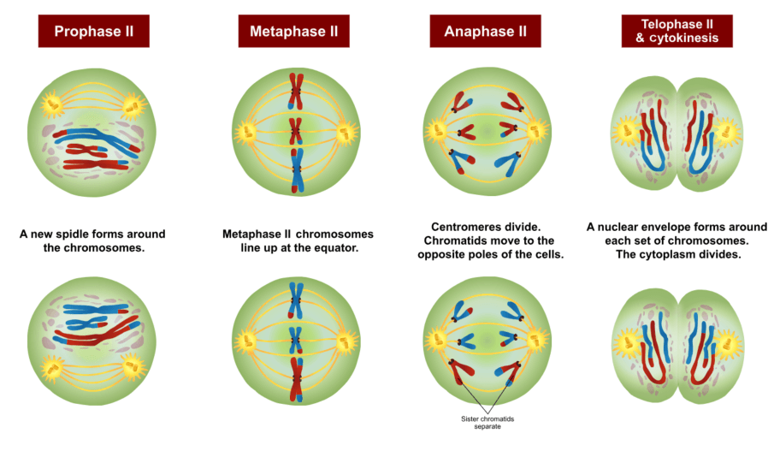

What happens during each phase?

Prophase I- *Anaphase I-

*Metaphase I- Telophase I-

What is the purpose of meiosis II?

How is it different from what goes on in meiosis I?

Why are metaphase II and anaphase II so important?

How many cells will be made at the end? ______

What happens during each phase?

Prophase II- *Anaphase II-

*Metaphase II- Telophase II-

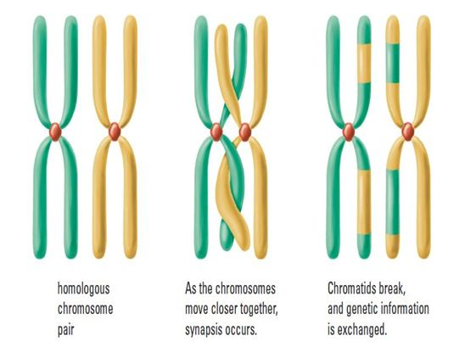

What happens during crossing over?

How does it create genetic variation?

Why would you not want this to happen during ***mitosis***?

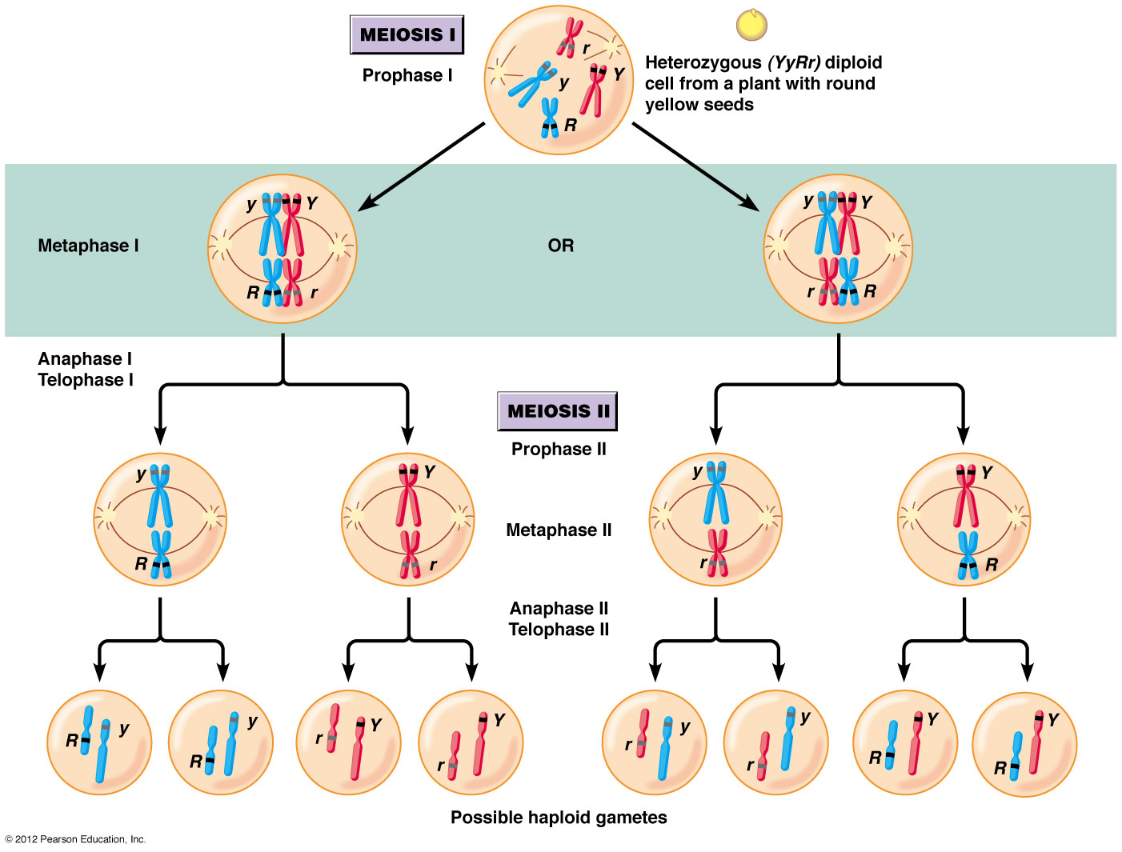

Does independent assortment happen during meiosis I or II?

During which phase?

What happens during independent assortment?

How does it create genetic variation?

***\*\*\*Independent assortment does not happen during meiosis II***

**OR**

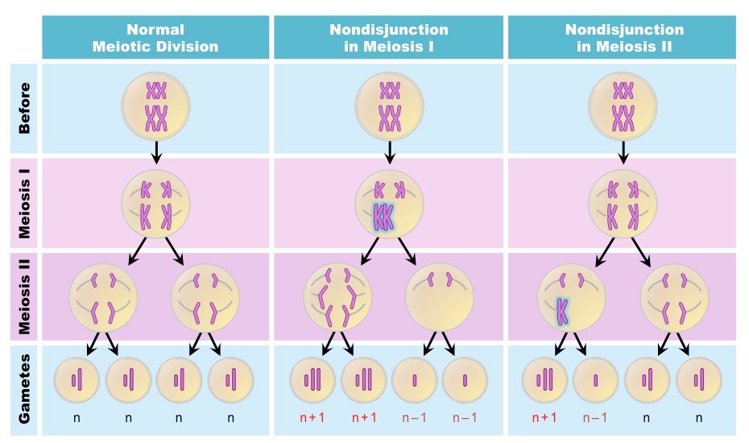

What is nondisjunction?

During which phase of meiosis I and meiosis II can it occur?

What types of disorders can this cause?

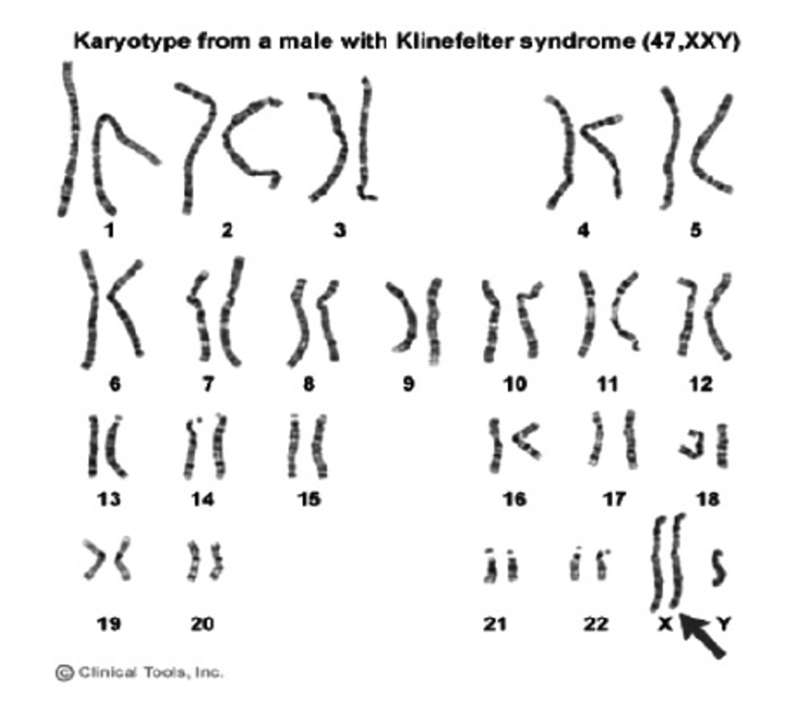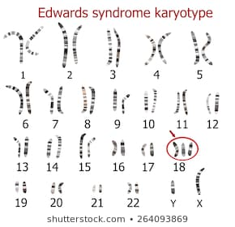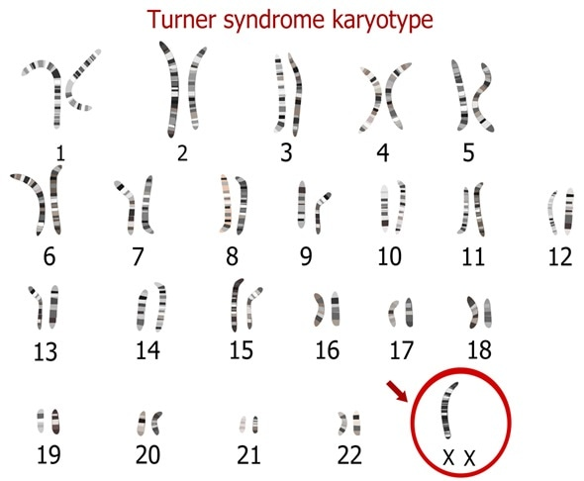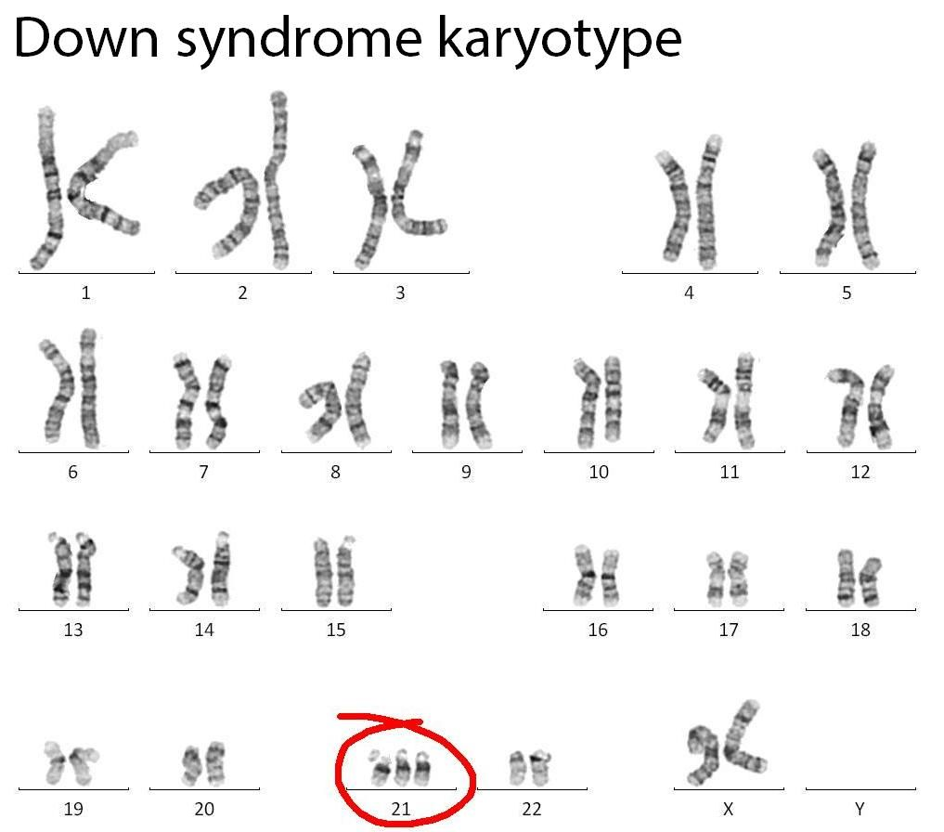

Girl

Girl

Boy

Pictures off all 46 chromosomes in order from longest to shortest with sex chromosomes last are called _________

How do we know these 4 people had a parent that had nondisjunction occur during meiosis?

Are these gene or chromosome disorders? Explain.

How many autosomes do humans have in a diploid cell? _____ How many sex chromosomes in a diploid cell? ____

How many autosomes do humans have in a haploid cell? _____ How many sex chromosomes in a haploid cell? ____

What 2 sex chromosomes does a female have? ______ What 2 sex chromosomes does a male have? ______

Boy

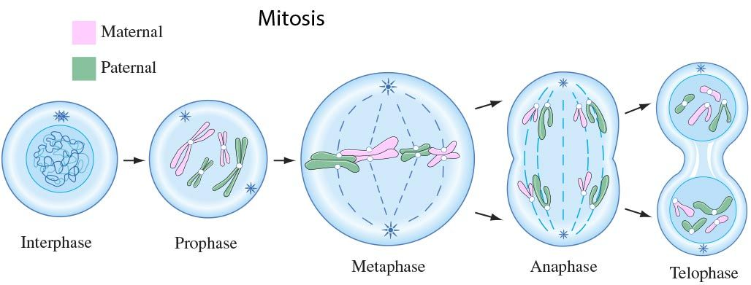

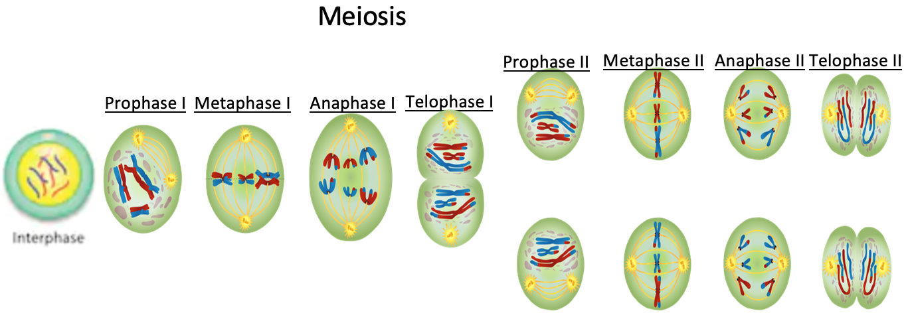

In what ways are mitosis and meiosis similar?

Mitosis Vs. Meiosis (mostly differences)

Mitosis Meiosis

Purpose:

Interphase?: ___________ ____________

Chromosome Numbers: 2n🡪2n 2n🡪n

Ploidy: ____________ Haploid

Number of daughter cells made: 2 _____________

Number of divisions: ____________ 2

Genetic Results: Identical _____________

Crossing over? : ____________ Yes

Independent assortment?: No _____________

Homologous chromosomes ____________ Yes in metaphase I, no in meiosis II

pair in metaphase?

Synapsis: No _____________

Sister Chromatid Separation: ____________ No in meiosis I, yes in meiosis II