4 Stages Mini-Project

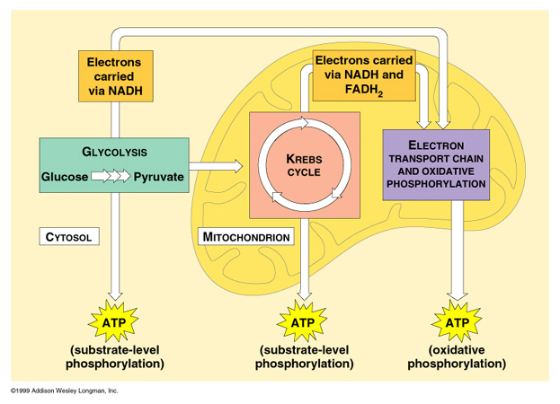
Show what you know about the 4 stages of cellular respiration. Summarize each stage with a visual and 20 words or less. You can create a mini poster, painting, PowerPoint, Prezi, YouTube video, story book, 3D model, web based app or anything else you can think of that is school appropriate. The point is to review each stage and identify the most important information for each. You will be graded on effort, creativity and accuracy of information. (100 pts)
Pyruvate Oxidation

