Energy and Calculating Energy Transferred
Name: ____________________
Period: _______ Seat: ________

Directions: Use the animals for each section to answer the questions
Deer Draw a food chain.  Wolf  Grass | - How many trophic levels in this food chain?__________________  - What is the producer in this food chain? ____________________  - What organism is at the second trophic level? _________________  - Place your food chain into the pyramid on the right.  - If the producers start off with 450, 000 calories calculate how much  energy the other levels will receive.  Label the pyramid with the energy available.
Killer Whale  Phytoplankton (tiny plants)  Big fish  Small fish  Zooplankton (tiny animals)  Draw a food chain | - How many trophic levels in this food chain?__________________  - What is the producer in this food chain? ____________________  - What organism is at the fourth trophic level? _________________  - Place your food chain into the pyramid on the right.  - If the producers start off with 370, 000 J (joules) calculate how much  energy the other levels will receive.  Label the pyramid with the energy available
Human Draw a food chain.  Grass  Cow | - How many trophic levels in this food chain?__________________  - What is the producer in this food chain? ____________________  - What organism is at the third trophic level? _________________  - Place your food chain into the pyramid on the right.  - If the producers start off with 850, 000 calories calculate how much  energy the other levels will receive.  Label the pyramid with the energy available.
Caterpillar Draw a food chain  Leaves  Frog  Snake | - How many trophic levels in this food chain?__________________  - What is the producer in this food chain? ____________________  - What organism is at the second trophic level? _________________  - Place your food chain into the pyramid on the right.  - If the producers start off with 550, 000 J (joules) calculate how much  energy the other levels will receive.  Label the pyramid with the energy available.

Ecology Pyramids

1. Type of Pyramid: Energy Pyramid (see board)
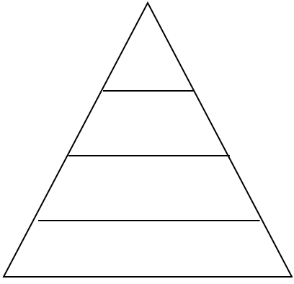

330,000 J

What information does this type of pyramid show us?

What does this tell us about energy in an ecosystem?

2. Type of Pyramid: Biomass Pyramid (see board)

150,000 kg

What information does this type of pyramid show us?

What does this tell us about matter in an ecosystem?

3. Type of Pyramid: Numbers Pyramid (see board)

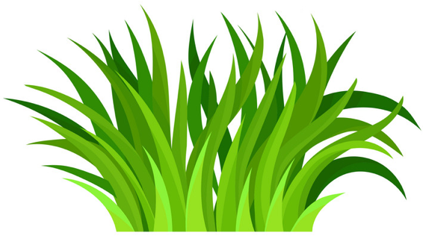

What information does this type of pyramid show us?

What does this tell us about matter in an ecosystem?

Think-Think-Think Questions:
1. Why is a pyramid a useful shape for representing our information?

2. Take a look at your numbers pyramid and then take a look at your energy pyramid. Why do you think the number of organisms in each trophic level decreases as you get closer to the top of the pyramid.

