Ecology Levels of Organization Drawing
1. Must have the title of your biome some where on the paper (same one as you chose for your biome project)
2. Must draw a picture for each level using ANIMALS AND PLANTS FROM YOUR BIOME
3. Each level should be named and have a definition
4. For the biome picture, use page 417 in your book. Choose 1 continent where your biome is found. Draw that continent and shade in the area where your biome is found.

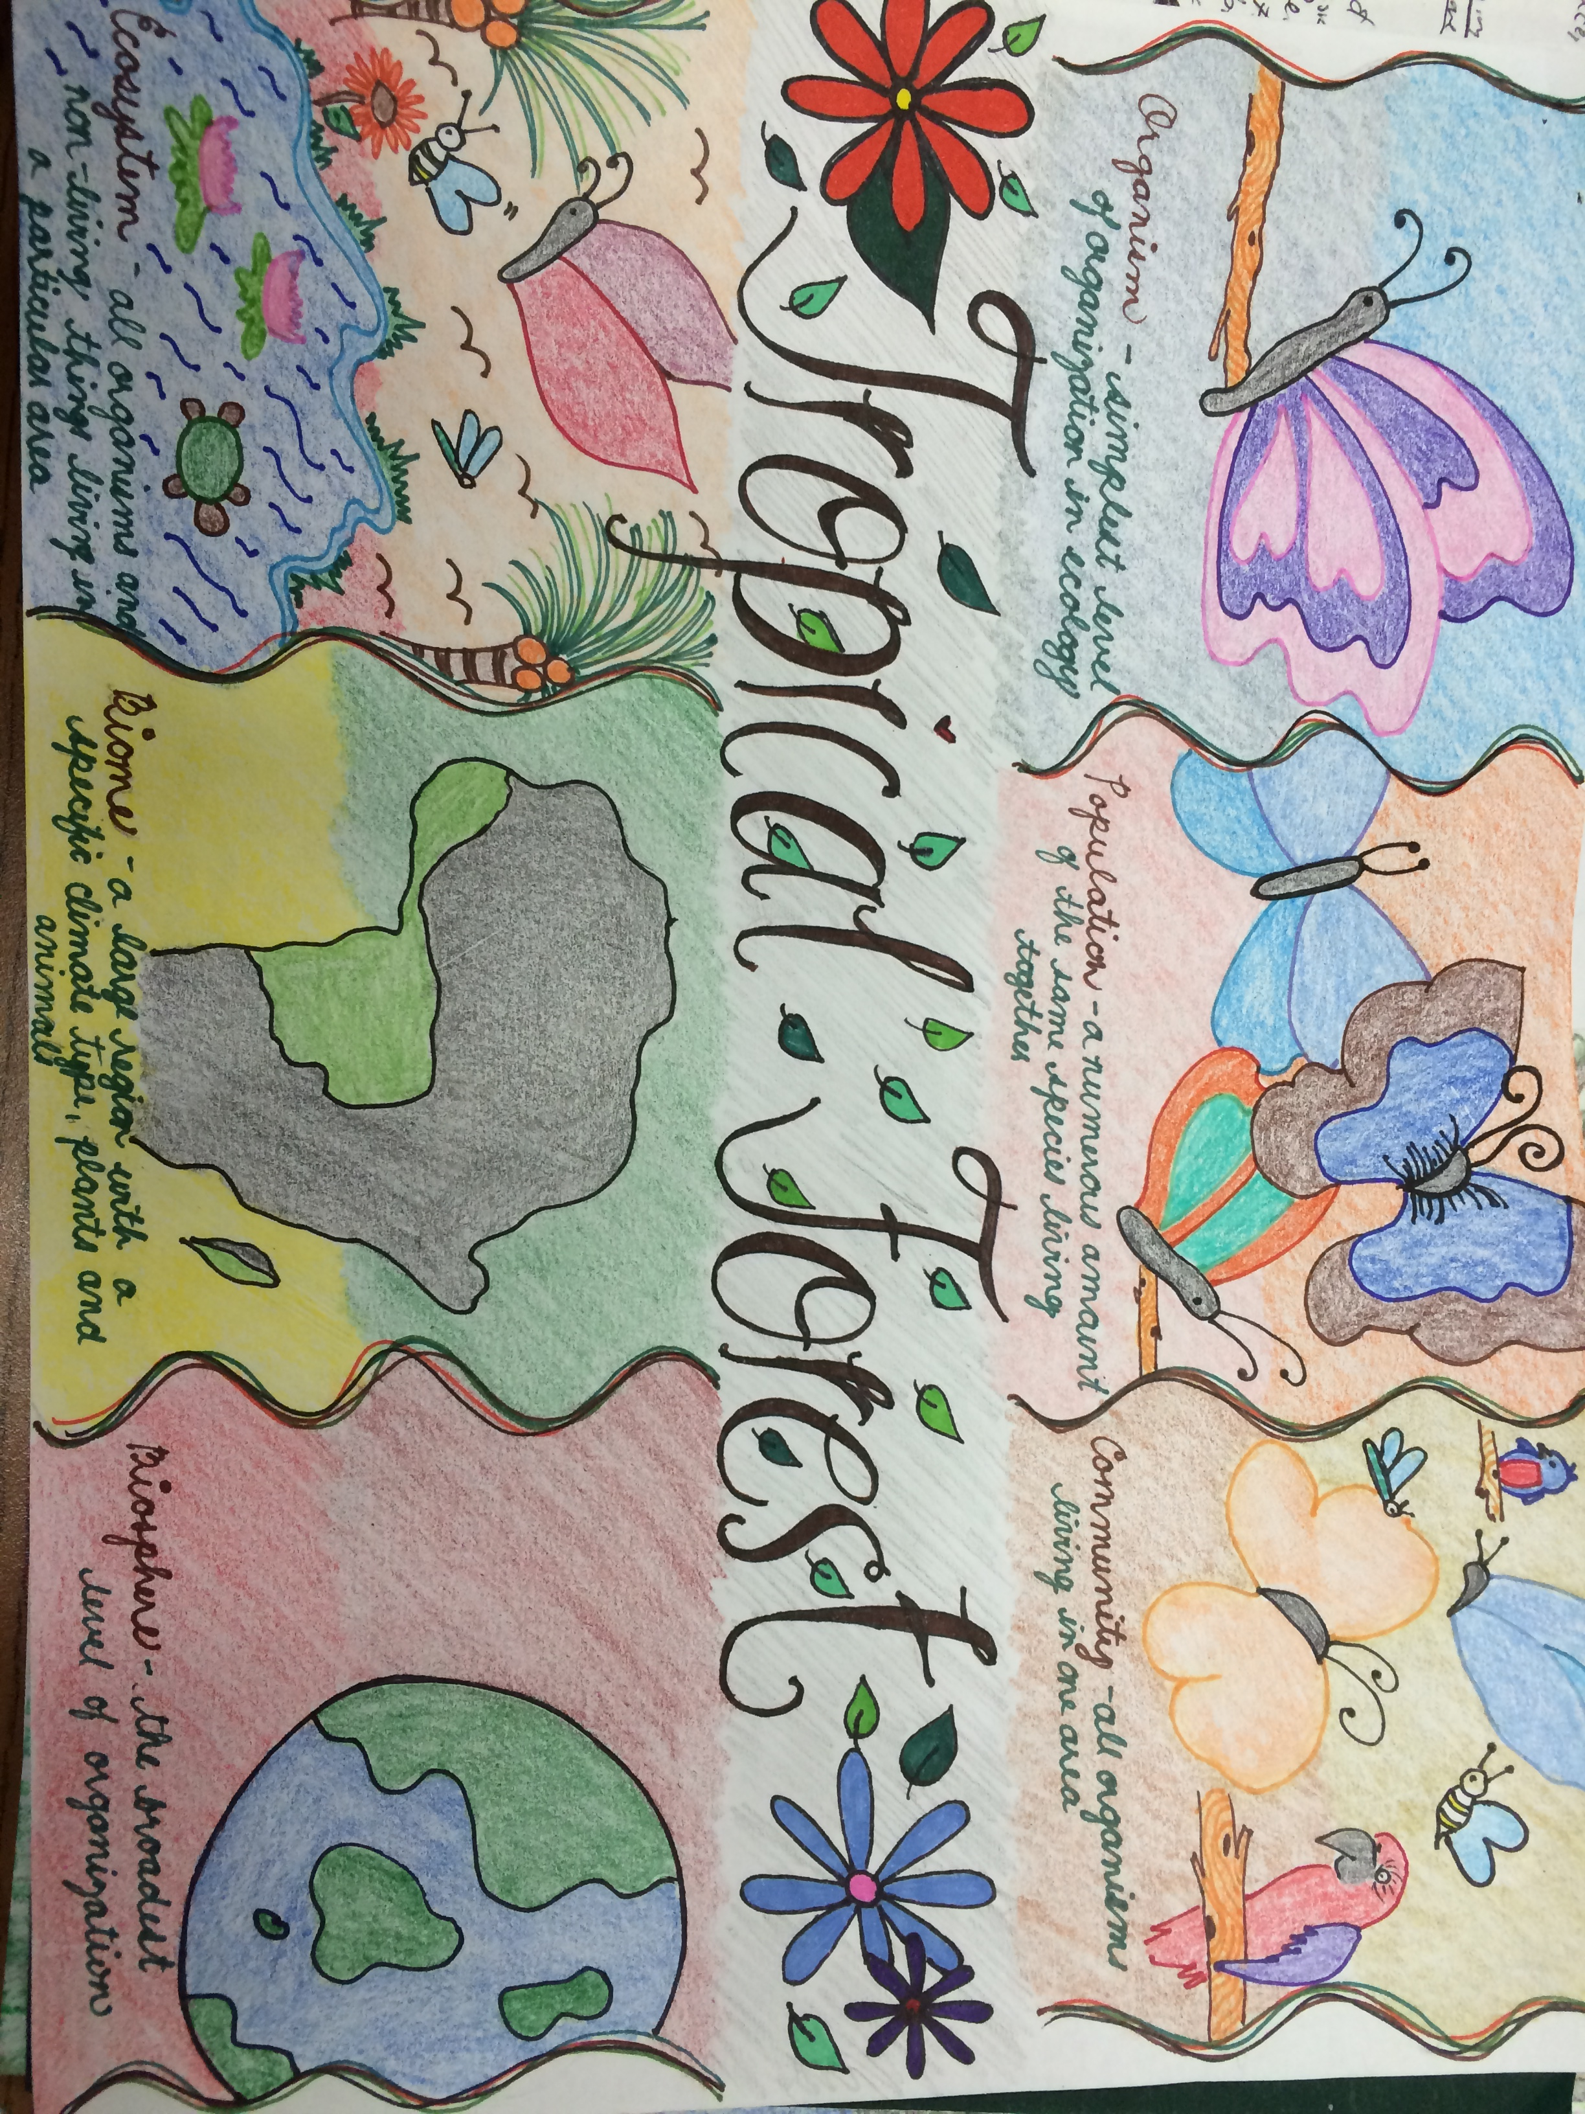5. MUST BE COLORED!!!
Picture

Biome Title
Level names and definitions

