Ecological Succession
Ecological Succession- ______________________________________________________________________
__________________________________________________________________________________________
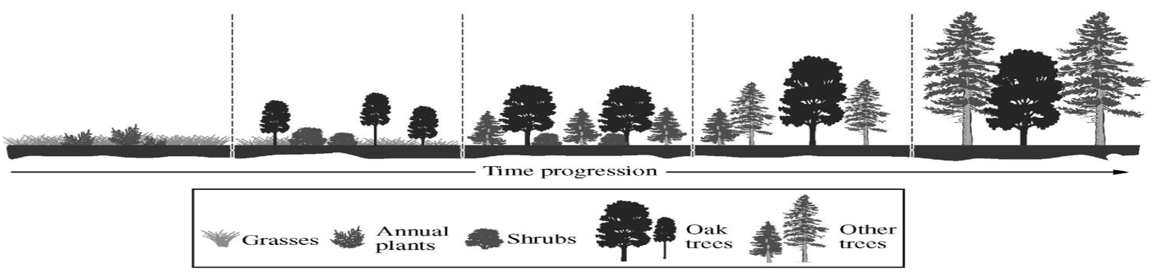

1. Primary Succession-______________________________________________________________________
__________________________________________________________________________________________

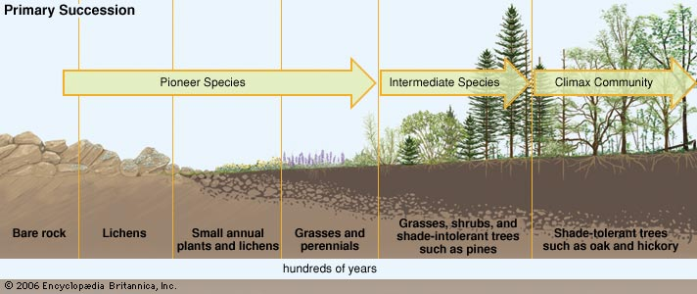

2. Secondary Succession- _____________________________________________________________________
__________________________________________________________________________________________
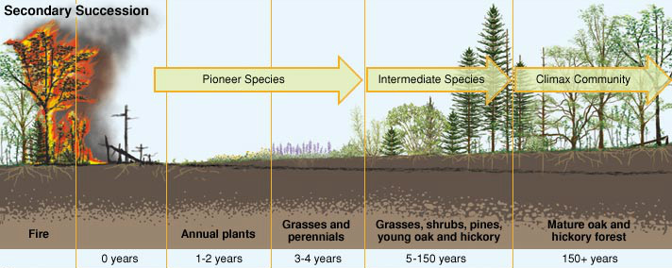

2a. Abandoned Field Succession
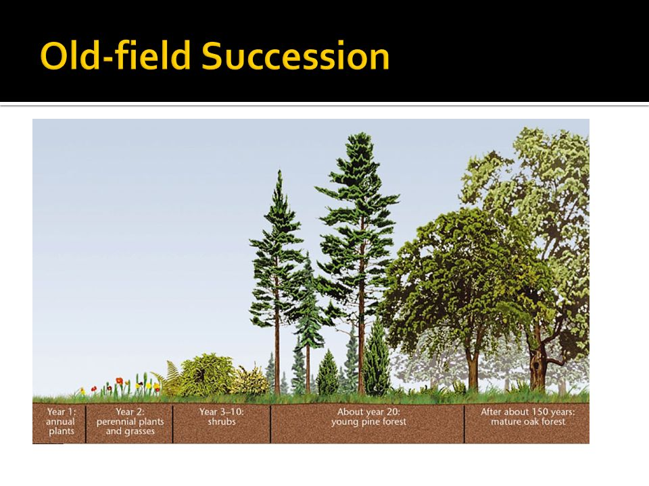

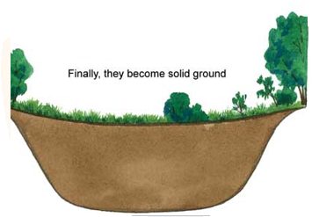
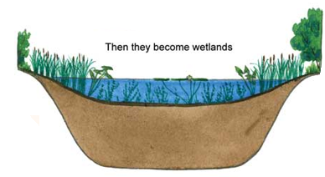
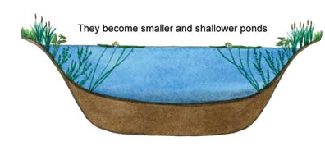
2b. Pond/Lake Succession
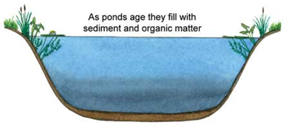

Changes that occur
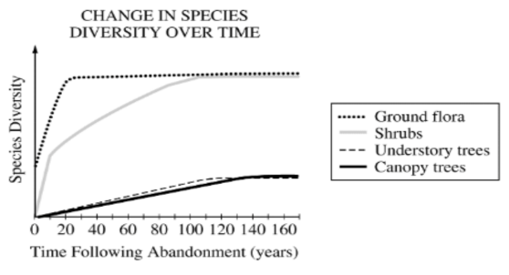

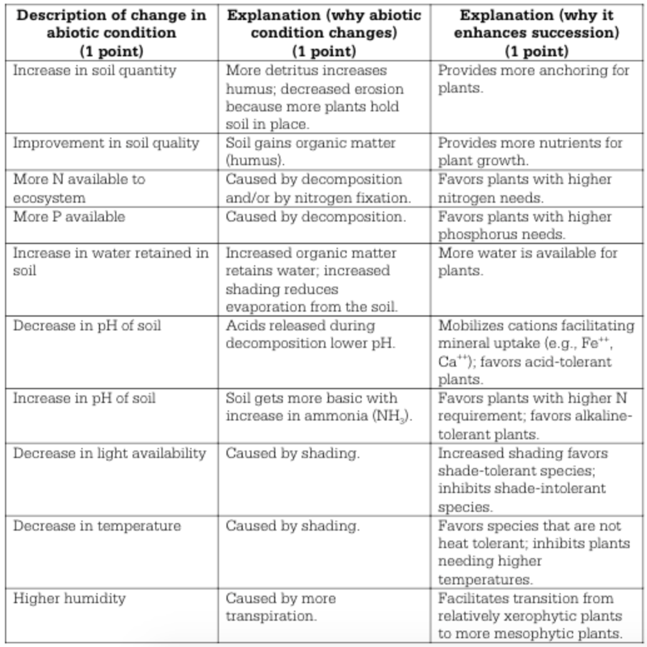
Abiotic changes that lead to succession Biotic and Abiotic factors that influence pattern of ecologic succession

