The Endocrine System
Your nervous system works much like a telephone system: Many impulses move swiftly over a system of wire-like neurons that carry specific messages from one cell to another towards one specific location. Its function is to control and coordinate the other body systems and maintain homeostasis. Another system, the endocrine system, works with the nervous system to regulate the other body systems and maintain homeostasis. However, it does what the nervous system generally cannot do. The endocrine system is made up of glands that release their products into the bloodstream. These products deliver messages throughout the entire body. In the same way that a tweet or Instagram post can reach thousands or even millions of people around the world, the chemicals released by the endocrine system can affect millions or trillions of cells in the body at the same time.
The chemicals that broadcast messages from the endocrine system are called hormones. Hormones are chemical messages released in one part of the body that travel through the bloodstream and affect the activities of cells in other parts of the body. Hormones do this by binding to specific protein receptors on the cell membrane, in the cytoplasm, or in the nucleus of a cell. When a hormone binds to a protein receptor, the binding triggers a series of events that lead to temporary changes within the cell. Cells that have receptors for a particular hormone are called target cells. If a cell does not have receptors or the receptors do not respond to a particular hormone, the hormone has no effect on it. Hormones affect only their target cells with the right protein receptors to match the hormones shape.
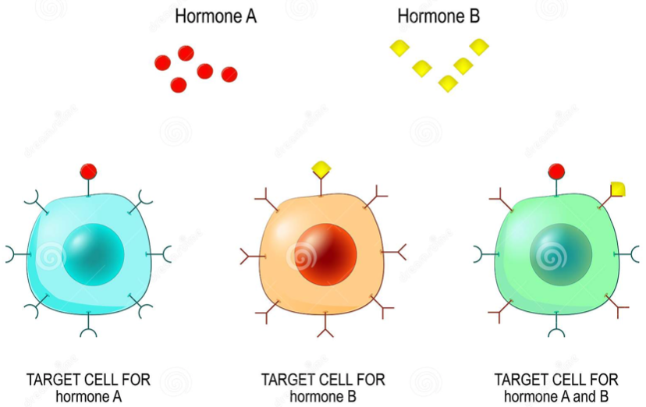
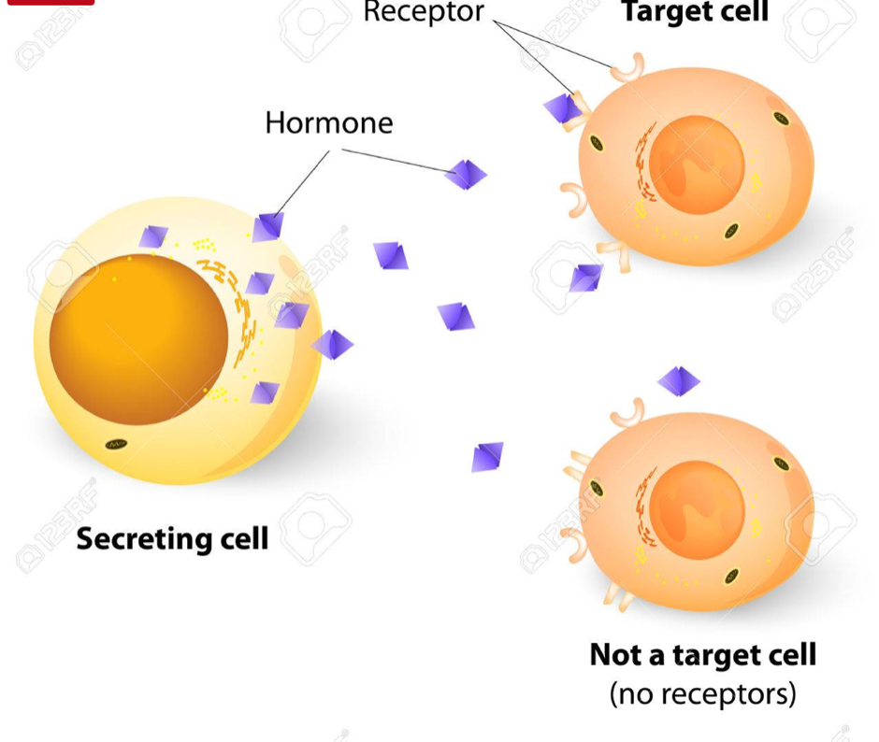

In general, the body’s response to hormones is slower and longer lasting than the response to nerve impulses. It may take several minutes, several hours, or even several days for a hormone to have its full effect on its target cells. A nerve impulse on the other hand, may take only a fraction of a second to reach and affect its target cells.
Hormones may be classified as belonging to two general groups—steroid hormones and amino acid-based hormones. Amino Acid-based: Amino acid-based hormones are made from amino acids and are water soluble. They cannot pass through the lipids of the cell membrane so they bind to protein receptors on the cell membranes surface. This binding activates enzymes on the inside of the cell which then temporarily turn on or off a function within the cell. Steroid: Steroid hormones are produced from a lipid called cholesterol and are fat soluble. Since they are fat soluble, they can diffuse through the cell membrane lipids and enter the cell. In the cell they bind to their receptors in the cytoplasm or nucleus. The new hormone-receptor complex causes the cell to temporarily activate existing enzymes or to initiate the synthesis of new enzymes or proteins. In the latter, the hormone receptor complex binds to the DNA itself and triggers transcription of mRNA, the first step in protein synthesis.
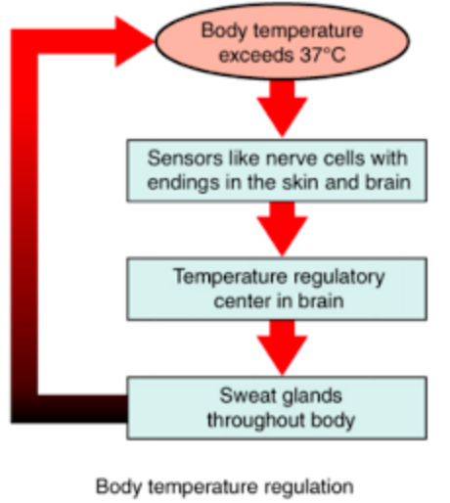
A gland is an organ that produces and releases a substance, or secretion. Exocrine glands release their secretions, through tube-like structures called, ducts, directly to the organs that use them. Exocrine glands include those that release sweat, tears, and digestive juices. Unlike exocrine glands, endocrine glands release their secretions (hormones) directly into the blood stream.
As powerful as hormones are, they must be monitored by the body in order to keep the functions of different organs in balance. Even though the endocrine system is one of the master regulators of the body, it too must be controlled. Like most systems of the body the endocrine system is regulated by feedback mechanisms that function to maintain homeostasis
Feedback inhibition (aka negative feedback) occurs when an increase in any substance “feeds back” to inhibit the process that produced the substance in the first place. Heating and cooling systems in your home controlled by thermostats are examples of mechanical feedback loops. The hormones of the endocrine system are biological examples of the same type of process.

Endocrine Reading Questions
Name:________________________
Period:________ Seat:_________
1. What is the function of the endocrine system?

2. What is the difference between the nervous system and the endocrine system?

3. What is a hormone?

4. How do hormones travel through the body?

5. How does a hormone know which cell to give the message to?

6. Can a hormone affect any cell? Explain.

7. What does a hormone do to its target cell that causes change?

8. Create a T-chart to compare Amino acid-based hormones to steroid hormones.

9. How does the body respond to hormones compared to the nerve impulses of the nervous system?

10. How is the endocrine system regulated (kept in check so it does not go out of control)?

*Examples:

Endocrine Reading Questions
Name:________________________
Period:________ Seat:_________
1. What is the function of the endocrine system?

2. What is the difference between the nervous system and the endocrine system?

3. What is a hormone?

4. How do hormones travel through the body?

5. How does a hormone know which cell to give the message to?

6. Can a hormone affect any cell? Explain.

7. What does a hormone do to its target cell that causes change?

8. Create a T-chart to compare Amino acid-based hormones to steroid hormones.

9. How does the body respond to hormones compared to the nerve impulses of the nervous system?

10. How is the endocrine system regulated (kept in check so it does not go out of control)?

*Examples:

