Energy Basics

How does this image relate to the 1st law of thermodynamics?

What kind of energy do living things use?

What chemical process makes energy from the sun, available to living things?

Which chemical process do organisms use to get energy out of their organic molecules?

How does the 2nd law of thermodynamics apply to chemical reactions?

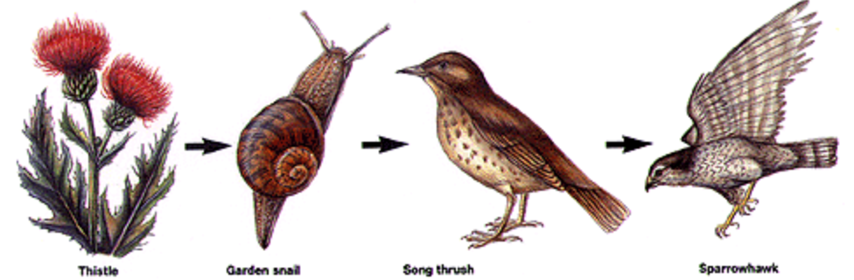

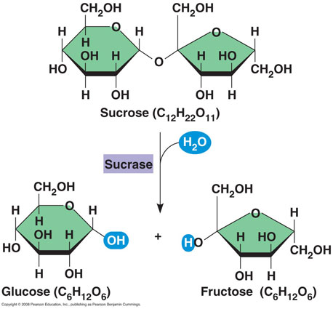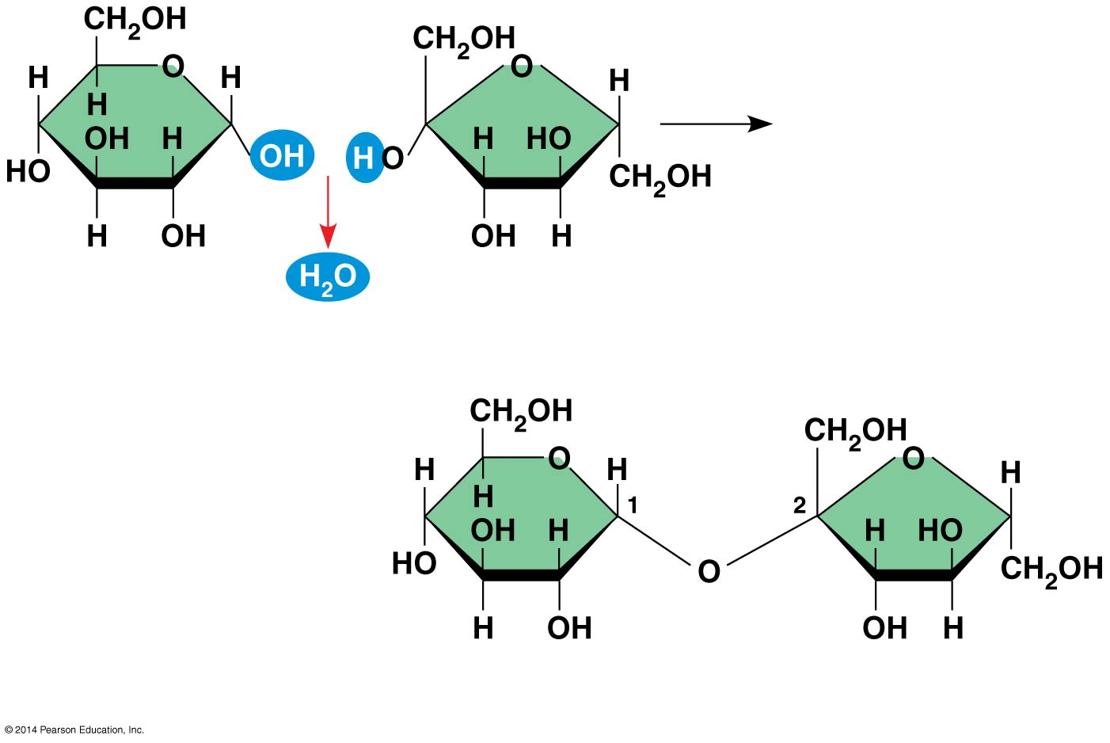

**Metabolism includes both the breakdown (catabolic) and building (anabolic) of molecules.**

Identify which image represents a catabolic reaction and which represents an anabolic reaction.

Explain how dehydration synthesis and hydrolysis fit in to these two types of reactions.

Figure 1 Figure 2

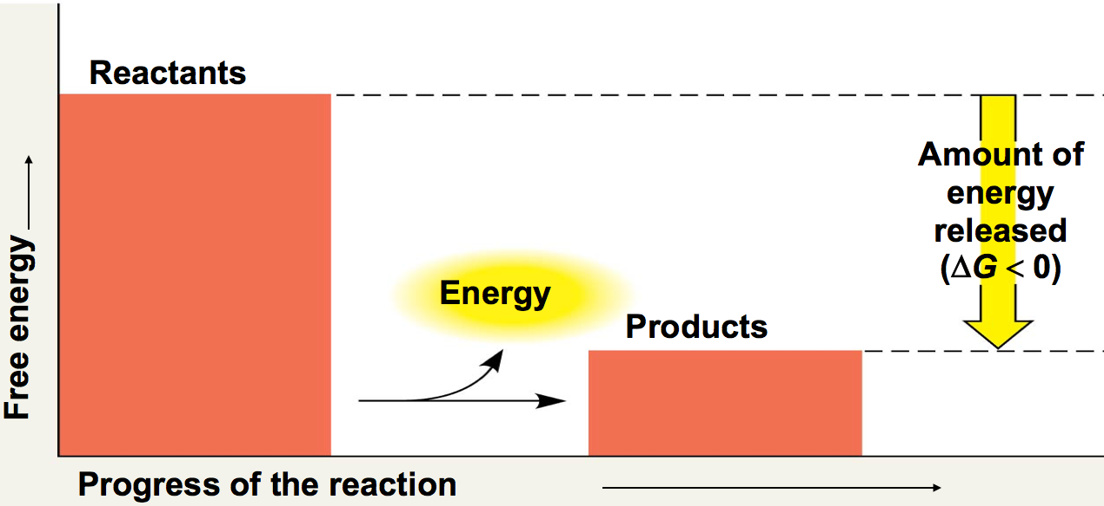

Define exergonic reaction.

Define endergonic reaction.

Does the graph represent an exergonic or endergonic reaction? Explain

***If a ΔG is a NEGATIVE number then energy is being released.***

Would the graph to the left be photosynthesis or cellular respiration? Explain.

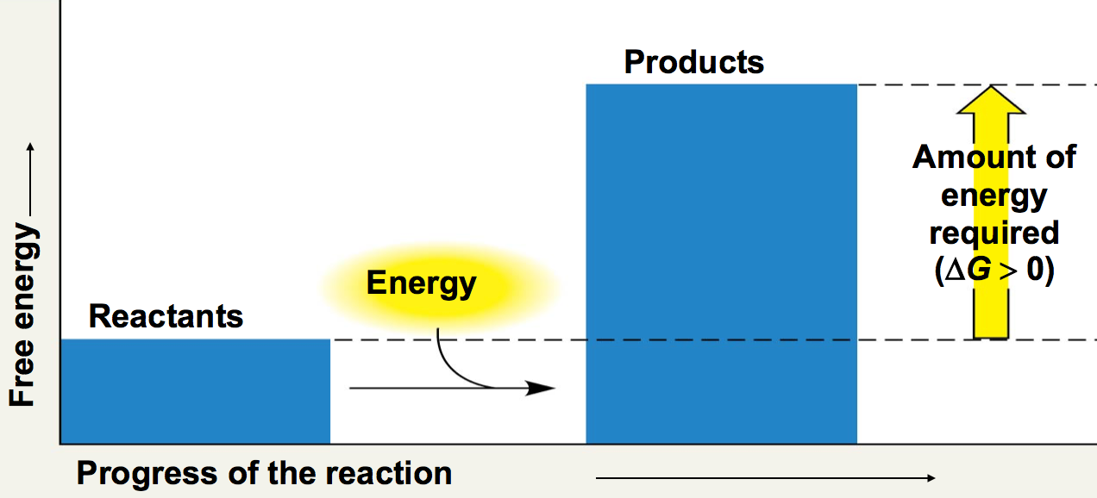

Does the graph represent an exergonic or endergonic reaction? Explain

***If a ΔG is a POSITIVE number then energy is being absorbed.***

Would this be photosynthesis or cellular respiration? Explain.

Identify this molecule on the left: __________________

During which metabolic pathway(s) does it get made? (Think,think,think)

In which part of the molecule is most of its energy stored.

This molecule mostly alternates between two forms. If a phosphate is removed, what is it called?

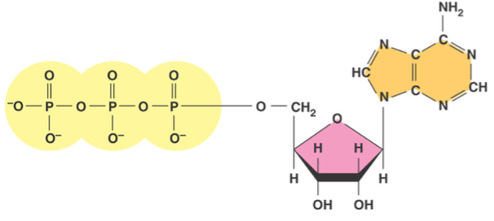

The image to the left shows ATP transferring one of its phosphates to another molecule. What is this process called?

This image does not show it, but what type of enzyme is usually used to catalyze this process?

The molecule labeled C is known as a phosphorylated intermediate. Explain its significance in a chemical reaction.

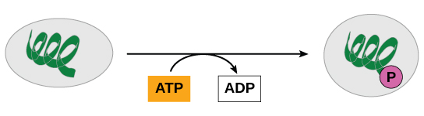A B C