**Enzymes**

________________ _________________

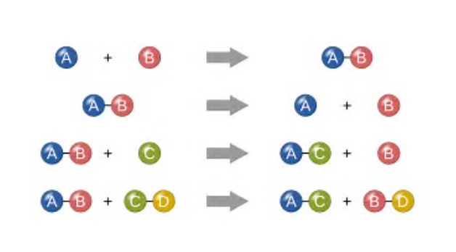

Explain what defines a chemical reaction.

Identify the products and the reactants.

What defines a catabolic reaction?

What defines an anabolic?

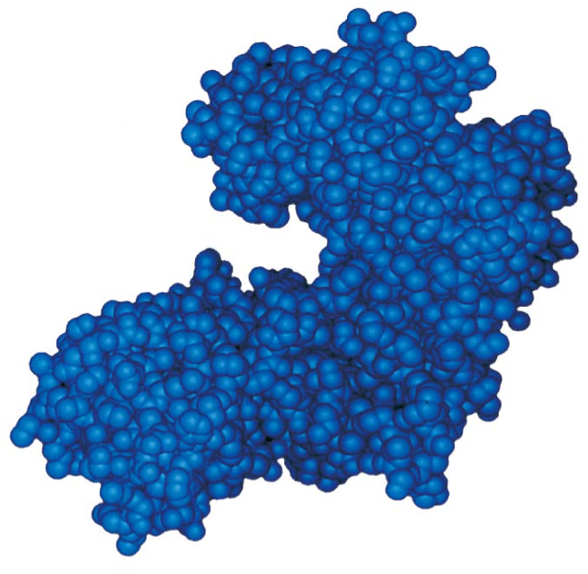

What type of macromolecule is an enzyme? What are its monomers called?

**You can tell if a protein is an enzyme if it ends with -ase. (most, not all…pepsin is an enzyme that helps break apart proteins)**

**Ex: amylase, kinase, alcohol dehydrogenase, hexokinase, catalase**

What determines its primary structure? Tertiary structure?

Where would you find hydrophobic amino acids? Hydrophillic?

Why is the 3D shape (tertiary structure) soooooo important?

Label the active site and allosteric site.

What do we call a molecule that will bind to the active site of the enzyme? (hint- another name for reactants when enzymes are involved:) _________________________



What part of the enzyme do substrates bind to?

Explain how the lock and key model demonstrates enzyme **specificity**.

Explain what is meant by induced fit.

How does induced fit help in lowering activation energy?

What happens to the enzyme and the substrates by the end of the reaction?

----------------------------------------------------------------------------

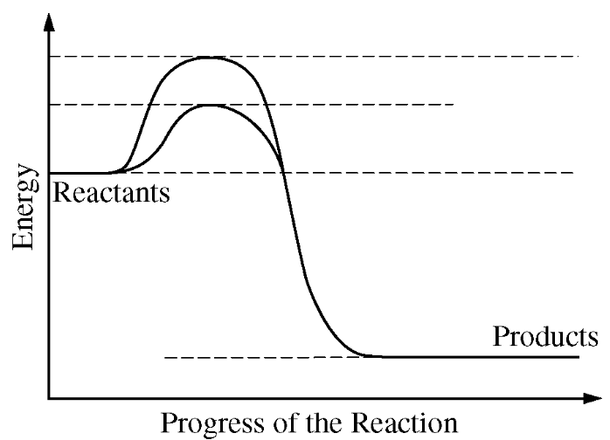

What is activation energy?

This is the graph that is used everywhere to show how enzymes affect reaction rates. What is it showing us?

Identify the line that represents the chemical reaction with an enzyme and without an enzyme.

Is this an endergonic or exergonic reaction?

.

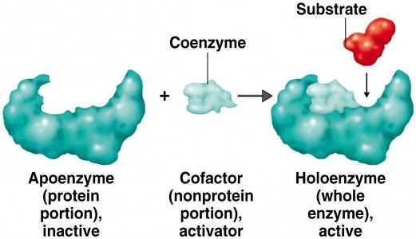

Activators:

Use the diagram to explain the role of

Cofactors or coenzymes in enzyme catalysis.

Explain how a competitive inhibitor works.

What effect would it have on the rate of a reaction?

Does increasing substrate amounts (saturating a solution with substrates) help against competitive inhibitors? Explain.

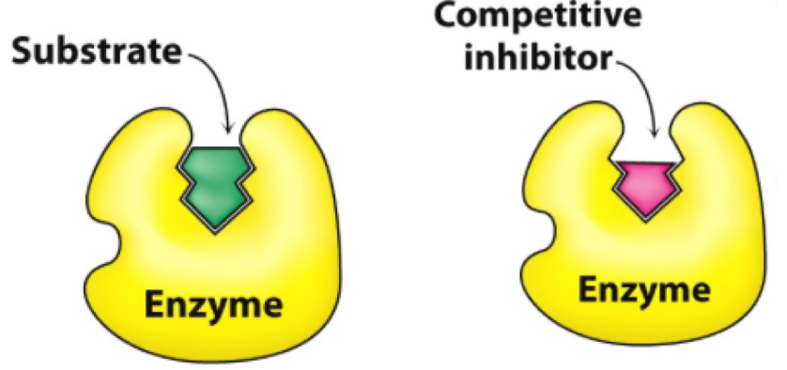

Explain how a noncompetitive inhibitor (aka: allosteric inhibitor) works.

What effect would it have on the rate of a reaction?

Does increasing substrate amounts (saturating a solution with substrates) help against noncompetitive inhibitors? Explain.

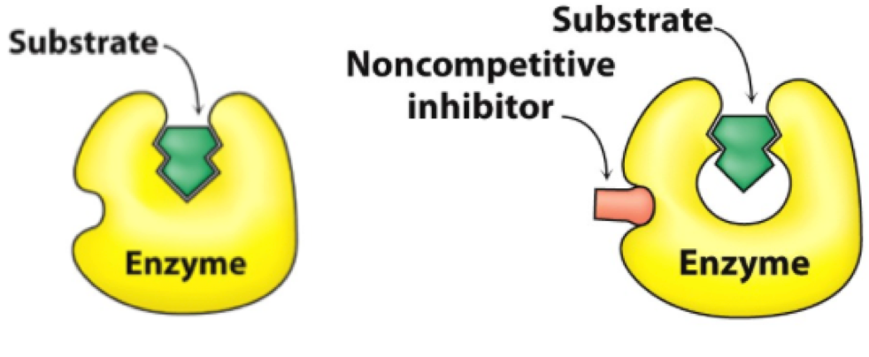

To be clear: If a solution is saturated with substrates, which type of inhibitors would lose its effect?

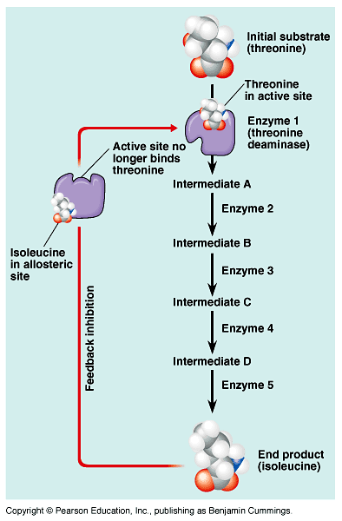

Explain feedback inhibition.

In which body system is this process instrumental in controlling communication signals?

Explain why cells need to control enzymes and chemical reactions.

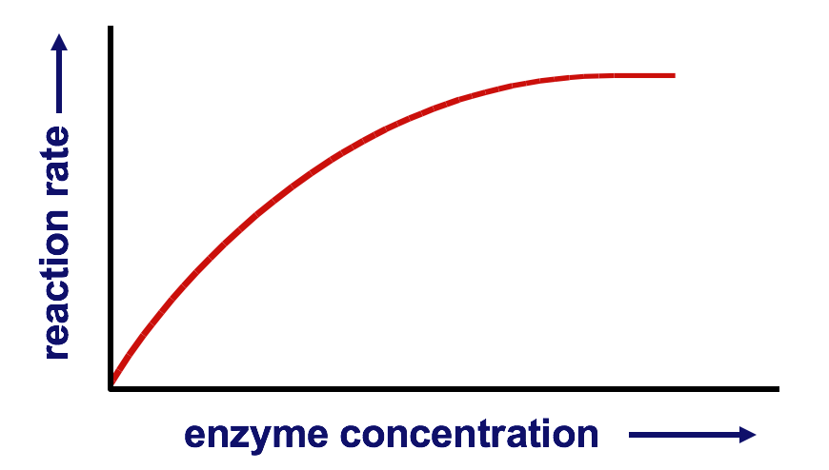

Explain the affect enzyme concentration has on rate of reaction. (Why does it level off?)

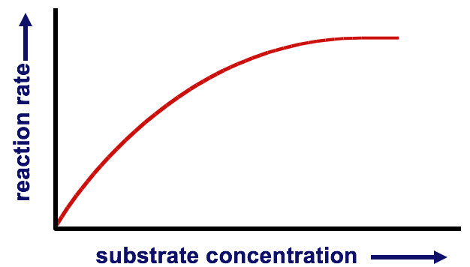

Explain the affect substrate concentration has on rate of reaction. (Why does it level off?)

Optimal Temperature

Explain the affect temperature has on rate of reaction. Be specific.

What is meant by optimal temperature? Do all enzymes have the same optimal temperature?

What happens to the enzyme if it gets to hot?

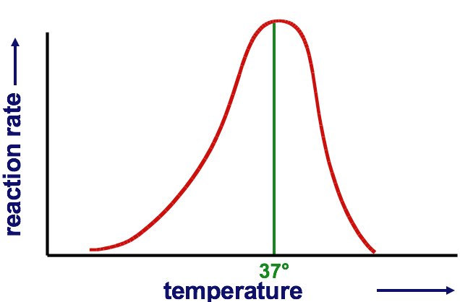

Explain the affect pH has on rate of reaction. Be specific.

What is meant by optimal pH? Do all enzymes have the same optimal pH?

What happens to the enzyme if the pH is too high or too low?

Would pepsin from the stomach (optimal pH 2) work in your mouth (pH 7)? Explain.

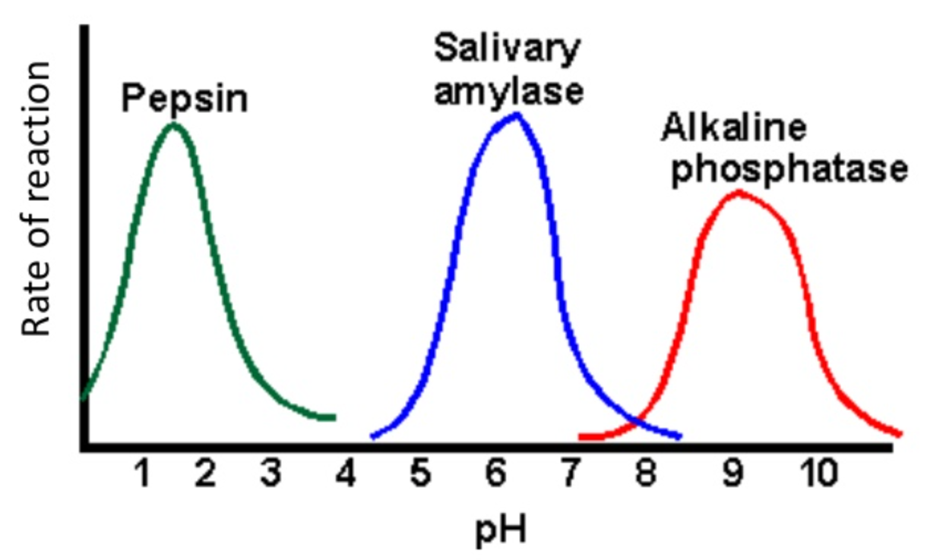Optimal pH

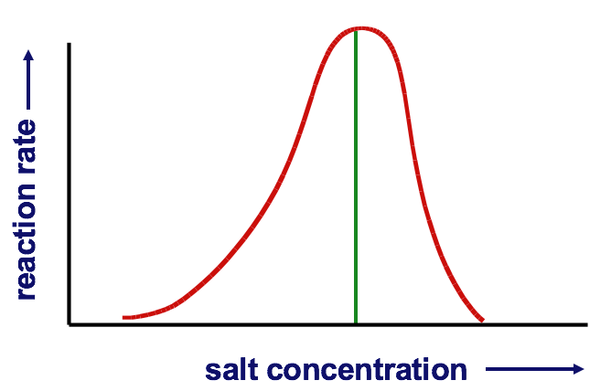Optimal Salinity

Explain the affect salinity has on rate of reaction. Be specific.

What is meant by optimal salinity? Do all enzymes have the same optimal salinity?

What happens to the enzyme if salinity gets too high or too low?