Name: ___________
Main Ideas Title: Eukaryote Gene Expression Period: ___ Seat:__

Why do eukaryotes 1) Conserve ___________________
regulate their 2) Conserve ___________________
genes?

Levels of Three major ways eukaryote genes are regulated:
eukaryote gene -At the chromatin level -_____________________ -Post Transcription
regulation

Differential gene ***Every cell in an organisms body has the same copy of DNA instructions (genome) but…
Expression ______________________________________________________________________
(In humans only 20-40% of genes are expressed in each cell)
This makes cells look and behave different

Chromatin -The genes location of its promotor relative to the nucleosome
structure affects determines if it can be transcribed
gene expression -____________________________________
-____________________________________

Histone -Addition of an acetyl (-COCH₃) to a histone tail amino acid ___________________
Acetylation ____________________________________

DNA methylation Addition of methyl group (-CH₃) to DNA bases (usually cytosine) ____________________________________________________________________________
- Few methyl groups means gene is transcribed less
-Heavy methylation means genes are not expressed
- Removal of methyl groups can resume expression

Transcription In most organisms, _______________________________________________________ by signals sent from the outside of the cell
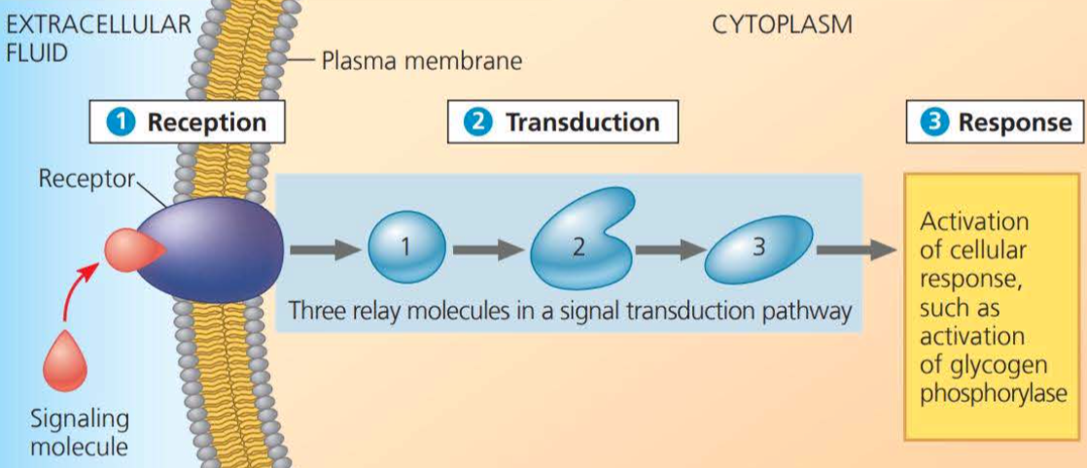

Gene Regulation BIG IDEA!!!
___________________________________________________ in response to signals from internal and external environments
-Hormones
-Death of surrounding cells (growth factors)
-Eating
-Temperature Changes
- Cyclins/CDKS

Components of -_______________________- DNA segments that are binding sites for transcription factors
Transcription *Enhancer- control elements upstream of the gene that must be bound for transcription to
occur
-____________________________________- proteins that must bind to control elements and the promoter in order for RNA Polymerase to bind
*__________________________________
-______________________________________- Additional group of proteins that must be present to interact with the promoter.

Activation of 1) _____________________________________________________
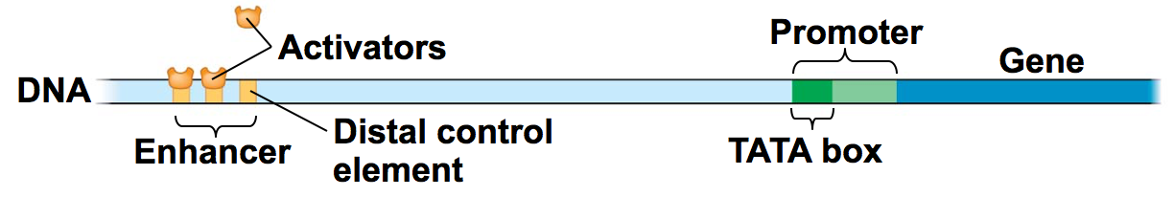
Transcription

2) __________________________________________________________________________
___________________________________________________________________
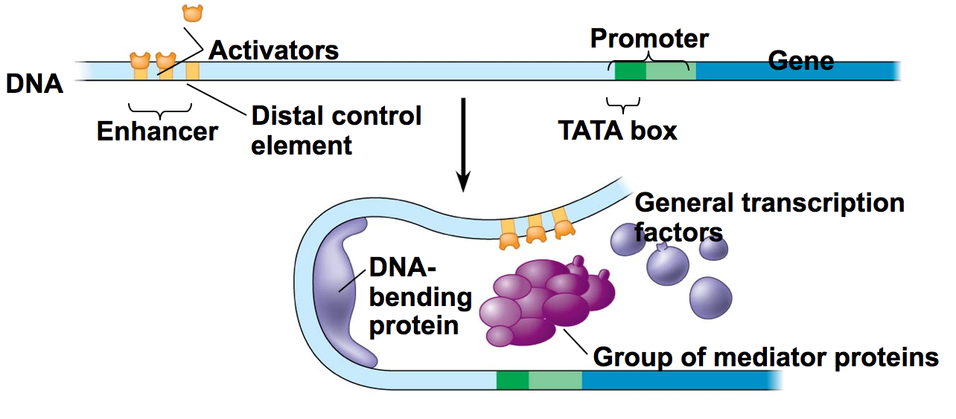

3)__________________________________________________________________________
___________________________________________________________________
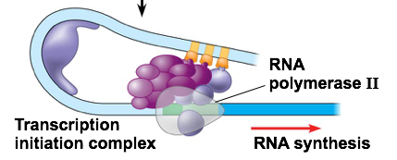

Repressors in _____________ bind to enhancer which blocks activators from binding…stopping transcription
Eukaryotes

Alternative
Splicing

