Feedback Mechanisms
Why?
The heating system of a house works to keep the temperature constant. If the house gets too cold,
then the heat automatically turns on to warm the house. The heat stops when the preset temperature is reached. This is an example of a feedback mechanism. Organisms use many feedback mechanisms to either maintain or amplify important chemical systems. This could happen at a molecular level to coordinate the function of a single enzyme or it could happen throughout the body to regulate the organism’s internal temperature.

Model 1 – Positive and Negative Feedback
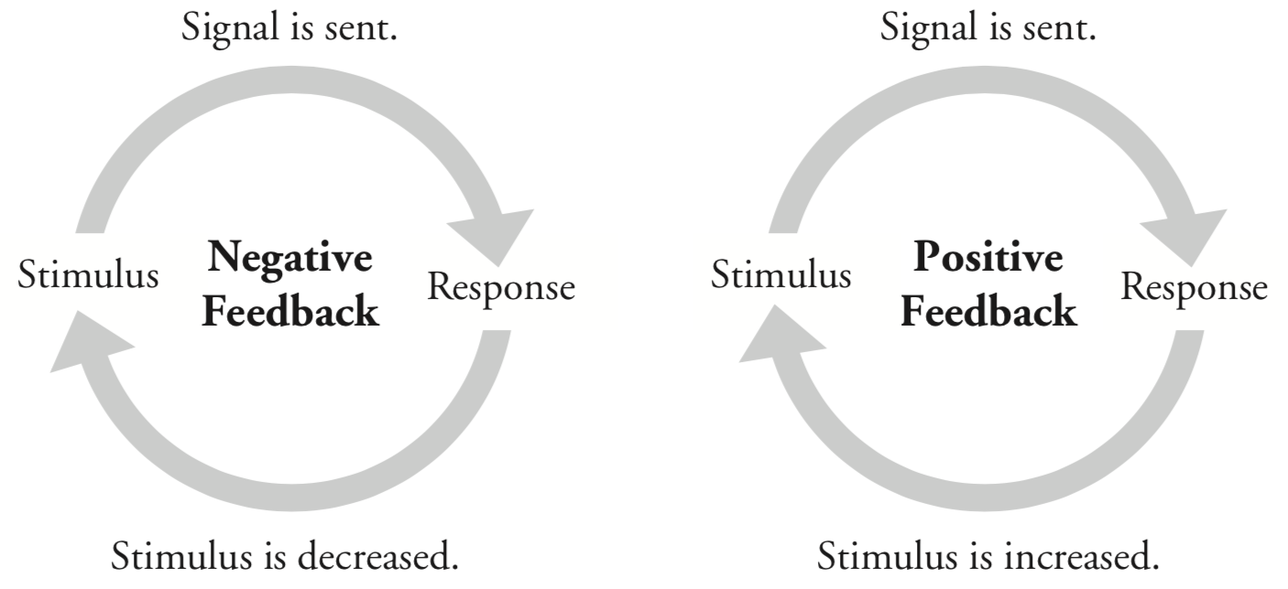

1. What two types of feedback mechanisms are illustrated in Model 1?

2. Define the words below as they are used in everyday language.
Stimulus
Signal
Response

3. Identify at least three similarities in the two types of feedback mechanisms in Model 1.

4. Imagine that you have just gotten a puppy. In the course of playing with the puppy you throw a ball and the puppy chases after it. You then say “Good job!” and rub the puppy’s head to show him he did what you wanted him to do.
a. Is the puppy likely to chase the ball the next time you throw it? Justify your reasoning.

b. Identify the portions of the scenario as stimulus or response.
Puppy chases the ball. __________________ “Good Job” and head rub. __________________

c. Is this scenario an example of positive or negative feedback? Justify your reasoning using the words
“stimulus” and “response.”

5. Later that day your puppy urinates on the couch. You then say “No, bad dog!” and place the puppy outside.
a. Is the puppy likely to urinate on the couch again? Justify your reasoning.

b. Identify the portions of the scenario as stimulus or response.
Puppy urinates on the couch. __________________ “No, bad dog!” __________________

c. Is this scenario an example of positive or negative feedback? Justify your reasoning using the words
“stimulus” and “response.”

6. Which of the feedback mechanisms in Model 1 would be most useful for amplifying a condition that is advantageous for the organism?
7. Which of the feedback mechanisms in Model 1 would be most useful for stopping a condition that is
detrimental or limiting a condition to specified levels?
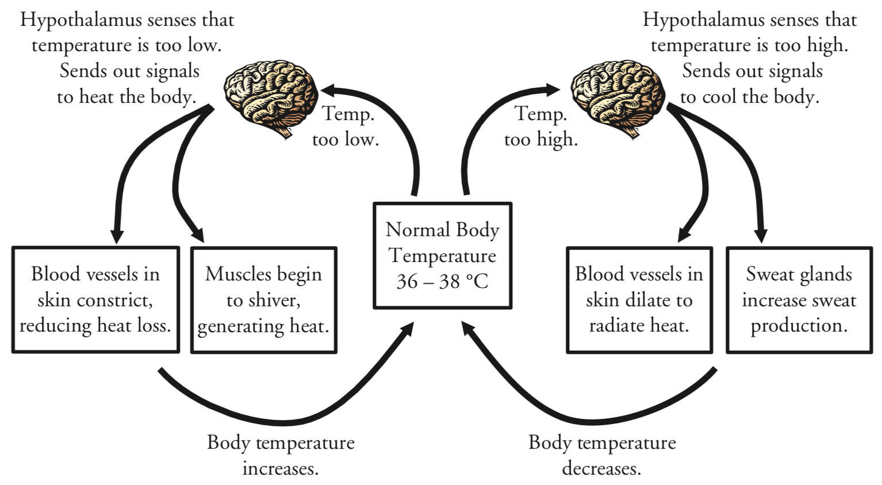
Model 2 – Thermoregulation in Humans

8. Examine Model 2. Based on what you see in the model, propose a definition for “thermoregulation.”

9. According to Model 2, what portion of the brain contains sensors that monitor body temperature?

10. According to Model 2:
a. What are two mechanisms the body uses to cool itself? What cells are “temporarily” changed?

b. What are two mechanisms the body uses to heat itself? What cells are “temporarily” changed?

11. Consider the feedback loop that cools the body when it is too warm.
a. Identify the “stimulus” and “response” in the feedback loop.

b. Is this feedback loop positive or negative feedback? Justify your reasoning.

12. Consider the feedback loop that heats the body when it is too cold.
a. Identify the “stimulus” and “response” in the feedback loop.

b. Is this feedback loop positive or negative feedback? Justify your reasoning.
Model 3 – Childbirth and Contractions
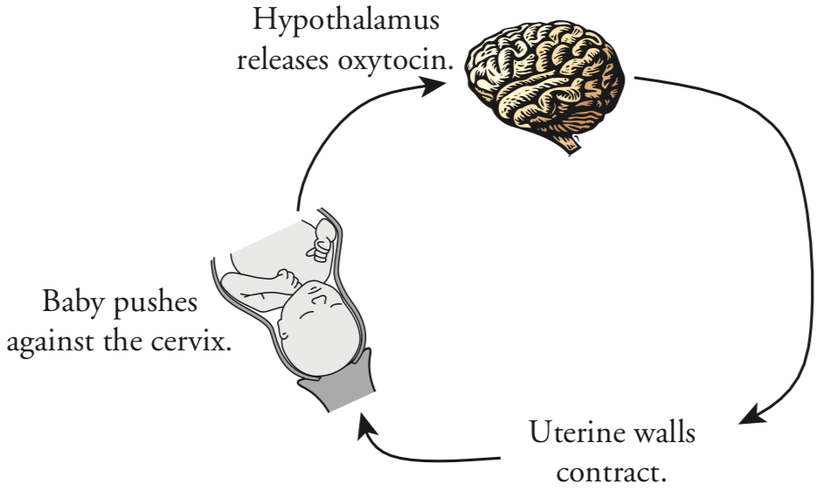

13. According to Model 3, what is the stimulus and what is the response during childbirth?

14. What hormone, released from the hypothalamus, increases the intensity of contractions? What are its target cells?

15. When the intensity of contractions increases, will the stimulus increase or decrease?

16. Is childbirth an example of a positive or negative feedback system? Justify your answer.

17. What will eventually stop the stimulus and thus stop the childbirth feedback loop?

Read This!
Many of the systems in the body are delicate. They function only under a specific range of parameters. Enzymes will denature if they get too hot or cold or if the pH of the solution they are in is too high or too low. Cells will not be able to process glucose for energy if the concentrations of oxygen in the blood are not high enough. Feedback mechanisms are used to keep the body in homeostasis. That is, many systems are in place that monitor and regulate important parameters of the body and keep them within normal levels.

18. What role does cell signaling/cell communication play in all of this?

