Prokaryote and Eukaryote Gene Expression Visual Review

Use the image to state the central dogma of biology.

What is a gene?

What are the two steps of protein synthesis?

**\*\*\*Why do genes need to be regulated?**

**\*What is a promotor?**

**Central Dogma**

*What are the 3 main ways eukaryotes regulate gene expression?

In general, what is an operon and in what types of cells are they found?

What is the purpose of operons?

Define the following:

Promotor-

Operator-

Repressor-

Corepressor-

Inducer-

Explain how a repressible operon works:

Explain how an inducible operon works:

**Repressible Operons**

**Incucible Operons**

**1) Eukaryote Transcription Regulation**

What can cause a eukaryote to turn its genes on or off (turn transcription on or off)?

Identify the function of the following components necessary for eukaryote transcription:

RNA polymerase II-

Promotor-

TATA box-

Transcription factors-

Enhancer-

Control element-

Activators-

Mediator proteins-

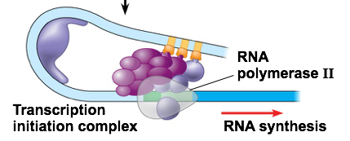

What are the key components that must be assembled to form the initiation complex?

Describe the 3 steps to forming the initiation complex and beginning transcription.

How do repressors work in eukaryotes?

How is cell communication connected to all of this?

Steroid hormones binding with their receptors usually act as…

**2) Eukaryote Chromatin (pre-transcription) Regulation**

**Cell Differentiation**

What is a stem cell?

Do all cells (except gametes) have the same DNA or different DNA? How do you know? (Hint: mitosis)

What is cell differentiation?

So, do all cell express the same genes? Why or why not?

What is the difference between heterochromatin and euchromatin?

How is the promotor involved in gene regulation with heterochromatin and euchromatin?

**Heterochromatin and Euchromatin**

**Acetylation and Methylation**

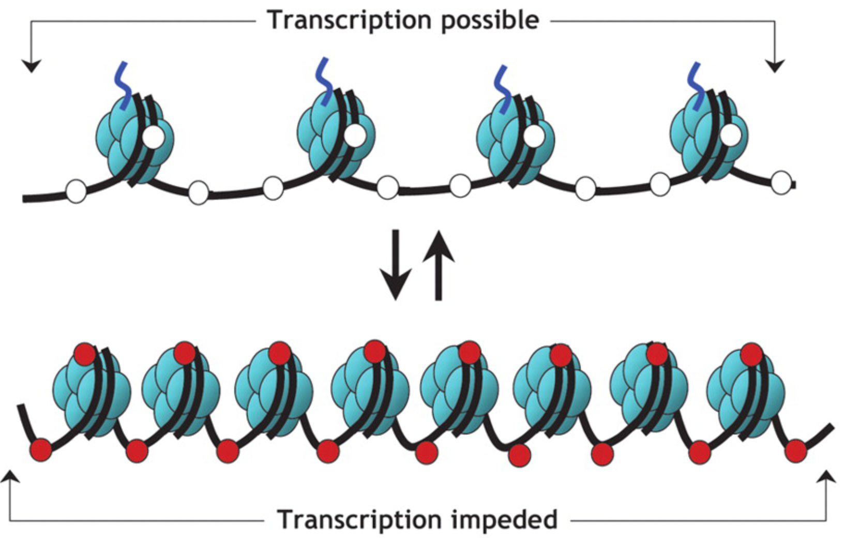

What does acetylation do to the chromatin? How does it affect gene expression?

What does methylation do to the chromatin? How does it affect gene expression?

What is epigenetics? Give an example.

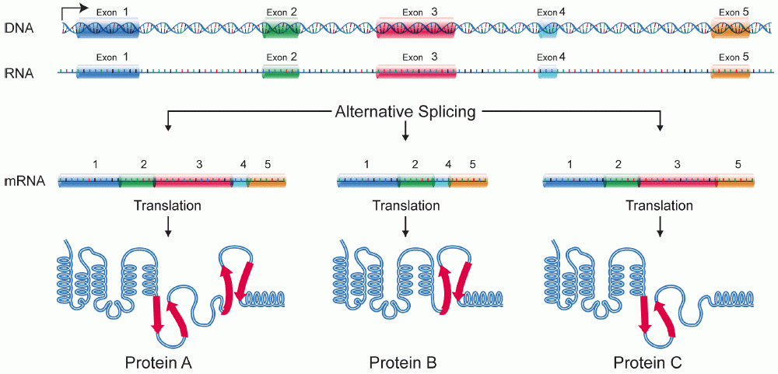

**Be able to identify the similarities and differences between prokaryotes and eukaryotes in gene regulation!!!**

What is a protease?

What happens to proteins that are meant to be temporary?

How are enzymes turned on or off?

**Protein Degradation and Enzyme Control**

**RNA Processing and mRNA Degradation**

How is RNA processing used to regulate gene expression?

How is alternative splicing a means of regulation?

**3) Post Transcription Regulation**