**Genetics Review Images**

Dominant/Recessive & Phenotypes/Genotypes

State the principle of dominance.

What is the difference between genotypes and phenotypes?

What are the 3 possible genotypes?

- Homozygous Dominant

-

-

If purple petal color is dominant over which pedal color, what color would each of the following organisms with these genotypes be?

PP= Pp= pp=

If dimples are dominant (D) to no dimples (d) what is the genotype(s) of someone who has dimples? No dimples?

Dimples: No dimples:

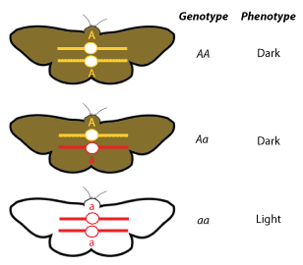

Generations

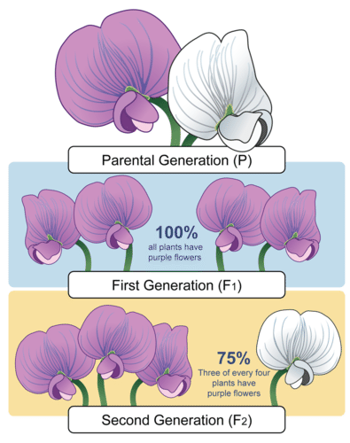

Traditionally, what genotypes are the organisms that start everything in the P generation?

Following tradition, the F1 generation offspring usually all come out as which genotype? What are their phenotypes?

Still with tradition, the F2 generation offspring that are created by crossing 2 individuals from the F1 generation, usually have what genotypes? What are their phenotypes?

What is represented in the boxes of a Punnett Square?

What is the law of segregation?

How does a Punnett Square help demonstrate the law of segregation?

How does a Punnett Square help demonstrate random fertilization?

If A represents the allele for Achondroplasia (a type of dwarfism) and a represents the normal allele.

What are the percent chances of this couple have a child with Achondroplasia? ____

Phenotype ratio: Genotype ratio:

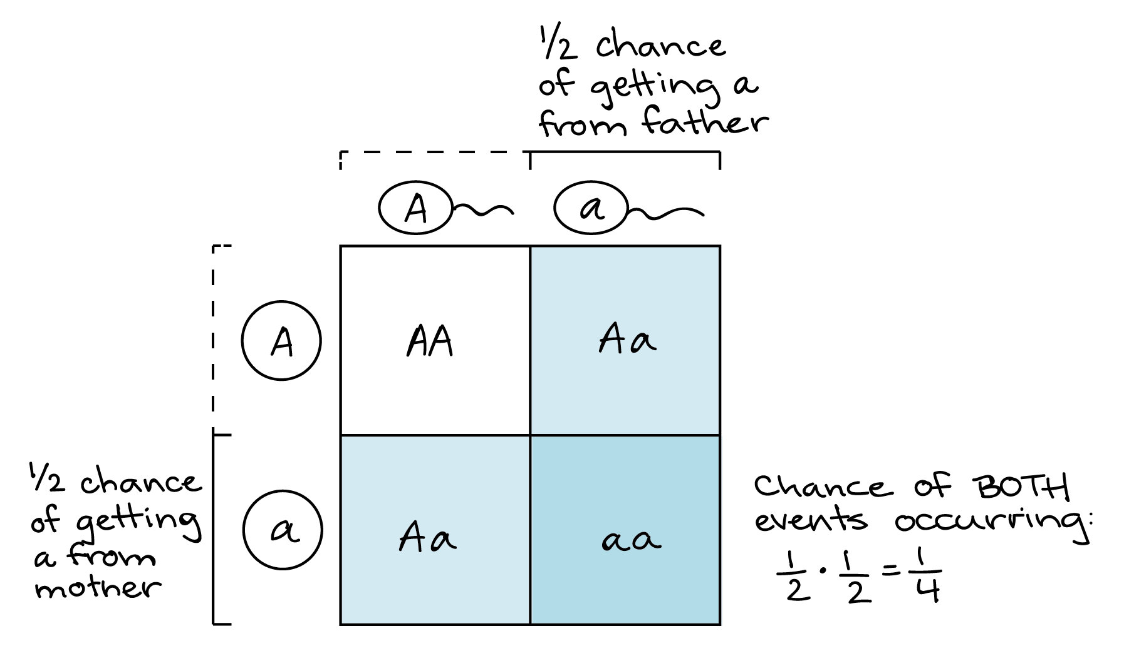Punnett Squares

Chances of having a boy or a girl

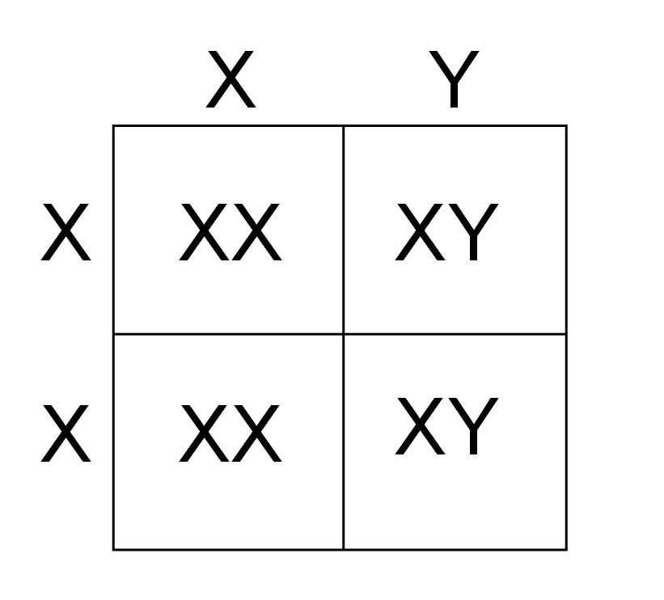

What are the chances of having a boy or a girl?

In humans, which parent determines the sex of the child?

Law of independent assortment

If the two genes represented to the left are unlinked (on different chromosomes), what possible gametes can be made with an individual with these alleles? Draw them out.

DdFf

ddFf

If the two genes represented to the left are unlinked (on different chromosomes), what possible gametes can be made with an individual with these alleles? Draw them out.

DDff

If the two genes represented to the left are unlinked (on different chromosomes), what possible gametes can be made with an individual with these alleles? Draw them out.

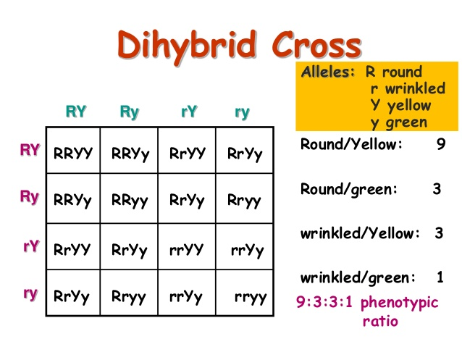

What are unlinked genes?

How does a Punnett Square help demonstrate the law of independent assortment?

What is always the phenotype ratio for a dihybrid cross of two heterozygotes? Does this ratio apply to linked genes?

Parent genotypes: RrYy x RrYy

Why do we use chi square in genetics?

What is the formula for chi square?

How do you calculate degrees of freedom?

What are the values called listed in the row with the p value of .05?

When do you reject the null hypothesis? When do you accept?

**Dihybrid Cross Ratios to memorize:**

Homozygous dominant purebred crossed with a homozygous recessive purebred

AABB x aabb = all offspring heterozygous AaBb (genotypes), all phenotypes express the dominant of both traits

Heterozygote crossed with a heterozygote

AaBb x AaBb = 9:3:3:1 ratio (phenotype ratio)

9 that show the dominant phenotype of both genes

3 that show the dominant phenotype of the first gene and recessive of the 2nd

3 that show the recessive phenotype of the first gene and dominant of the 2nd

1 that shows the recessive phenotype for both genes

Heterozygote crossed with a homozygous recessive

AaBb x aabb = 4:4:4:4 or 1:1:1:1 ratio (phenotype ratio)

4 that show the dominant phenotype of both genes

4 that show the dominant phenotype of the first gene and recessive of the 2nd

4 that show the recessive phenotype of the first gene and dominant of the 2nd

4 that shows the recessive phenotype for both genes

Homozygous dominant crossed with a heterozygote

AABB x AaBb = all offspring phenotypes show the dominant of both traits

4:4:4:4 or 1:1:1:1 genotype ratio of AABB:AABb:AaBB:AaBb

Chi-Square

Probability

AaBbCC

What are the chances of the individual on the left producing a gamete that is AbC?

In a cross between the two individuals to the left, what is the probability that the offspring will be aaBBCc?

AaBbCC x aaBbcc

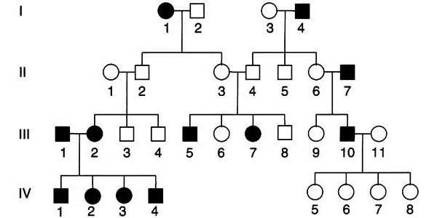Pedigrees

Autosomal dominant, autosomal recessive or x-linked?

Use the chart to explain the pattern for this type of inheritance.

Predict the genotypes . (D=normal, d=diabetes)

What are the chances that the next child of individuals 10 and 11 in generation III has a disorder?

Autosomal dominant, autosomal recessive or x-linked?

Use the chart to explain the pattern for this type of inheritance.

Predict the genotypes .(H=normal, h=hemophilia)

In generation IV, what are the chances of individual 4 having a son who has the disorder if he marries a woman with no family history?

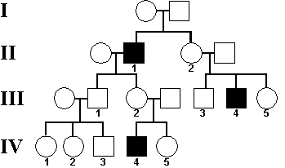

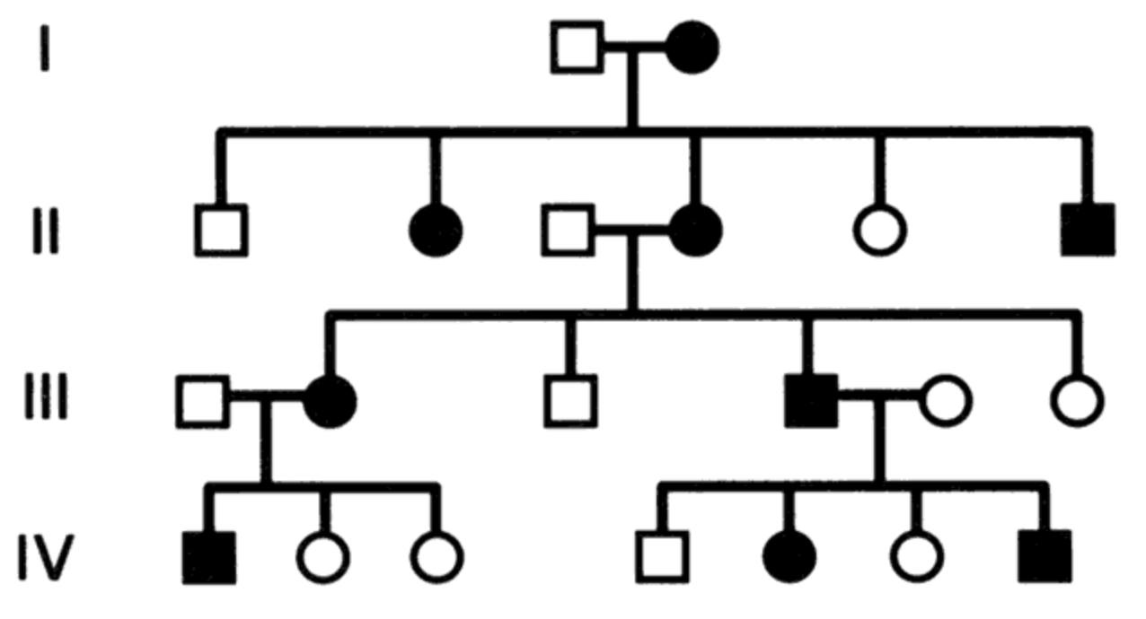

Autosomal dominant, autosomal recessive or x-linked?

Use the chart to explain the pattern for this type of inheritance.

Predict the genotypes . (H=Huntington’s, h=normal)

What are the chances of the only couple in generation II having their next child with a disorder.