Local and Long Distance Signaling (Communication)

1. Team work: Consider each of the following cellular communication examples. Divide the work with your partner (odd take ab, even take cd). Have each person determine which type of signaling is being used in their scenario (autocrine, juxtacrine, paracrine or endocrine), and then share their reasoning.

a. Quorum sensing is used by bacteria to determine the population density of their species
in a local area. (Many bacterial functions would be ineffective in small numbers—infecting a host organism with a toxin, for example—and would therefore be a waste of energy and resources to the bacteria.) Each bacterium produces a ligand. Once the concentration of that ligand reaches a critical concentration, thus indicating a sufficient population density for the response to be effective, all bacteria will respond simultaneously.
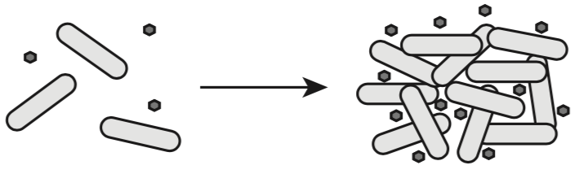

b. Plants construct channels between cells called plasmodesmata that allow ligands to move directly from one cell to another throughout the plant structure.
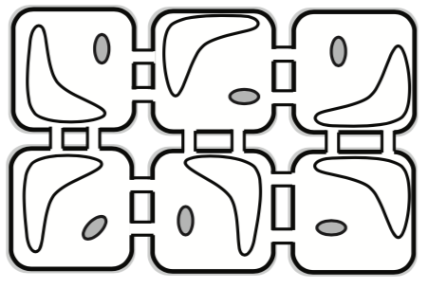

c. Morphogens are produced in embryos from a central source early in development. They dif- fuse throughout the tissue creating a concentration gradient that provides a spatial reference for developing cells. Cells far from the morphogen production will develop into one type of tissue while cells close to the source will develop into a different type of tissue. This allows for differentiation of cell structure early in embryotic development.
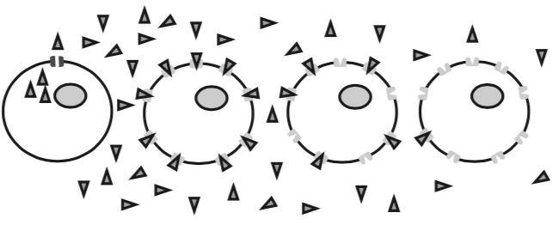

d. Cells in the human pancreas release insulin when blood sugar levels are elevated. The insulin signals cells in the liver to begin absorbing glucose and convert it to glycogen for storage.

2. Team work: Consider each of the following cellular communication examples. Divide the work with your partner (odd take ab, even take cd). Have each person determine which type of signaling is being used in their scenario (autocrine, juxtacrine, paracrine or endocrine), and then share their reasoning.

a. Pheromones released by a female gamete cell (egg) provide a pathway for the male gamete cell (sperm) to travel, increasing the possibility of fertilization.

b. Some cancer cells release their own growth hormone rather than relying on growth hormones from the host organism or from other cells. This presents challenges to cancer researchers looking for ways to slow the growth of cancer cells.

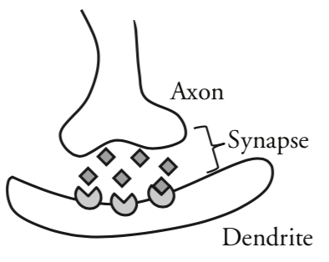
c. Neurotransmitters are ligands that are released from the axon of one nerve cell to the dendrite of another nerve cell. This helps to propagate the signal across several cells.

b. Cells in the pituitary gland produce thyroid stimulating hormone (TSH), which is received by cells in the thyroid. The arrival of TSH in the thyroid triggers production of several hormones, which then travel throughout the body to regulate metabolism.

Think, Think, Think
3. If a medical researcher wanted to prevent communication between cells in order to cure a disease or prevent a malady, how might they achieve that? Propose two or more general methods that could be used to stop a signal transmission from cell to cell.

4. If a medical researcher wanted to enhance communication between cells in order to cure a disease or prevent a malady, how might they achieve that? Propose two or more general methods that could be used to enhance signal transmission from cell to cell.

5. The examples of cellular communication used in this activity vary from bacteria to plants to vertebrates. However, the mechanisms of cellular communication are similar among varied species. Explain how scientists might use cellular communication systems to show evolutionary related- ness between species.

6. Some hormones such as estrogen and testosterone are lipids and are therefore nonpolar. Explain why a receptor protein would not be needed for this type of ligand to activate a response in a cell.

7. Suggest some stimuli that might cause a cell to release a ligand and begin communication between cells.

