Name: ________________
Main Ideas/Questions
Title: ENZYMES Period: _____Seat:_____
Chemical Reactions A ____________________________ is a process that changes one set of substances
into another set of substances by ____________________________________________
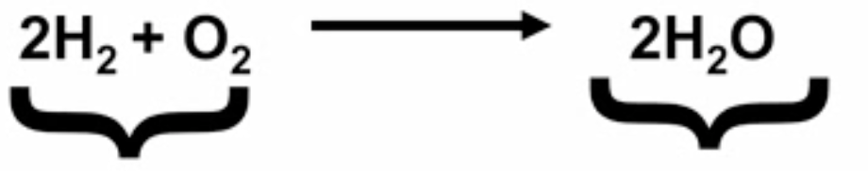

Chemical Reactions Trillions of chemical reactions happen every second in your body as part of the metabolic
Inside Cells pathways in each cell
________________________________________ that make life possible _________________
to make them practical for living tissue

Activation Energy Most chemical reactions in our metabolic pathways will not occur without ___________
____________________________________________________…even exergonic ones.

The energy required to get a chemical reaction started is called ____________________

Enzymes Enzymes are a type of protein that help speed up chemical reactions in metabolic
pathways (aka catalyst)

_______________________________________________________________________

The GRAPH

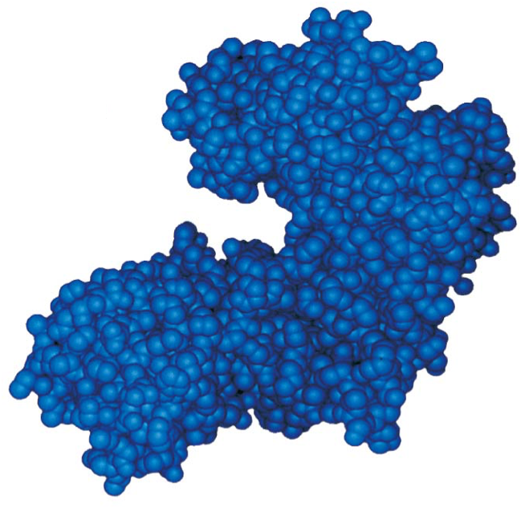

Enzyme Shape 3 Important parts to enzyme shape:
_______________________________
_______________________________
_______________________________

Enzyme and Substrate _________________________________________ due to their shape
*They only work with specific molecules that we call ________________
The enzyme and substrate _______________________________________
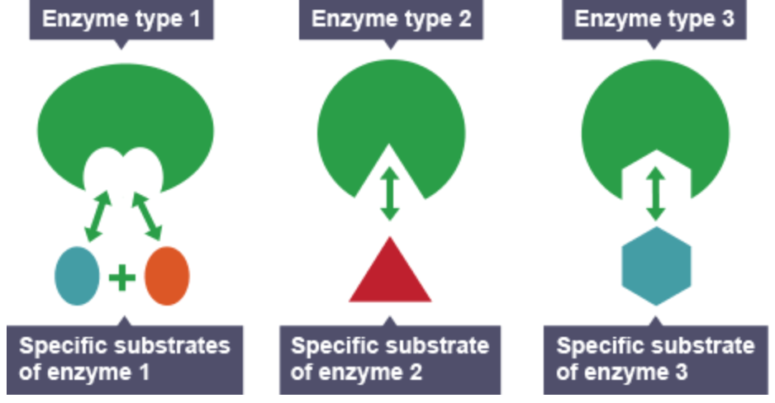

How do enzymes lower When the substrate binds to the activation site, _________________________________
Activation energy? ___________________________________________
INDUCED FIT *Due to weak _________________________________________________________
______________________________ in the active site

This change in shape weakens chemical bonds by destabilizing the substrate= less
activation energy

4 Major Ways to 1) ________________________________________ in the correct position to each other
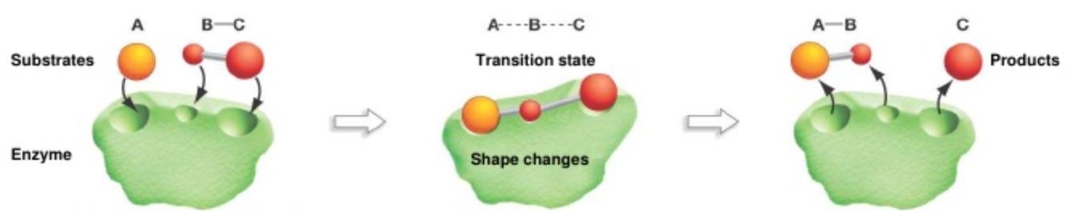
Lower Activation
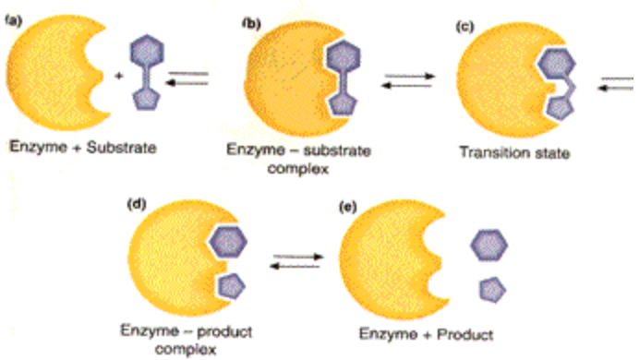
ENERGY

2) Induced fit may ___________________________________
to be broken

3) _________________________________________________
*Using R-groups to lower or increase pH, positive or negative charges

4) _____________________________________________________________________
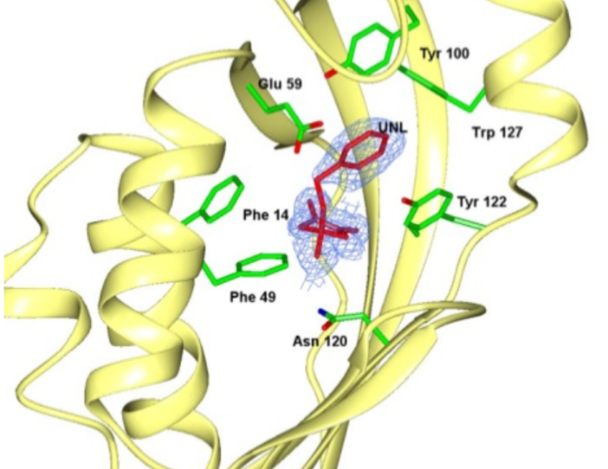
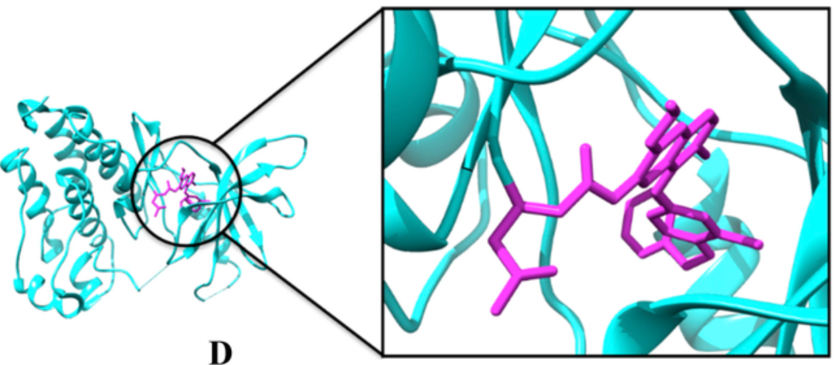
chains in active site

Summary:

