Murder and a Meal
CLASS SET
CLASS SET

The Case:
A murder has occurred right here in our peaceful little town of Eastvale, California. As top-notch biology students at Eleanor Roosevelt High School, you have been asked to assist in the investigation of this most unfortunate incident. Central to identifying the individual who committed this crime is establishing where the victim was the day of the crime so that detectives can question the individuals with whom the victim came into contact. An autopsy was performed on the victim and has revealed that the victim ate just prior to the time of death. Upon questioning the victim’s friends and family, detectives working the case have learned that the victim enjoyed eating at the following places.
Blaze Fast Fire’d Pizza
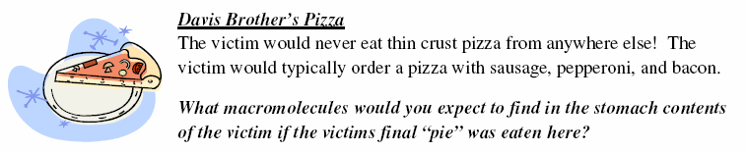

The victim would never eat pizza from anywhere else! The victim would typically order a pizza with sausage, pepperoni and bacon.

What macromolecules would you expect to find in the stomach contents of the victim if the victims final “pie” was eaten here?

Buffalo Wild Wings

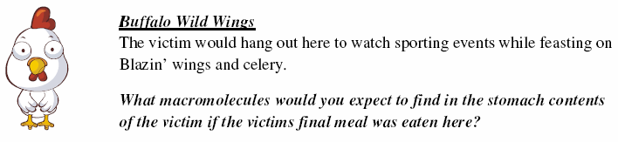
The victim would hang out here to watch sporting events while feasting on Blazin’ wings.

What macromolecules would you expect to find in the stomach contents of the victim if the victims final meal was eaten here?

Carinos
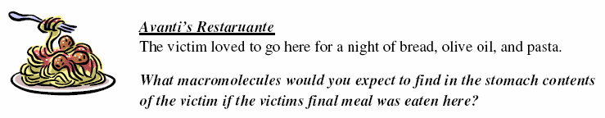

The victim loved to go here for a night of bread, olive oil and fettuccini pasta.

What macromolecules would you expect to find in the stomach contents of the victim if the victims final meal was eaten here?

The forensic pathologist has removed the contents of the victim’s stomach for you to analyze in order to determine where the victim had his last meal. (See the lovely looking stomach contents in the front of the room )

Where do you get your macromolecules from?
CLASS SET
CLASS SET
Murder and a Meal Lab
Lipids
-Butter
-Vegetable or Canola Oil
-Olive oil
-Twinkies
-Ice Cream
-Potato chips
-Cheese

Almost everything contains lipids. Even many fruits and vegetables. The goal is to eat the right kinds of lipids in the right amounts.

Proteins
-Meats like
Pork
Beef
Chicken
Tuna (Fish in general)
-Soy
-Eggs

Simple carbohydrates
Simple carbohydrates are also known as sugars.

**Natural sugars are found in fruit and vegetables.
Refined sugars are found in:
- biscuits, cakes and pastries
- chocolate
- honey and jams
- jellies
- brown and white cane sugar
- pizzas
- prepared foods and sauces
- soft drinks
- sweets and snack bars.
Simple carbohydrates (sugar) cause tooth decay.

Complex carbohydrates (long polymers)
Complex carbohydrates as natural starches are found in:
- bananas
- barley
- beans
- brown rice
- chickpeas
- lentils
- nuts
- oats
- parsnips
- potatoes
- root vegetables
- sweet corn
- wholegrain cereals
- whole wheat breads
- whole wheat cereals
- whole wheat flour
- whole wheat pasta
- yams.
Complex carbohydrates as refined starches are found in:
- biscuits, pastries and cakes
- pizzas
- sugary processed breakfast cereals
- white bread
- white flour
- white pasta
- white rice.

Name: ________________
Period: ______ Seat:_____
Observation: Different macromolecules are part of different types of __________________ we eat.
Question: Where did our murder victim eat his last meal? Or _____________________________________
_________________________________________________________________________________________.

Prediction: ___________________________________________________________________________.

Materials
Dimple tray Iodine solution Dropper Distilled water
Benedicts solution Paper towels 2 Tooth picks Biuret solution

Pre-Lab Questions:
1. What type of macromolecules would you expect to find in the stomach contents of the victim if he ate his last meal at Blaze Fast Fire’d Pizza? (see description in lab handout) __________________________________
_______________________________________________________________________________________________________________________________________
2. What type of macromolecules would you expect to find in the stomach contents of the victim if he ate his last meal at Buffalo Wild Wings? (see description in lab handout) ______________________________
_______________________________________________________________________________________________________________________________________
3. What type of macromolecules would you expect to find in the stomach contents of the victim if he ate his last meal at Carinos? (see description in lab handout)_________________________________________
______________________________________________________________________________________________________________________________________

Data:
Macromolecule | Chemical Test | Positive Test Result looks like | Negative test result looks like
Lipids | Paper Towel Test | Translucent/Shiny/Almost see through | Dries and looks like regular paper towel
Proteins | Biruets solution | Purple or Pink Color | Blue Color
Simple Carbohydrates  (Monosaccharides like Glucose) | Benedicts Solution | Red Orange/ Brick Red Color | Blue Color
Complex Carbohydrates  (Polysaccharides like starch) | Iodine Solution | Dark Purple or Black Color | Yellowish Brown Color

Test for Proteins | Test for Carbohydrates  (Complex sugars-starch) | Test for Lipids | Test for Carbohydrates  (simple sugars)
Observations: | Observations: | Observations: | Observations:
_____Positive Test Result _____Negative Test Result | _____Positive Test Result _____Negative Test Result | _____Positive Test Result _____Negative Test Result | _____Positive Test Result _____Negative Test Result
Protein present? Yes/ No | Complex carb present? Yes/ No | Lipid present? Yes/ No | Simple Carb present?  Yes/ No

Conclusion: (Write your conclusion on the back) COMPLETE AT HOME!!!
Report your findings as if you were writing a professional report of your findings for the murder (paragraph form).
-Open with a statement regarding which restaurant the victim visited for his last meal. (3 points)
-Provide a logical explanation, using the data from the tests on the stomach contents- describe the results from each test and how it helped you identify or eliminate a possible last eating place to explain how you reached your final conclusion (7 points)
Conclusion—review of scientific method and controlled experiments:
1. Why did we use distilled water in our tests? (2 points)
2. Why did we do 3 trials per test? (2 points)

